Hyperion Planning Reporting
Process Guide

Table of Contents
What is Hyperion Reporting? 3
Training Goals: 3
Helpful Reference Links on the Hyperion SharePoint Site: 4
Setting Reporting Preferences: 4
Hyperion Reporting Task Lists: 6
Hyperion Reporting Web Forms and Reports 7
What are Web Forms? 8
Steps to access the Actuals and Budget web form 8
Interpreting the Actuals and Budget web form 18
Steps to access the Annualized Projection web form 19
Interpreting the Annualized Projection web form 29
What are Hyperion Reports? 30
Actual to Actual report: 30
Steps to run the Actual to Actual All Funds report 31
Steps to run the Actual to Actual Practice Plan Report 54
Interpreting the Actual to Actual reports 70
Actual to Budget Forecast report: 75
Steps to run the Actual to Budget Forecast All Funds report 75
Steps to run the Actual to Budget Forecast Practice Plan report 93
Interpreting the Actual to Budget Forecast reports 109
Annualized Projection report 114
Steps to run the Annualized Projection All Funds report 114
Steps to run the Annualized Projection Practice Plan Report 134
Interpreting the Annualized Projection reports 150
Interpreting Favorable vs. Unfavorable variances 154
Building Variance Explanations 158
Writing Variance Explanations 159
Exporting a report to Excel 162
Cover Explanations 172
Send to the EC Office 173

What is Hyperion Reporting?

- Hyperion Reporting is a financial management tool that will allow users to monitor department finances in order to help meet the overall goals of the UT Health Science Center at San Antonio. It is intended to provide summarized information on operational activities and budgets for high level analysis that can be used to support decision making efforts.

- Hyperion Reporting presents financial information consistent with Generally Accepted Accounting Principles (GAAP), as required by the State Comptroller, and as consolidated for all UT System components.

- Hyperion Reporting is not intended to provide transactional detail typically derived from PeopleSoft or the Data Warehouse.

- Hyperion Reporting consolidates budget entries and the activity from PeopleSoft at the general ledger account code level and categorizes them on a Profit and Loss statement based on their natural reporting classification.

Training Goals:

- Articulate the purpose and importance of the Hyperion Reporting system.

- Define, interpret, and apply the key concepts of financial reporting.

- Generate the two primary financial reports that require monthly analysis.

- Generate informational reports to facilitate further analysis of financial performance.

- Preview the functionality of quarterly forecasting in order to adjust original budget projections.

- Develop a complete, concise, and correct variance explanation.

- Navigate among task lists to obtain the reports needed to analyze financial performance, record variance explanations, and brief upper management on financial outcomes.

Helpful Reference Links on the Hyperion SharePoint Site:

Link to Hyperion SharePoint Site: (https://hscshare.uthscsa.edu/sites/budget/Hyperion/SitePages/Home.aspx)
- Hyperion Reporting training manual
- System Configuration & User Preferences
- Fund and Account groupings
- Financial Glossary
- Hyperion Reporting FAQs
- Hyperion Admin Mailbox ( hyperion@uthscsa.edu )

Setting Reporting Preferences:

Before you begin accessing web forms and running reports in Hyperion Reporting, follow the steps below to set your reporting preferences.
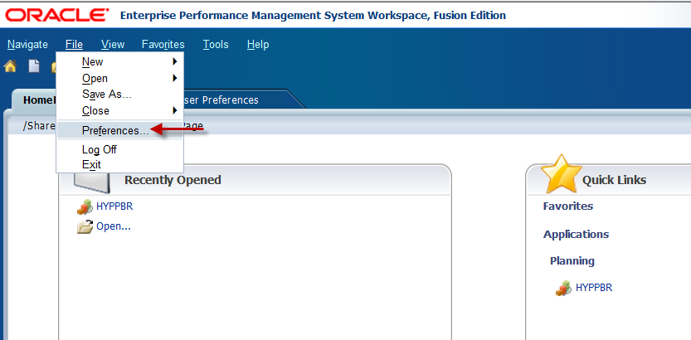

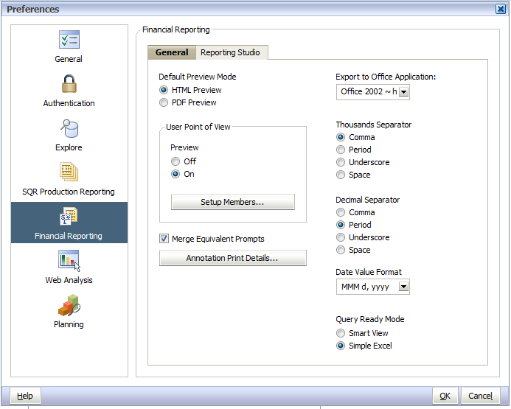

Hyperion Reporting Task Lists:

Obtaining and entering information in Hyperion is performed using steps located within task lists. The two task lists users will navigate among in the Hyperion Reporting application are the Monthly Task List and the Forecast Task List which are displayed below and highlighted in yellow.
In this training document we will only cover steps within the Monthly Task List to achieve the previous listed training goals. The Forecast Task List will be covered in detail in a separate training document.

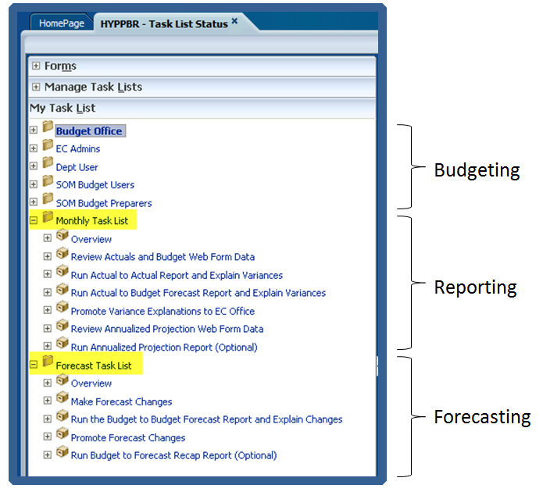

Hyperion Reporting Web Forms and Reports

The two types of data sources you will access from the Monthly Task List in order to analyze financial performance are Web Forms and Reports. The below images are examples to help you differentiate web forms and reports.
Web Forms:
The two web forms users can access from the Monthly Task List are the:
- Actuals and Budget web form
- Annualized Projection web form
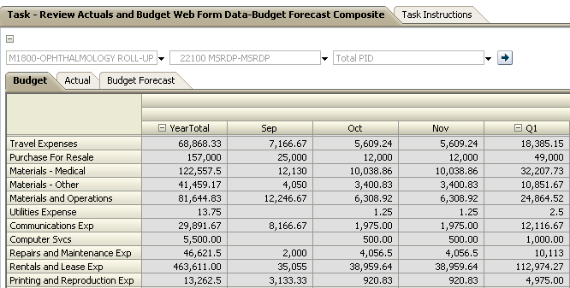
Reports:
The three reports users will run from the Monthly Task List are the:
- Actual to Actual report
- Actual to Budget Forecast report
- Annualized Projection report
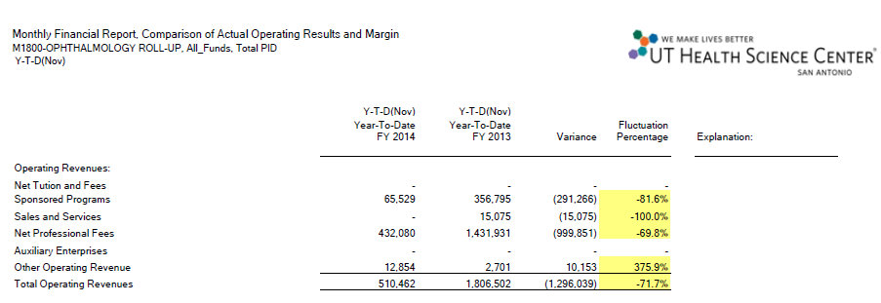

What are Web Forms?

- Web Forms allow users to review consolidated data by budget category and reporting period.
- They do not display the transactional detail that is available from PeopleSoft or Data Warehouse.
- Web Forms within the Monthly Task List are for informational purposes only and do not have data entry capabilities.
- No variance is calculated and no variance explanation is required.
- Web Form data is formatted in a grid and is presented by reporting period and by budget category for a specified entity and fund grouping.
- Web Forms cannot be printed or exported.

Steps to access the Actuals and Budget web form

Log in to Hyperion and click on Explore.
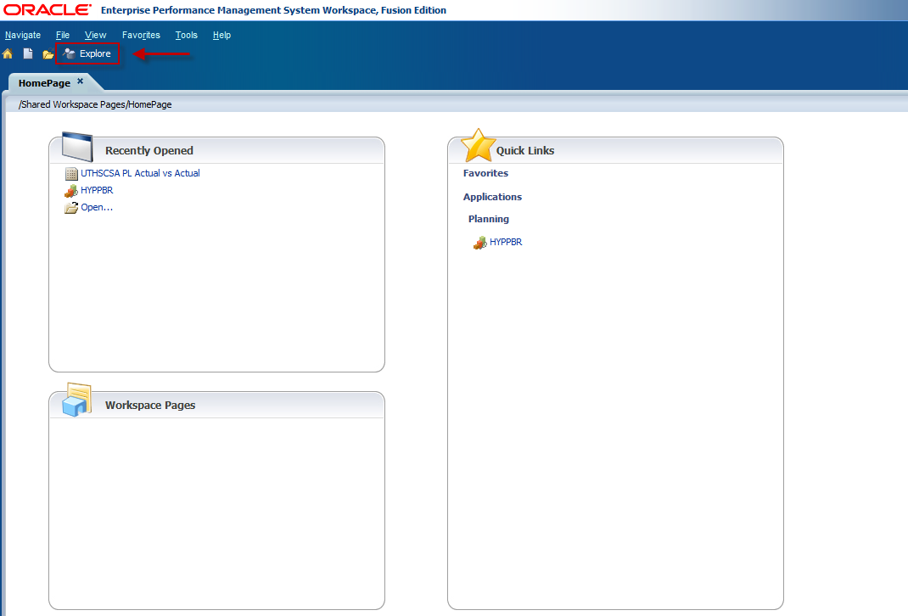

A new tab labeled Explore will appear.
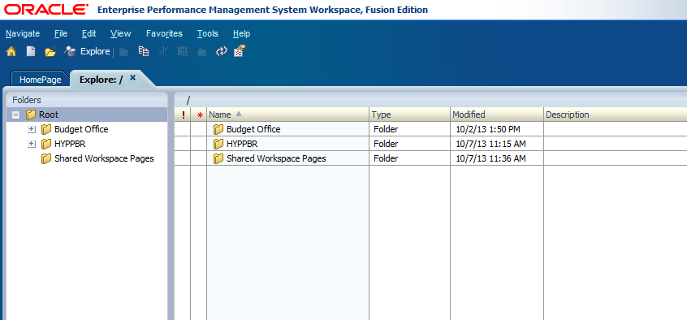

Click on the plus sign next to the HYPPBR folder to expand it.
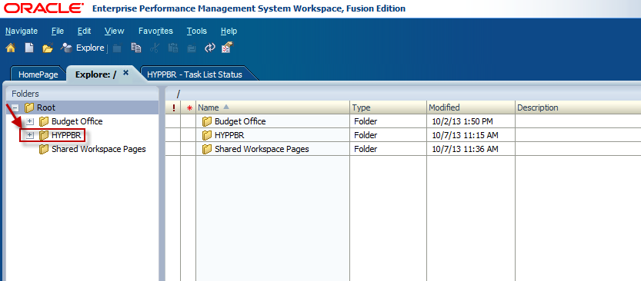

Then expand the Financial Reports folder.
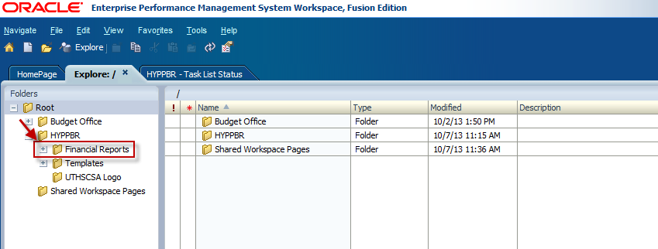

Expand the Institution folder.
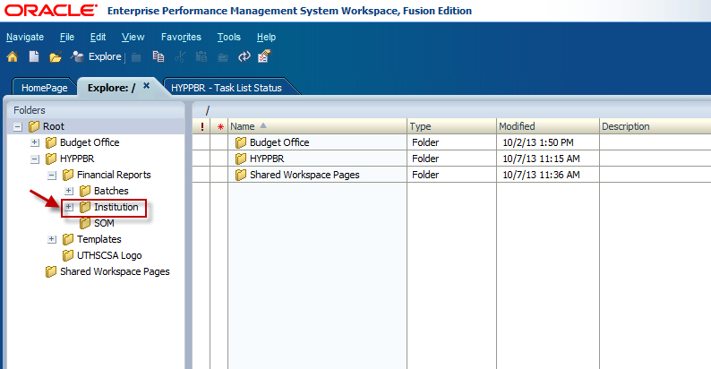

And finally, double click on the Reporting folder to open the list of reports.
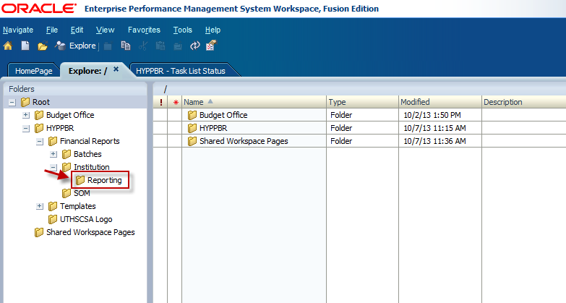

Be sure to leave this tab open with the Reporting folder expanded as you work in Hyperion. This first step is critical if you later plan to export reports to Excel. Refer to the Exporting a Report to Excel section for step by step instructions. Continue to the following steps to access the Actuals and Budget Web Form.
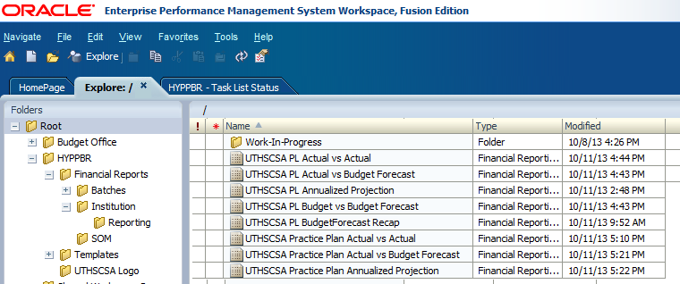

Navigate back to the HomePage tab and click on HYPPBR.
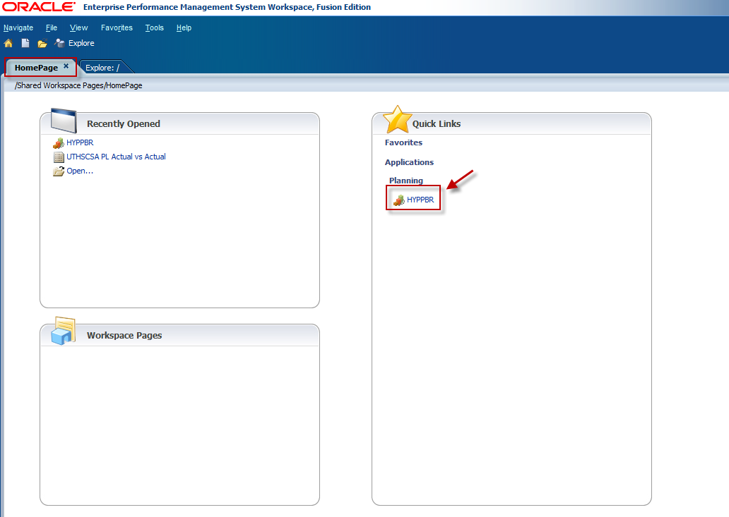
Navigate to the Monthly Task List by clicking the plus sign next to My Task List.
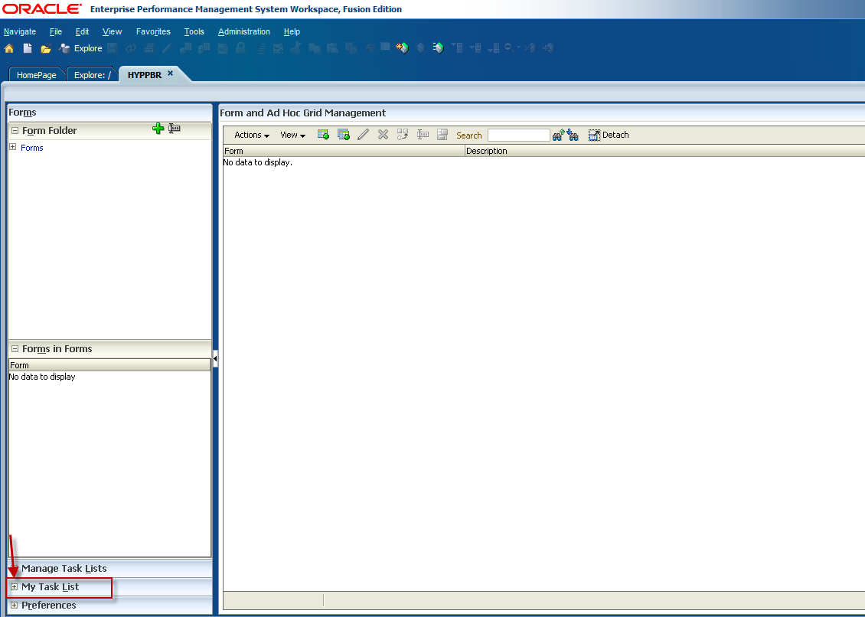
Click on the plus sign to expand the Monthly Task List.
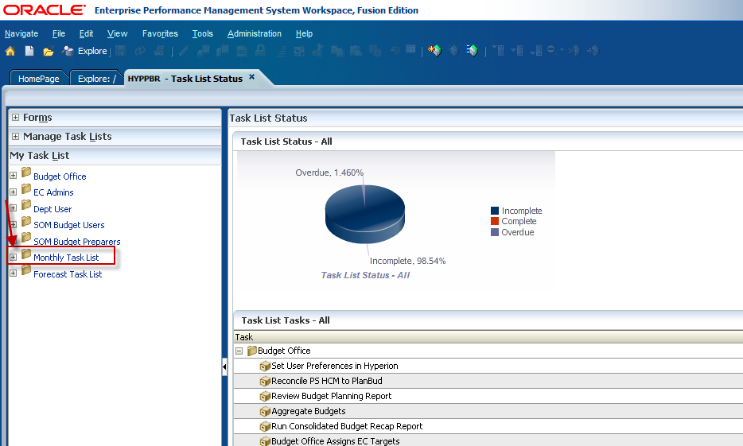

Double click on Review Actuals and Budget Web Form Data.
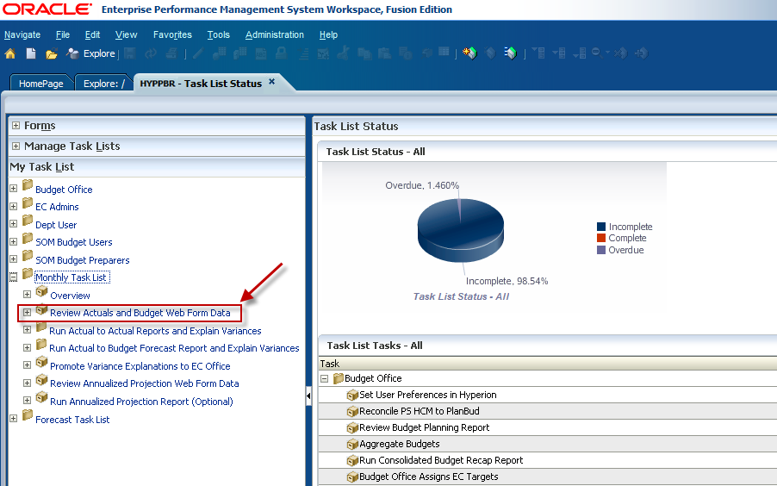

First you will select an Entity. In Hyperion, the “Entity” is equivalent to the department ID in PeopleSoft. It is the organizational unit code. Select an Entity by first clicking on the Entity drop-down box arrow.
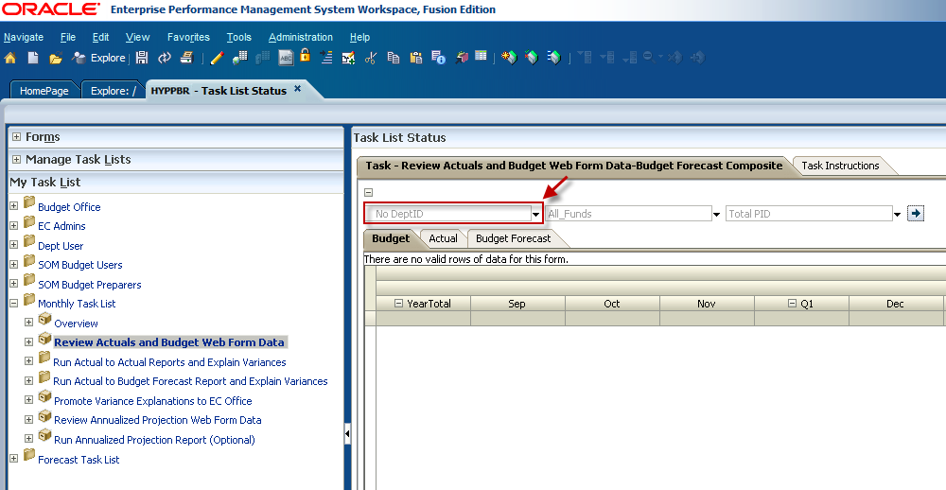

Entities can be selected at the individual department ID level or at the department roll-up level. In this example we will select the M1800 Roll up. This means that the primary M1800 department ID and all sub divisional Department IDs reporting under M1800 will be included in the results. Partially type the Entity code in the box to narrow your search, and then select the Entity from the drop-box list.
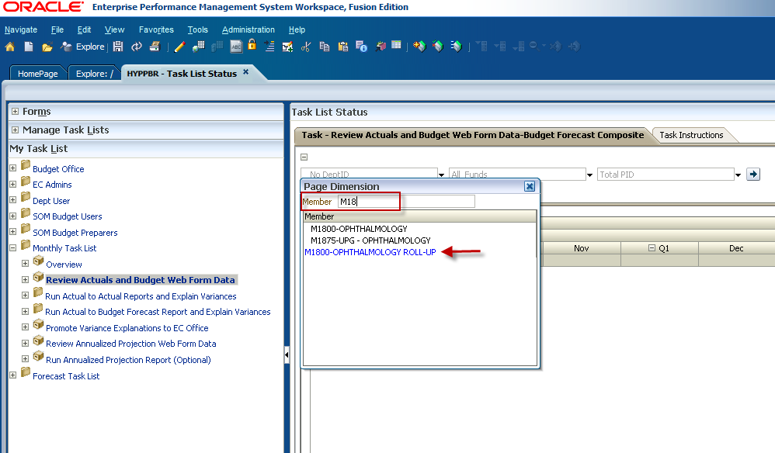

The Entity can also be located by utilizing the scroll bar to navigate among the drop-box list.
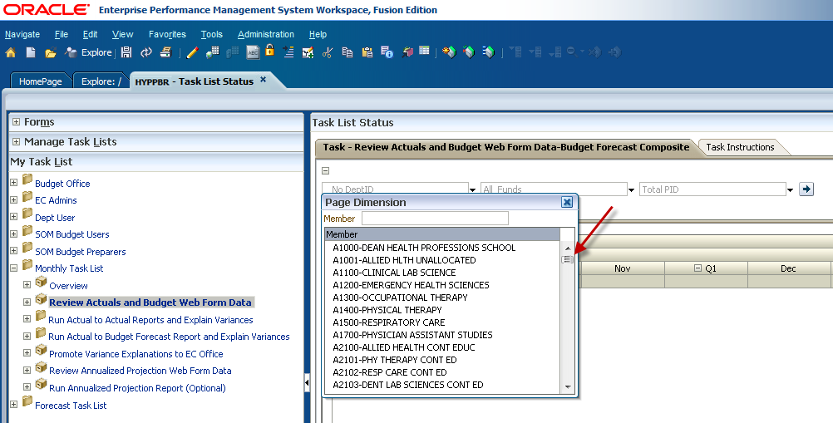

Next, select a fund using the Fund drop-down arrow.
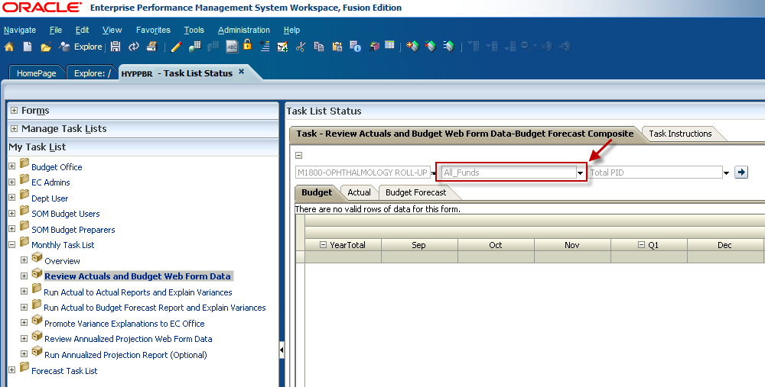

The Fund can be located much like the Entity. As previously mentioned, you can either scroll through the list or type the fund code in the member box to narrow your search. You are also able to access web forms either at a consolidated fund group level, or for All Funds. In this example we are accessing the web form for the Medical Practice Plan consolidated fund group.
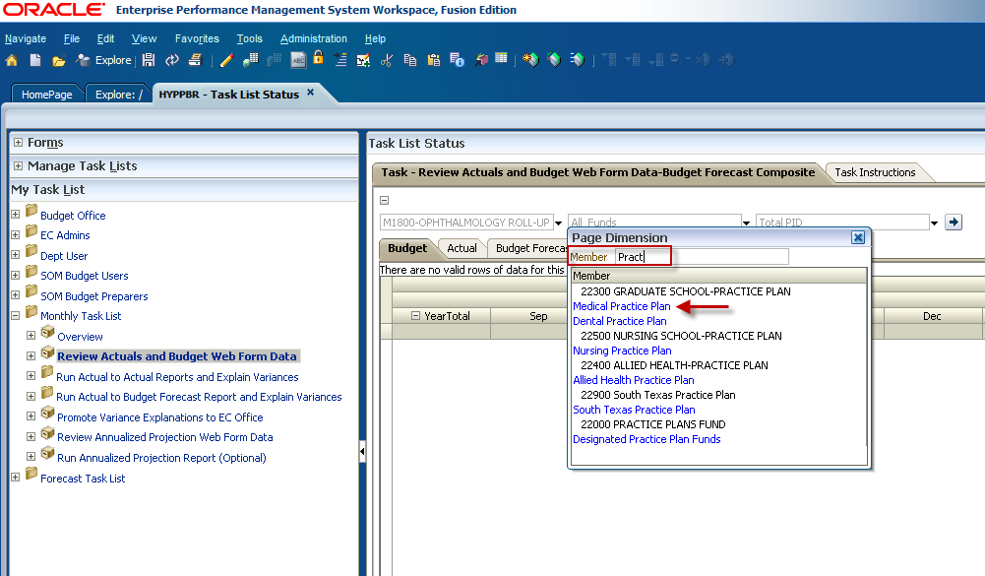
Finally, after you have selected an entity and fund group, use the drop-down box to make a project ID selection. Web Forms can be run by individual project ID or at a consolidated all PIDs level by selecting Total PID from the list.
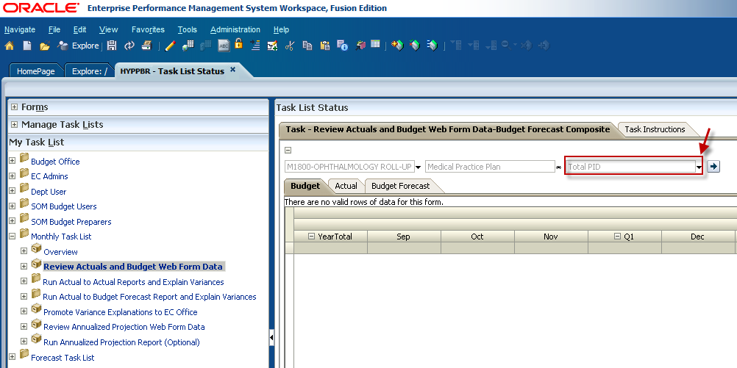

To narrow your search, type the PID in the member box and select it from the drop-box list. To access the data for all Project IDs either scroll to the bottom of the list and select Total PID, or type Total PID in the member box and select it from the list.
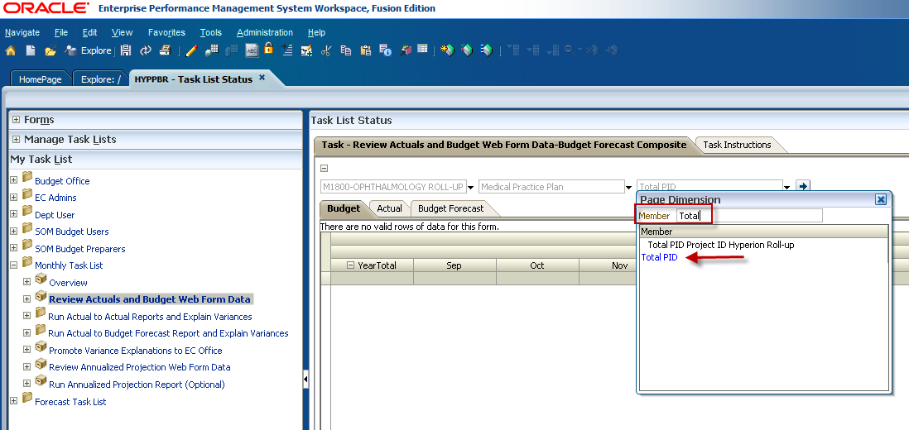

When you have selected the intended criteria and the member selection parameters are correctly displayed in the dropdown boxes, click the Go button.
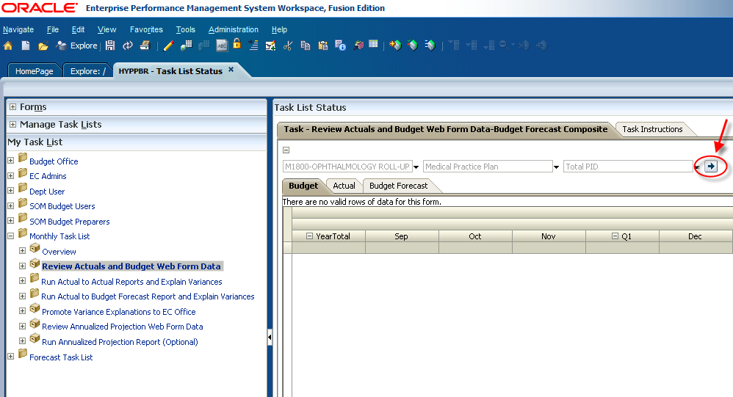

The web form will populate with data for the point of view you selected. In this example we have accessed the web form for all project IDs in all Medical Practice Plan funds for all M1800 departments. You can see that the web form is grayed out preventing any data entry, and that the data is displayed by month for the current fiscal year allowing users to see monthly changes for each budget category.
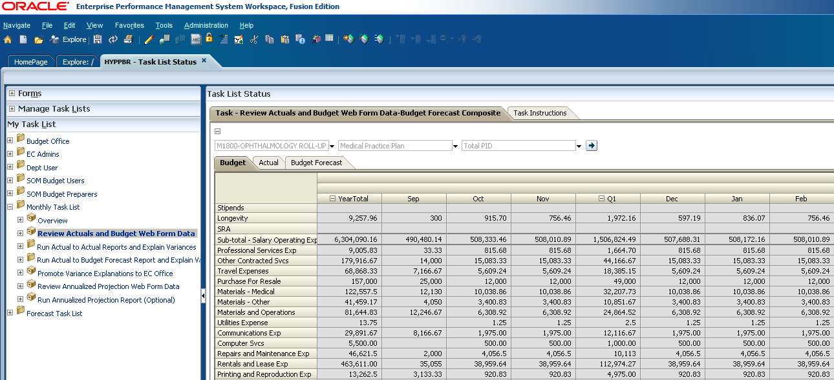

Interpreting the Actuals and Budget web form

The Actuals and Budget web form consists of the following three tabs:
- Budget Tab - shows the original budget from the planning phase by category.
- Actual Tab - shows actual activity by budget category for all closed reporting periods.
- Budget Forecast Tab - shows the adjusted budget by category.

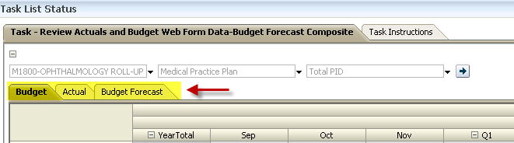

Steps to access the Annualized Projection web form

Log in to Hyperion and click on Explore.

This will open a new tab labeled Explore.

Click on the plus sign to expand the HYPPBR folder.

Then expand the Financial Reports folder.

Expand the Institution folder.

Double click on the Reporting folder to open the list of reports.

Be sure to leave the Explore tab open with the Reporting folder expanded as you work in Hyperion. This first step is critical if you later plan to export reports to Excel. Refer to the Exporting a Report to Excel section for step by step instructions. Continue to the following steps to access the Annualized Projection web form.

Navigate back to the HomePage tab and click on HYPPBR.

Navigate to the Monthly Task List by first clicking the plus sign next to My Task List.
Expand the Monthly Task List.

Double click on Review Annualized Projection Web Form Data.
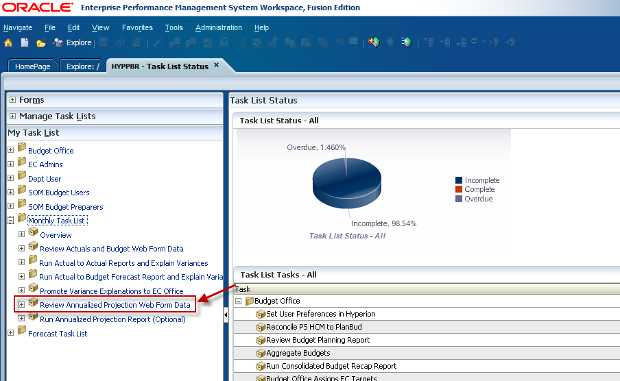

Select an Entity (DEPT ID) by first clicking on the Entity drop-down box.
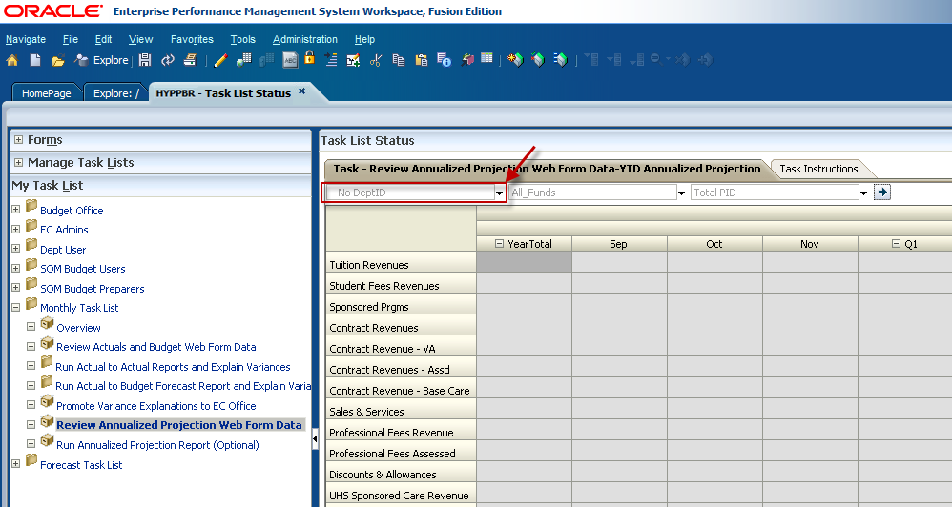

You can use the scroll bar, type the department ID, or type the department name in the member box to narrow your search. In this example we will again access the web form at the M1800 (Ophthalmology) roll up level.
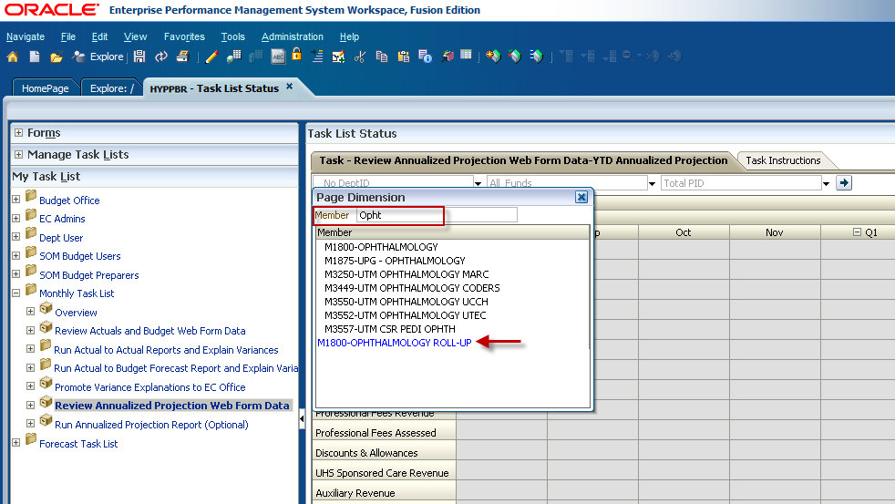

Next, select a fund using the drop-down arrow beside the Fund member box.
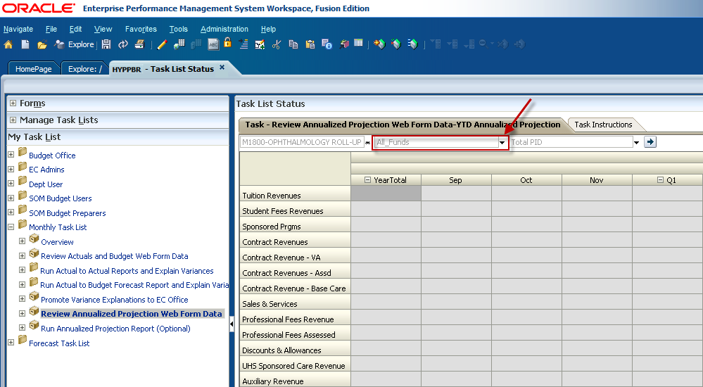

Locate the intended fund group by utilizing the scroll bar or by typing it in the member box. Then select it from the list. In this example we are again accessing the web form for the Medical Practice Plan consolidated fund group.
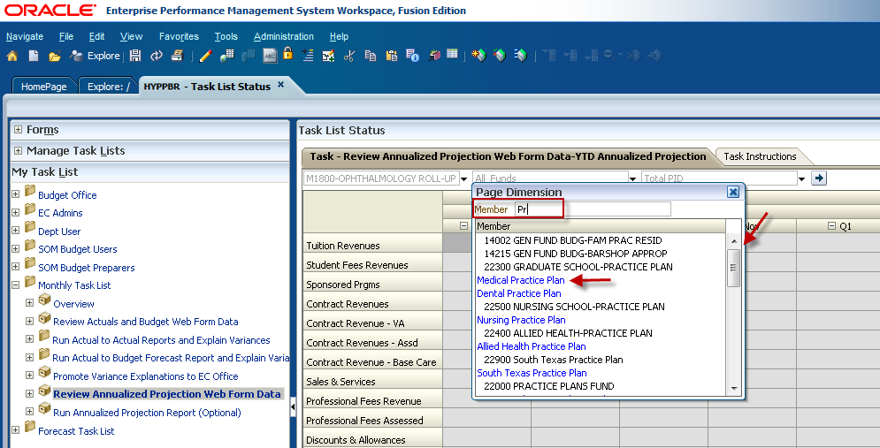

Finally, make a project ID selection by clicking on the drop-down box arrow.
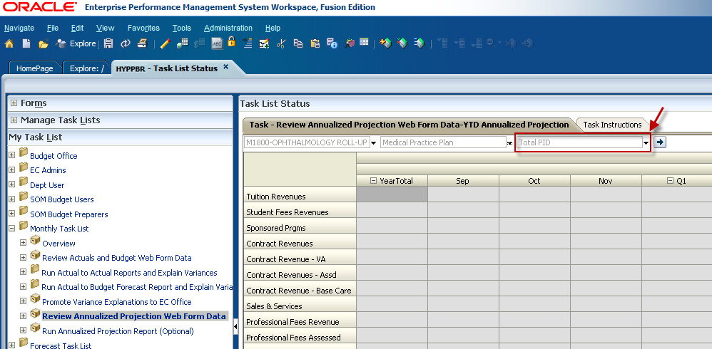

Web Forms can be run by individual project ID or they can be run at a consolidated all PID level by choosing Total PID. Use the scroll bar, type a project ID, or type Total PID in the member box to locate and make your PID selection.
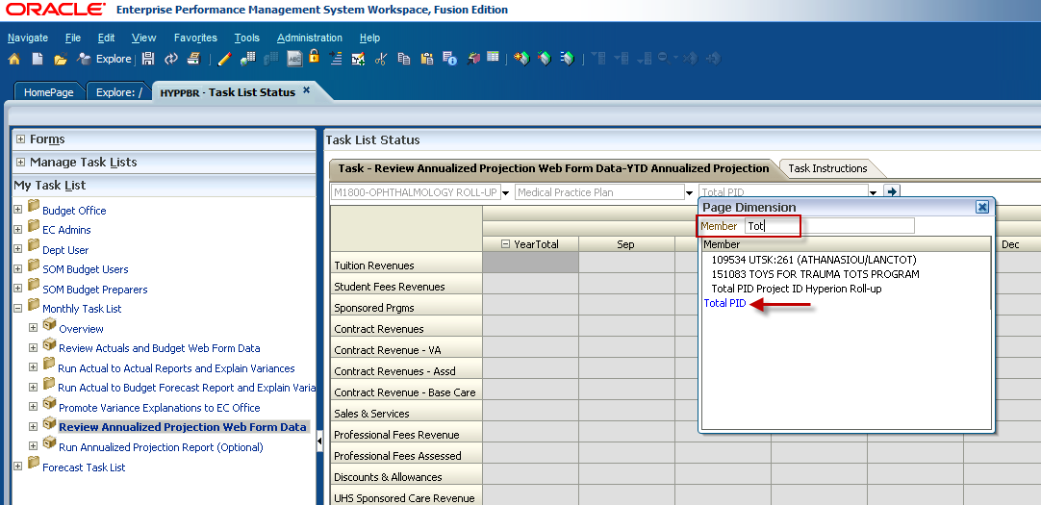

Confirm that the member selections are correct and click the Go button.
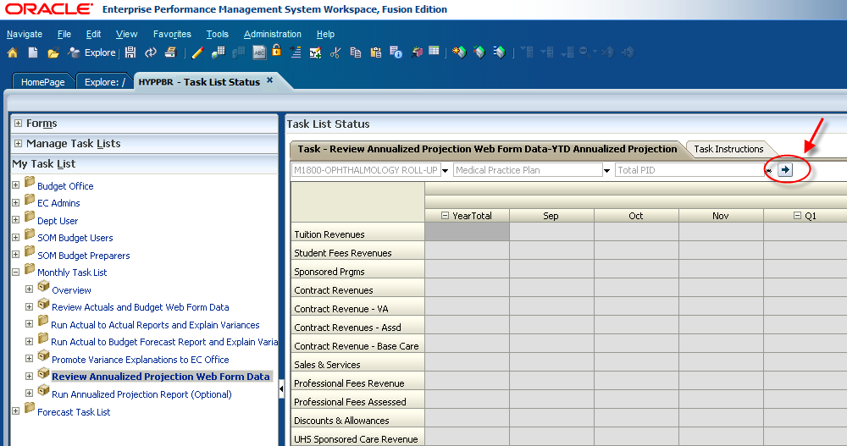

The web form will populate with data for the point of view you selected. In this example we have accessed the web form for all project IDs in all Medical Practice Plan funds for all M1800 departments. You can see that the web form is grayed out preventing any data entry, and that the data is displayed by month for the current fiscal year allowing users to see monthly changes for each budget category.

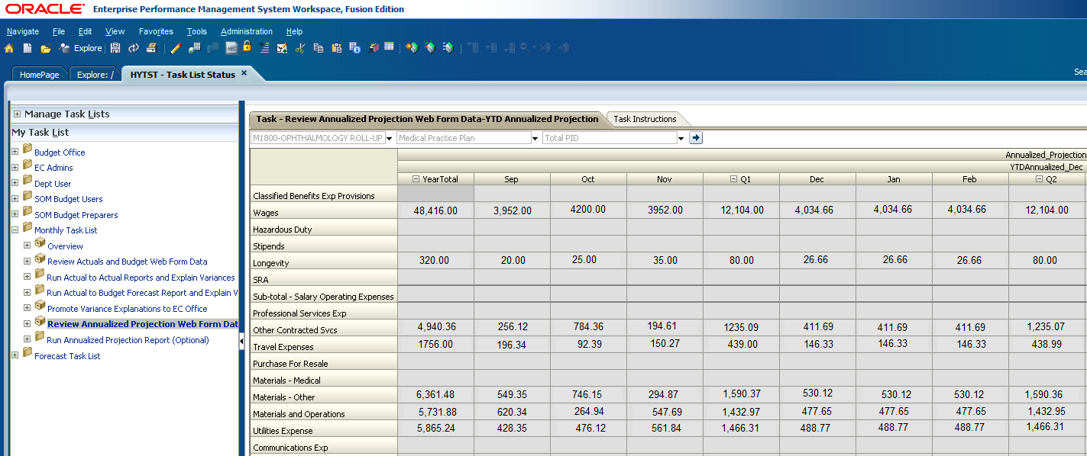

Interpreting the Annualized Projection web form

- The Annualized Projection is a calculated estimate of how operations will progress during the fiscal year based on the collection rate of revenues and the spend rate of expenses at a particular point in time.

- The Annualized Projection web form shows actual activity for all closed reporting periods that is fed directly from PeopleSoft Financials.

- For future reporting periods a projected monthly amount for each budget category is calculated based on average trends of previously closed reporting periods.

Annualized Projection Calculation = (Current Actuals / # of closed reporting periods) x 12 months
Example:
In the below example, September through November are closed reporting periods. For these months the actual travel expenditures totaling $439.00 are fed from PeopleSoft financials. Based on the average rate of spending ($439.00 / 3), Hyperion will insert a projected travel expense amount of $146.33 for all future reporting periods. This gives you an idea of where you will stand at the end of the fiscal year if your rate of spending stays the same. According to the annualization calculation this department will spend $1,756.00 on travel expenses by the end of the year if the current rate of spending remains the same. Keep in mind that the annualized projection calculation does not account for all known occurrences between now and the end of the fiscal year.
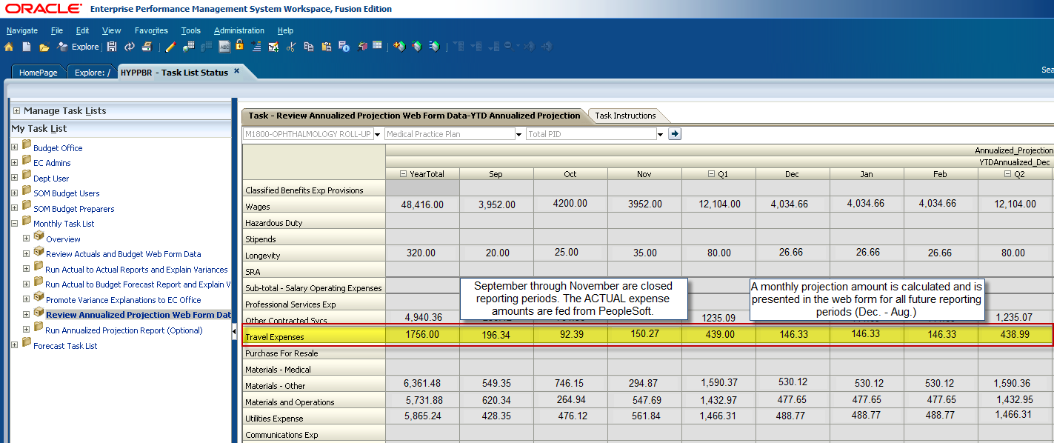
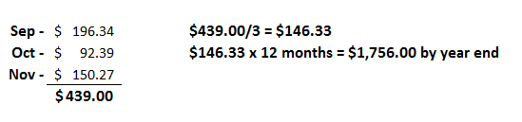

What are Hyperion Reports?

All of the Hyperion reports are presented as income statements that show profits and losses. We will often refer to these reports as the Profit and Loss (or P&L) reports. These reports were designed to calculate margin and change in net position in accordance with Generally Accepted Accounting Principles, or GAAP. Hyperion reports also categorize revenues and expenses in accordance with NACUBO standards that facilitate the consolidation of the Health Science Center’s financial information with UT System and the State of Texas.
In addition, all of the PeopleSoft general ledger account codes for revenues and expenses have been grouped into a specified line item. Refer to the Hyperion SharePoint site for a listing of the P&L account code groupings.
Hyperion reports are classified as either Primary or informational.
- Primary reports require analysis of key financial metrics, such as margin and change in net position, and calculate variances from past or budgeted operations that require explanation to Executive Committee (or EC) offices and the Budget Office. The two Primary reports departments will be expected to run on a monthly basis are the Actual-to-Actual report and the Budget-to-Actual report.

- Informational reports are just that – informational. They provide additional and relevant information that can be used to support financial decisions. They do not calculate variances, and therefore will not require analysis to be promoted to EC offices or to the Budget Office. Informational reports include the Annualized Projection report and the Budget Recap Report users generated during the budget cycle.

Actual to Actual report:

- The Actual to Actual report compares financial data for the current year to the previous year for the same time period.
- It is one of the two primary reports; therefore it calculates a variance, or change.
- Variances will be presented as a dollar amount and as a percent.
- Variance explanations will be required based on pre-defined threshold levels (+/-10% change).

Steps to run the Actual to Actual All Funds report

Log in to Hyperion and click on Explore.

This will open a new tab labeled Explore.

Click on the plus sign next to the HYPPBR folder to expand it.

Then expand the Financial Reports folder.

Expand the Institution folder.

Double click on the Reporting folder.

Be sure to leave this tab open with the Reporting folder expanded as you work in Hyperion. You will later navigate back to this tab to export reports to Excel. Refer to the Exporting a Report to Excel section for step by step instructions.

Navigate back to the HomePage tab and click on HYPPBR.
Navigate to the Monthly Task List by first clicking the plus sign next to My Task List.
Expand the Monthly Task List

Click on the plus sign next to Run Actual to Actual Reports and Explain Variances to further expand the task list.
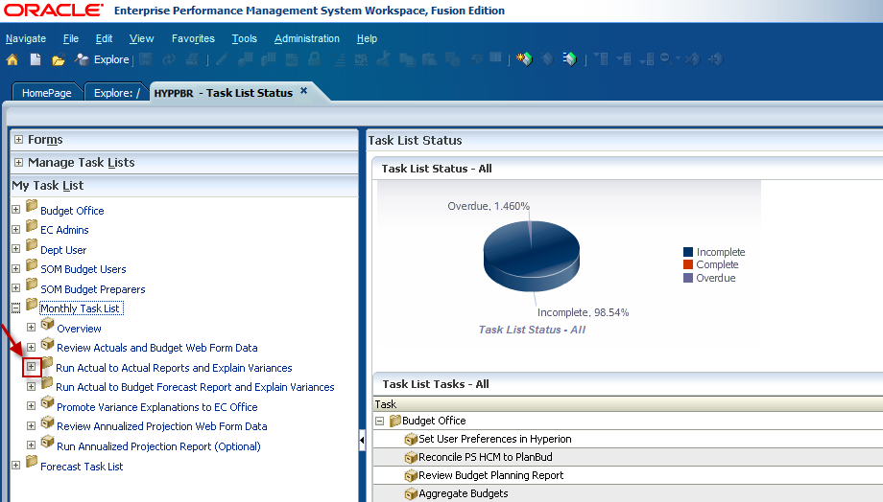

Double click on Run Consolidated All Funds Report.
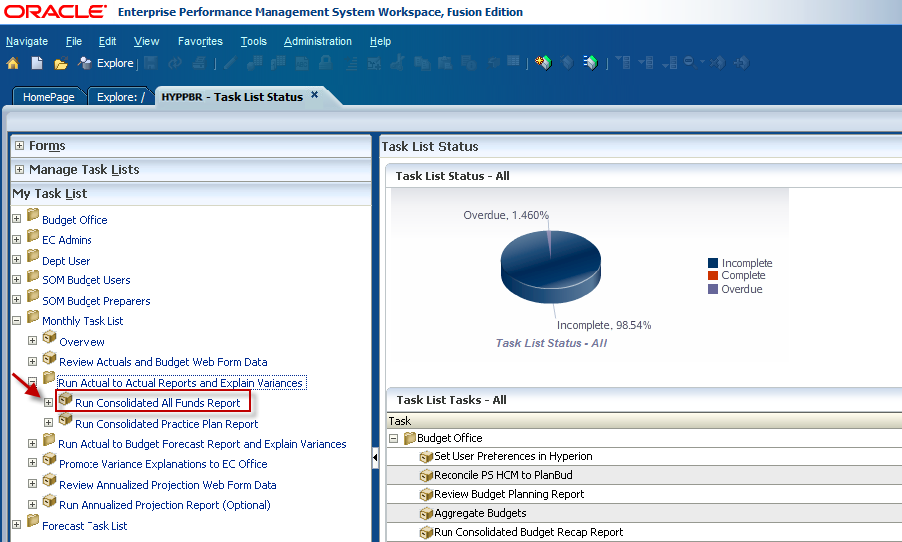

The Point of View window will appear and allow users to input the member selection criteria. To select a fund, click on the Select button next to the Fund member box.
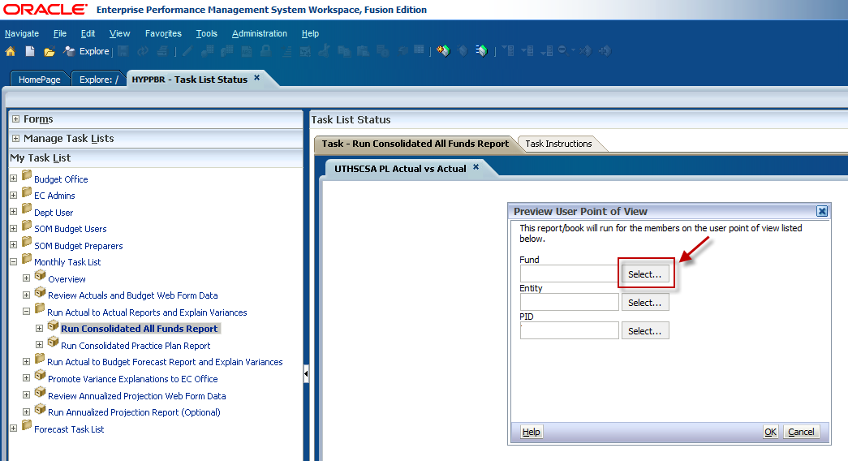

First, select the maximum amount of Rows Per Page using the dropdown menu. This will allow for all information to be visible when the folders are expanded.
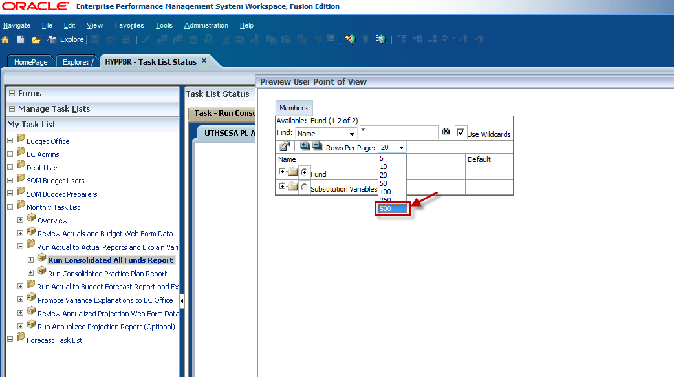

Expand the Fund folder by clicking on the plus sign.
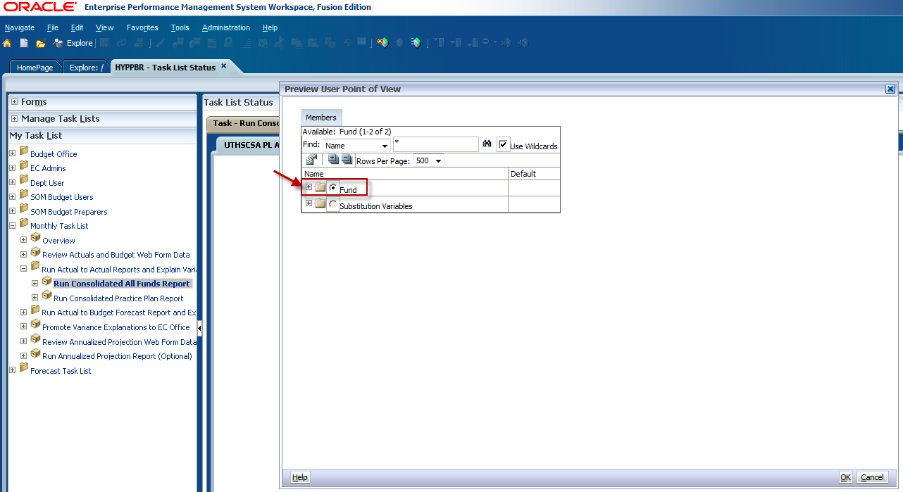

To run the report for all fund groups click the radio dial button next to All Funds and click OK.
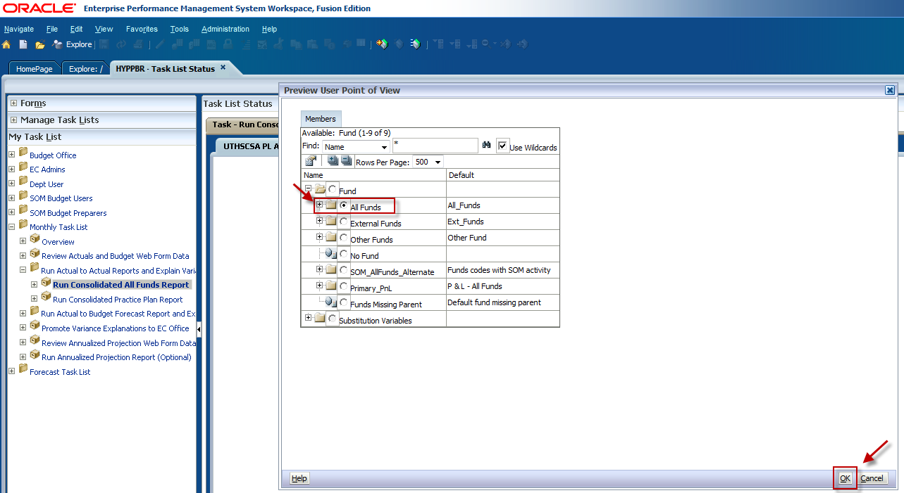

If you would like to specify a fund or run the report for a consolidated fund group click the plus sign to expand the All Funds folder.
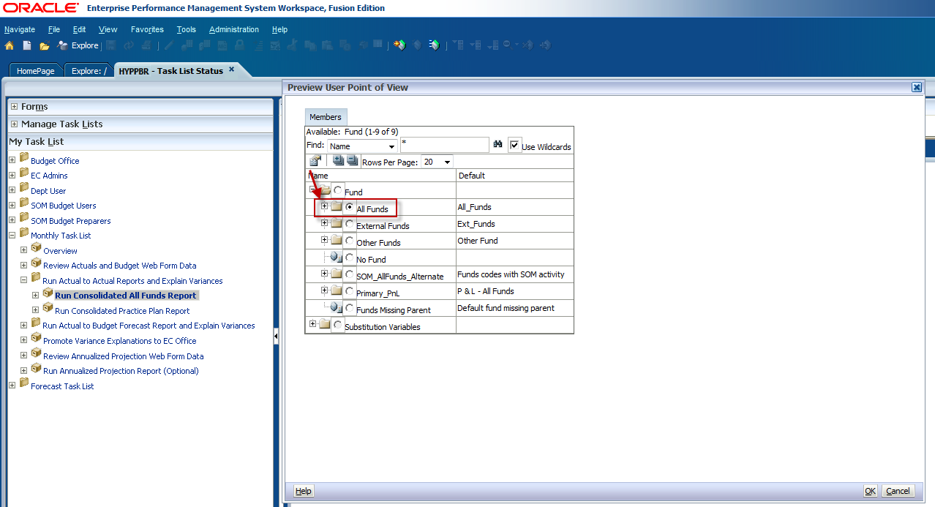
You will see the first level of consolidated fund groupings nested under All Funds. You can make a selection here, or you can continue to expand the folders to see the next level of consolidated fund groupings. For example, to run a report for Practice Plans, expand the Designated Funds folder again as Practice Plan funds are considered a designated fund group and will be nested within this folder.
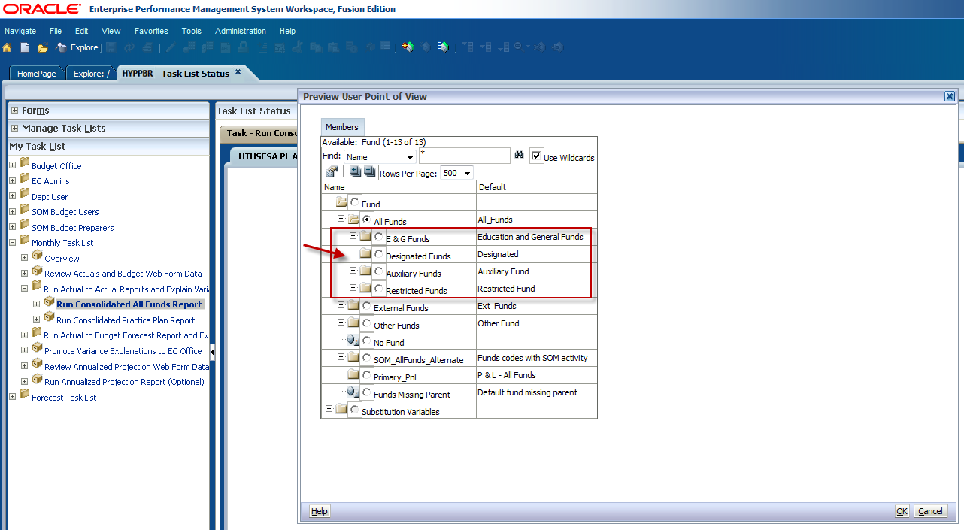

You will see the next level of consolidated fund groupings nested under Designated Funds. Make your selection by clicking the radio dial button, then click OK.
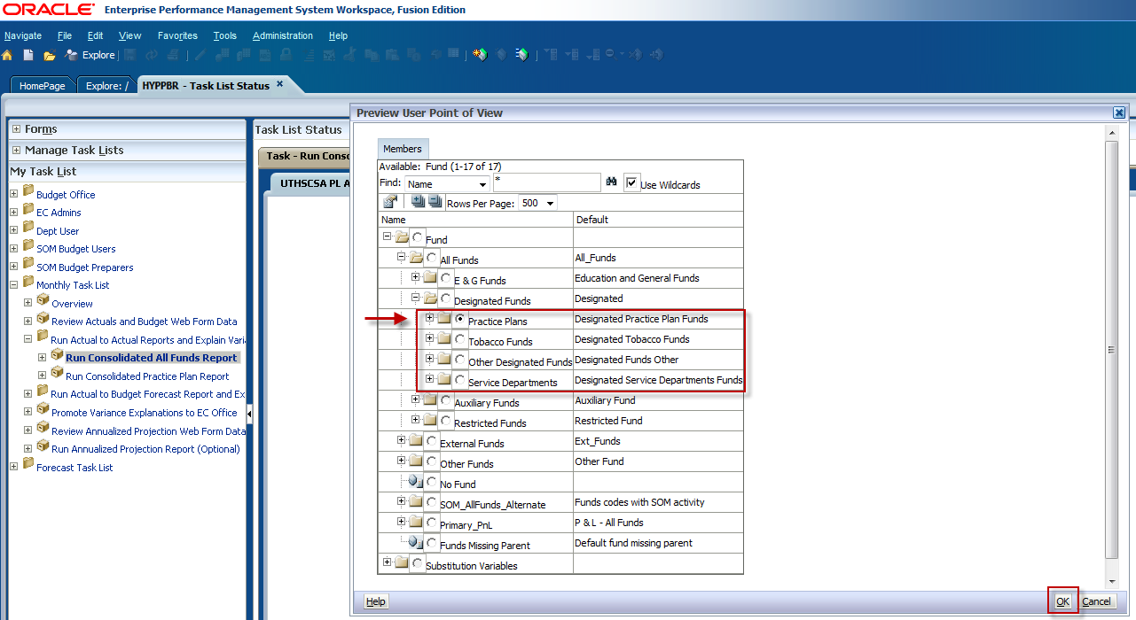

However; if you would like to run the report for a specific fund, continue expanding the folders until you see the lowest fund level as shown below. Make your selection and click OK.
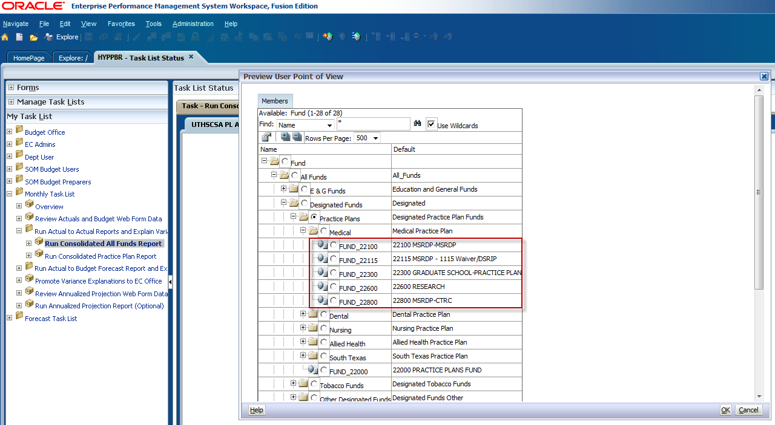

To select an individual fund group you can also utilize the search box. Type ‘FUND_ ‘and the fund group you would like to search, for example, FUND_22100. The asterisk must appear first in order to complete the fund search. Then click the binocular icon to the right of the search box.
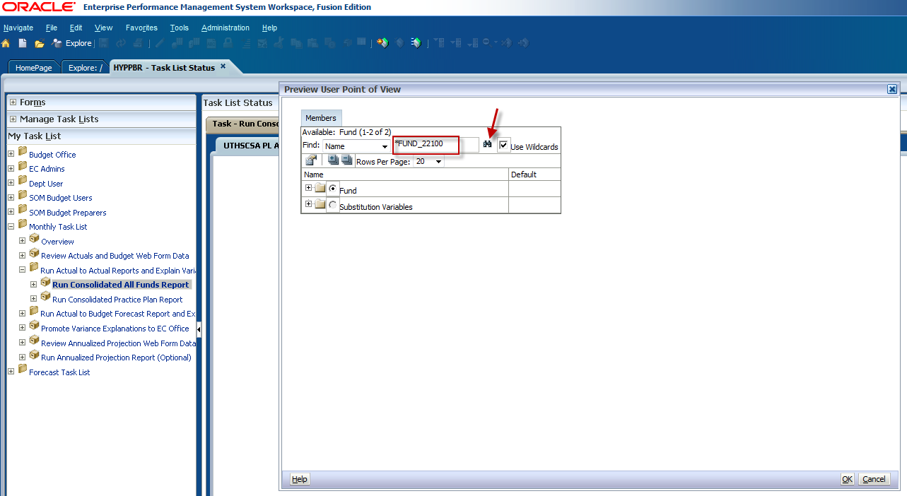

A default option will be selected. Click OK.
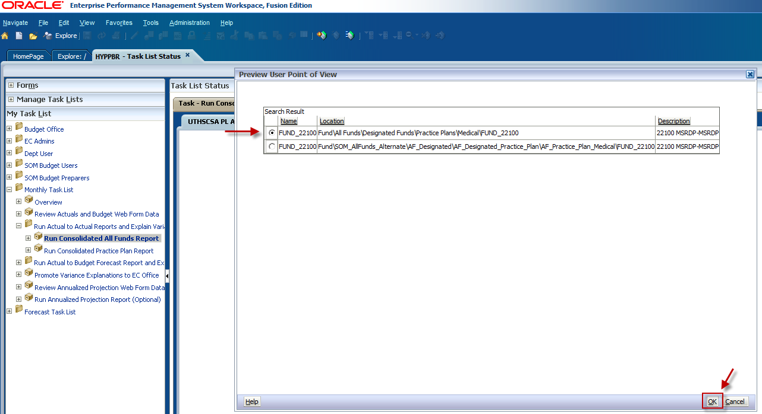

You will be directed back to the fund selection window where the fund you searched will automatically be selected. Click OK.
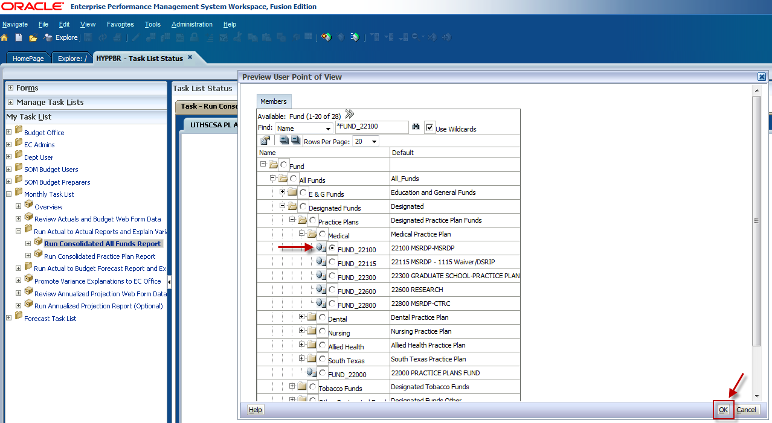

Click the Select button next to the Entity member box.
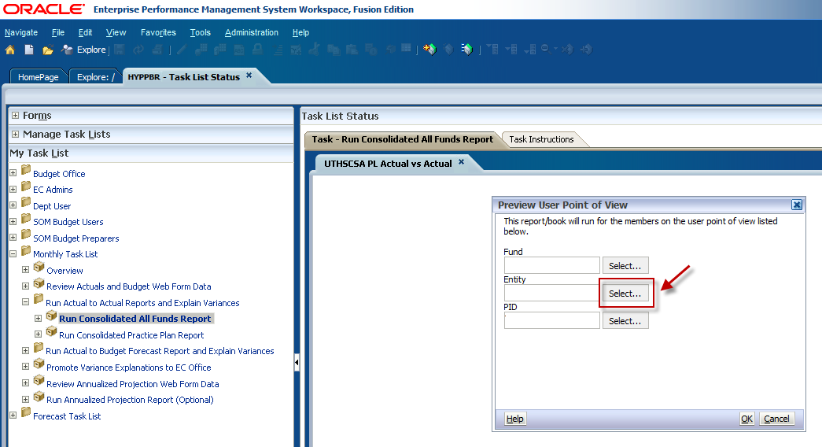

Select the maximum Rows per Page using the drop-down box.
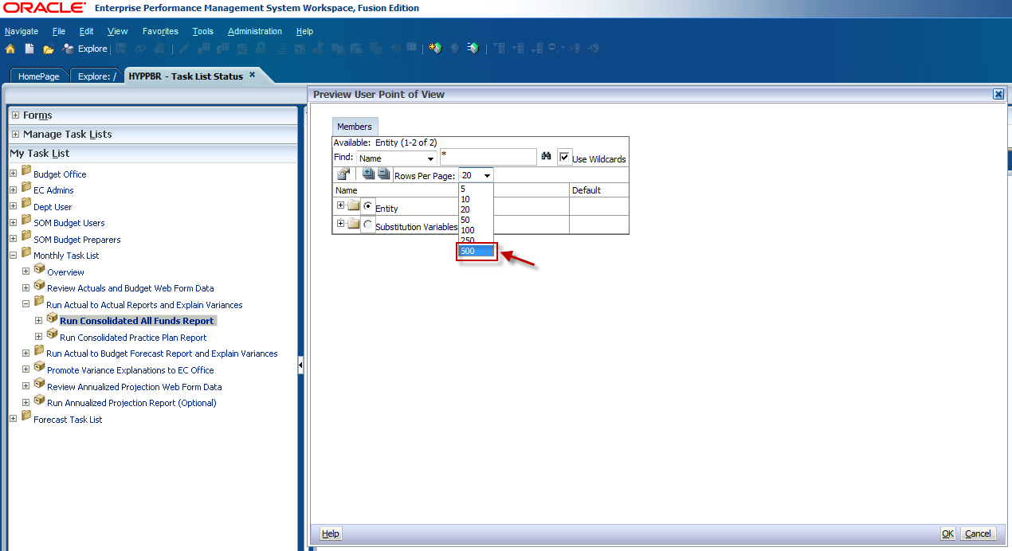

Expand the Entity folder.
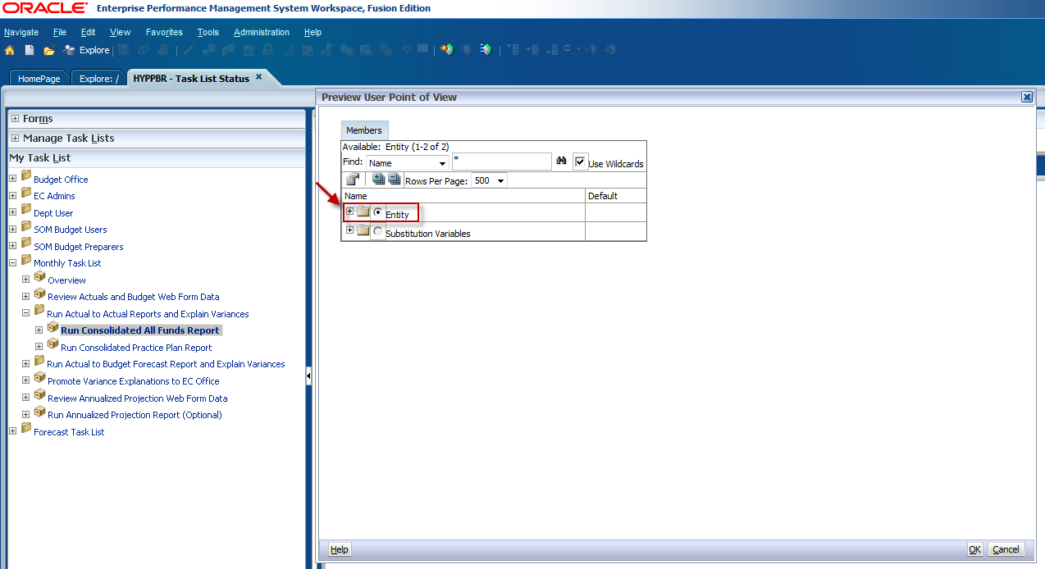

Expand the X9999- UTHSCSA Roll-Up folder.
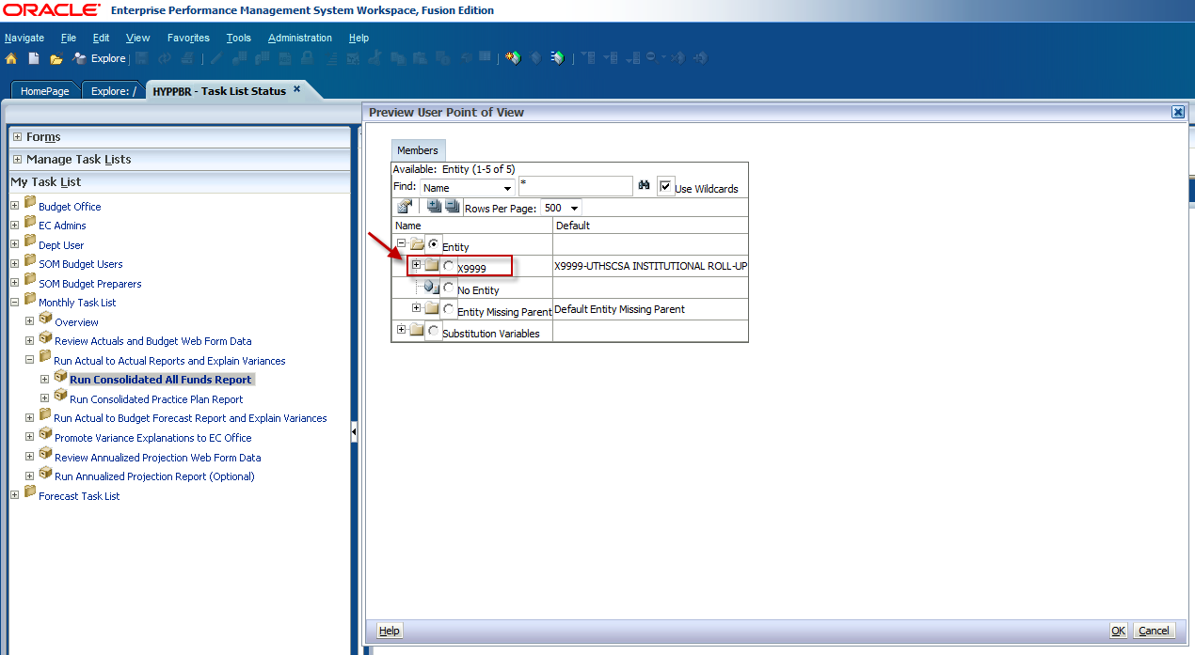

The next Entity hierarchy level will open, which is the Executive Committee (EC) roll-up level. To run a report at the EC level, make a selection here and click OK.
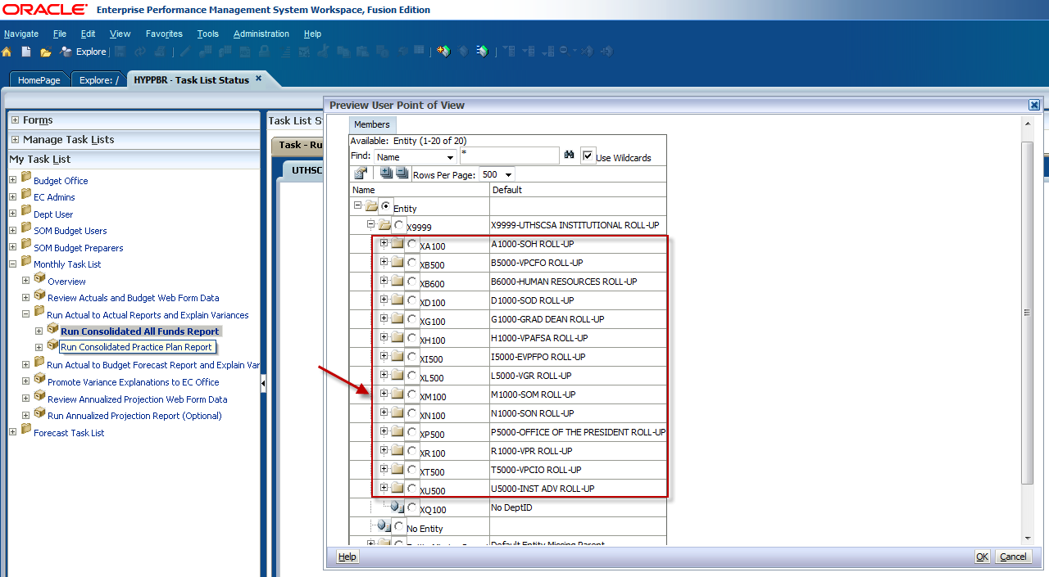

Expand the EC roll-up folder further to see the next Entity roll-up level.
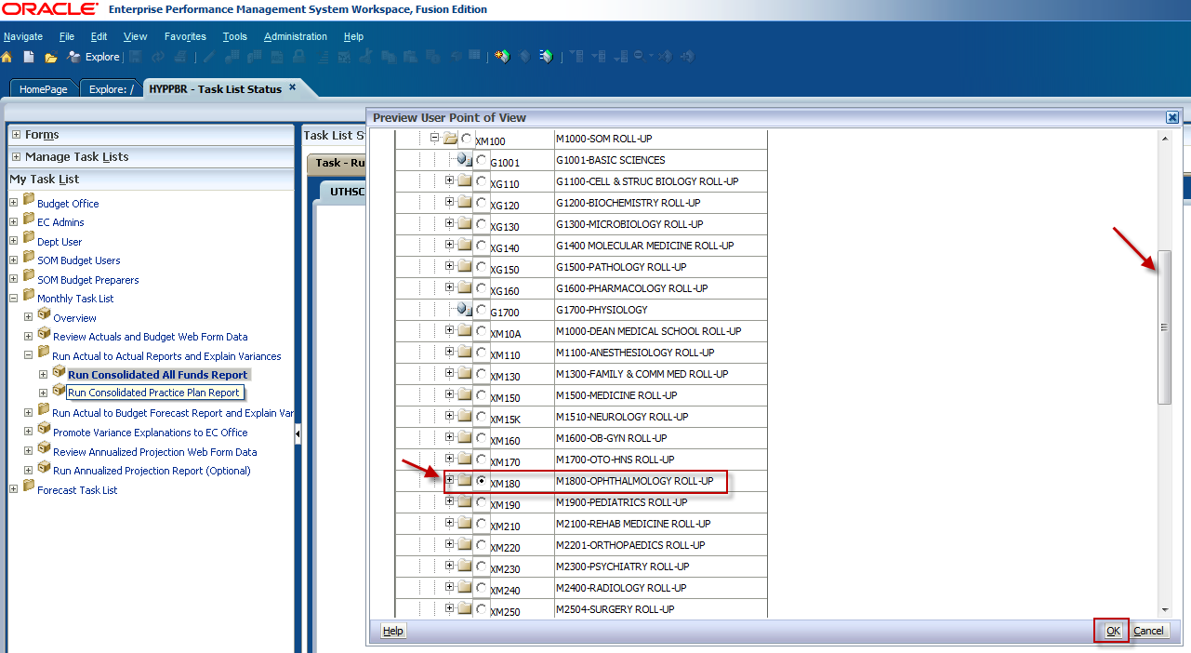

To select an individual department ID, continue expanding the folders to see the lowest entity level. Use the scroll bar to locate your intended entity, click the radio dial button to make your selection, and click OK.
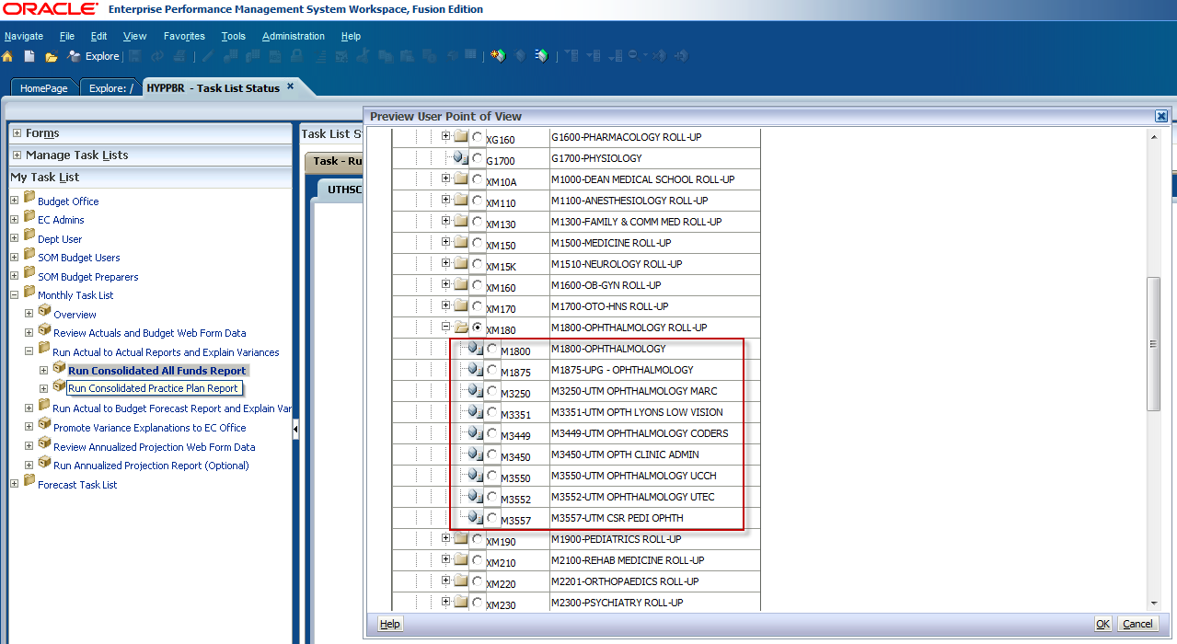

Finally, make a Project ID selection by clicking on the Select button next to the PID member box.
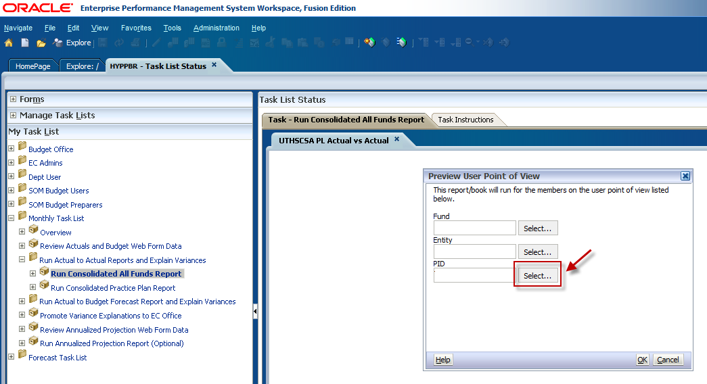

Expand the PID folder.
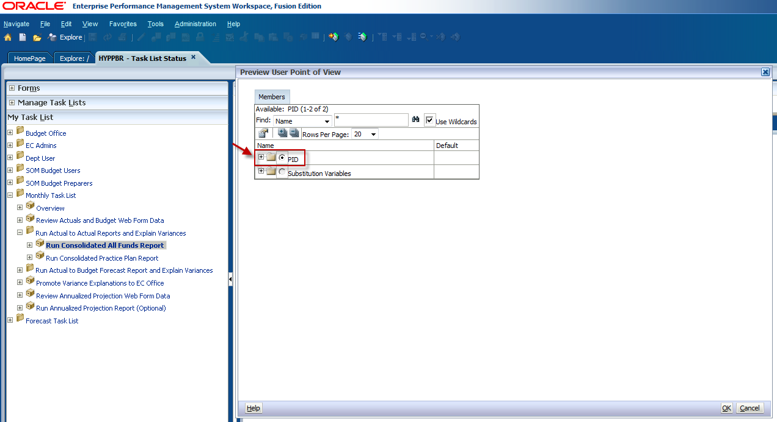

To run the report for ALL PIDs select Total PID and click OK.
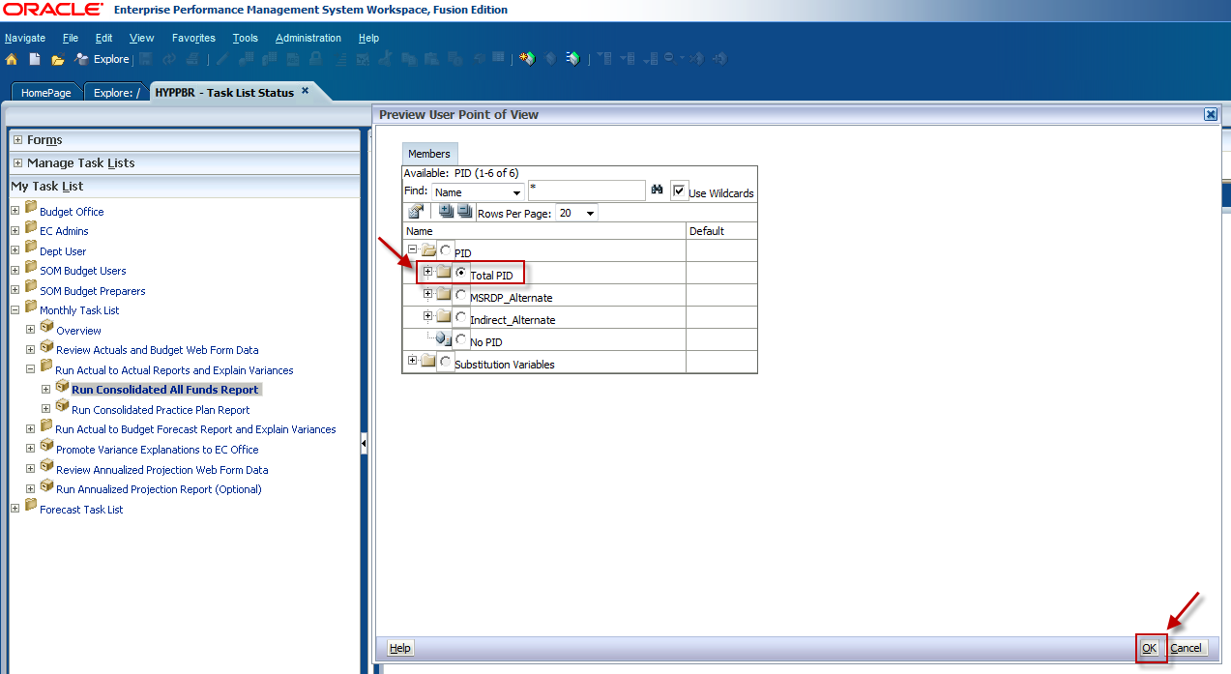

If you would like to run the report for a specific Project ID, expand the Total PID folder and use the scroll bar to locate the intended PID. Keep in mind that the number of rows per page may need to be increased for all projects to be visible.
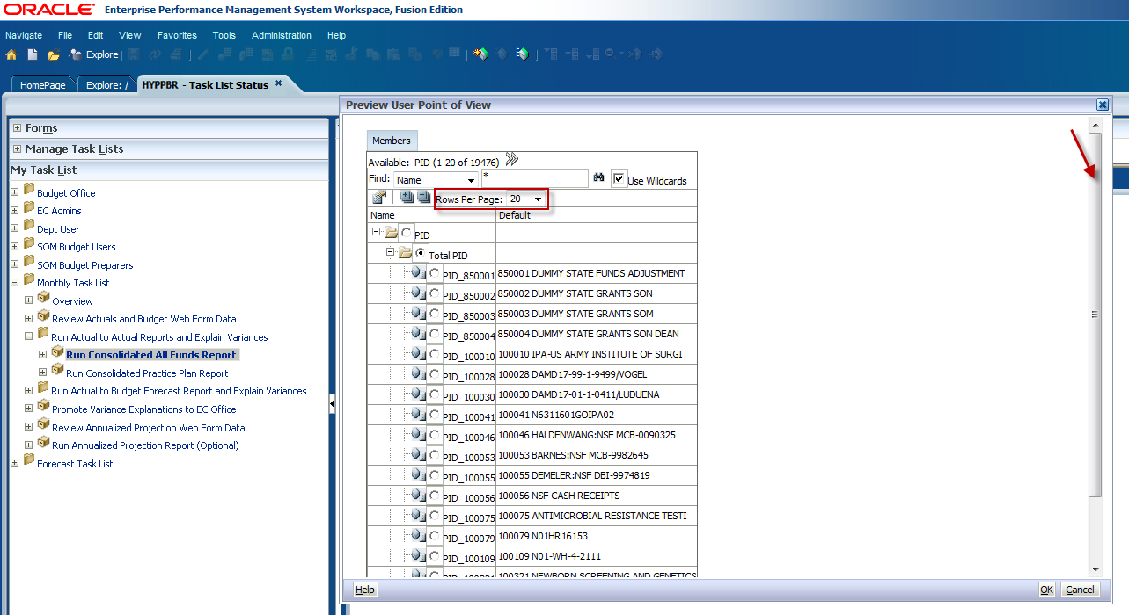

Click OK on the Point of View window.
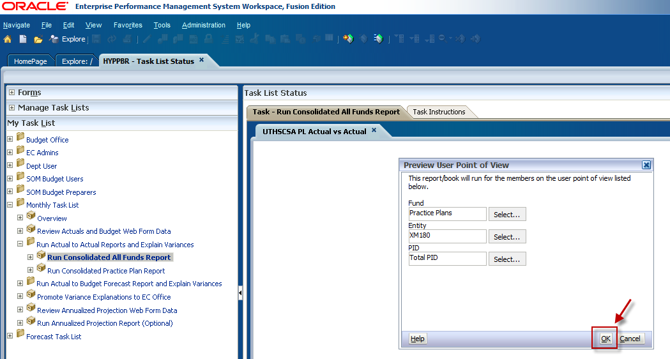

A new window will appear and prompt you to enter a reporting period. The most recent closed reporting period is selected by default. If you do not need to make an adjustment to the reporting period criteria, click OK.
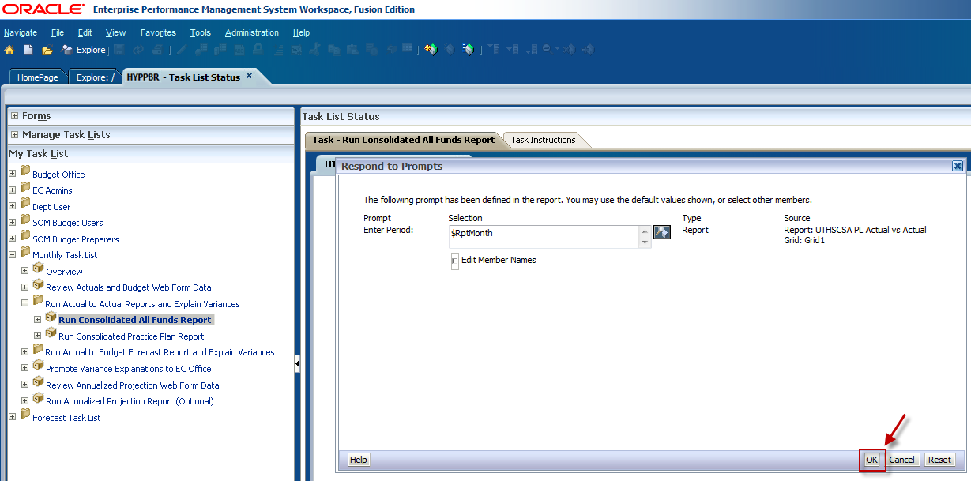

To change the reporting period, click on the icon to the right of the Selection box as shown below.
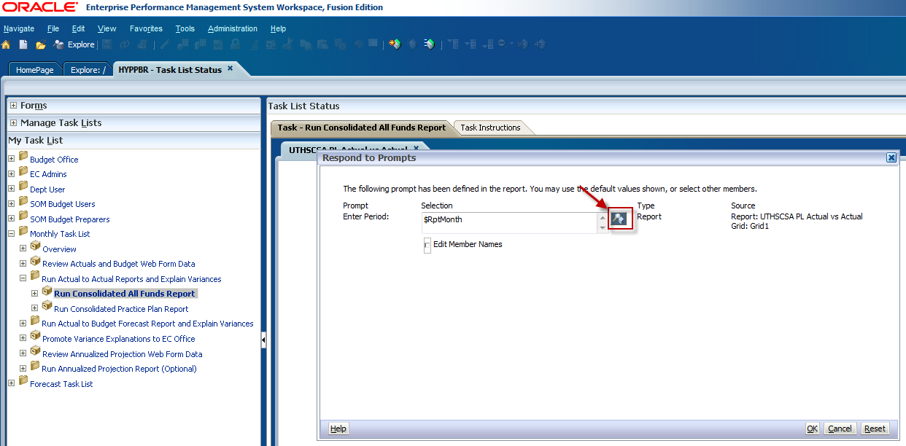

First, the current reporting period needs to be removed from the Selection list. Click the check box next to $RptMonth.
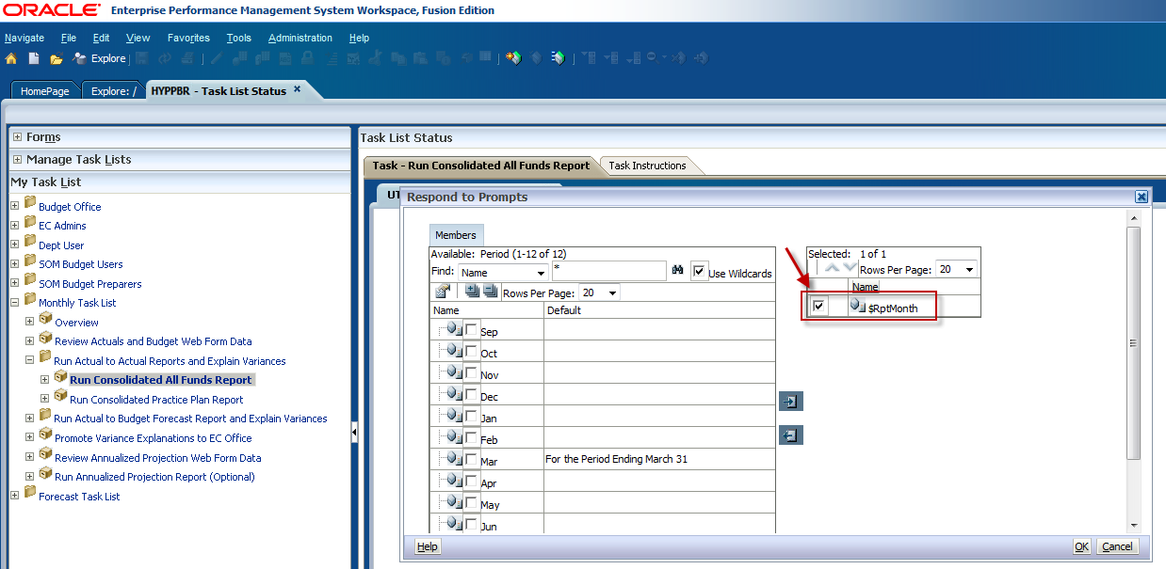

Then click the icon with the arrow facing left to remove it from the selection list.
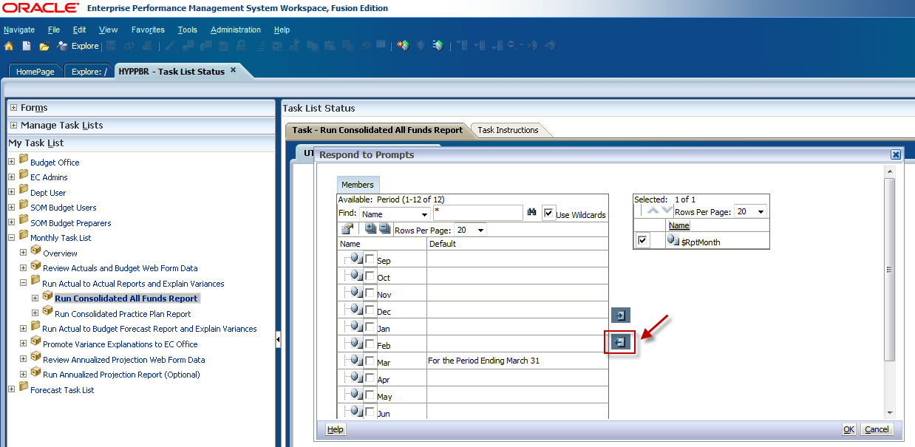

To select a period, click the checkbox to the left of the month abbreviation. In this example we will run the report as of November.
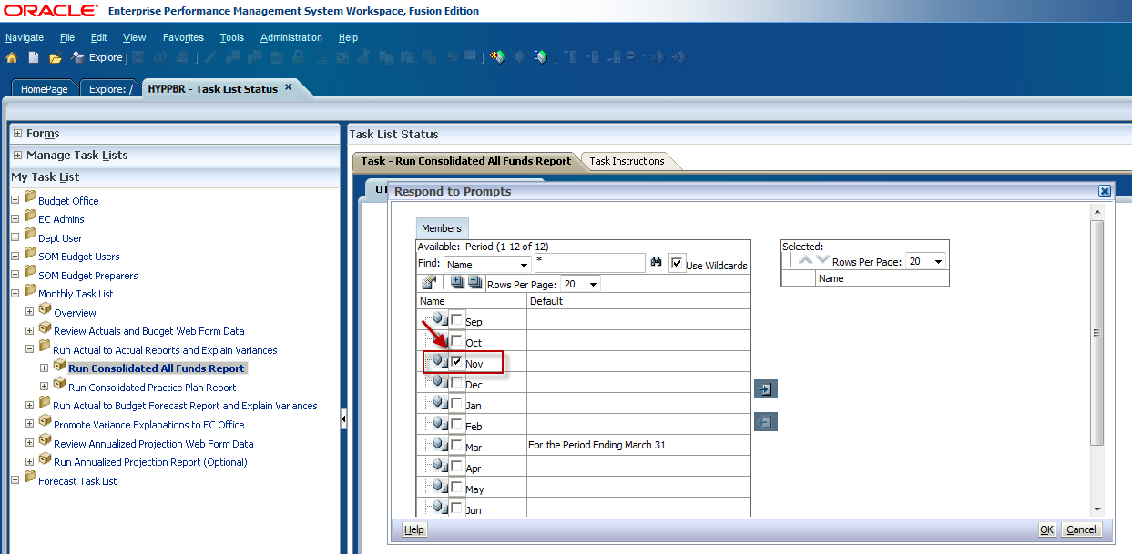

Then click the icon with the arrow facing right to add it to the Selection list.
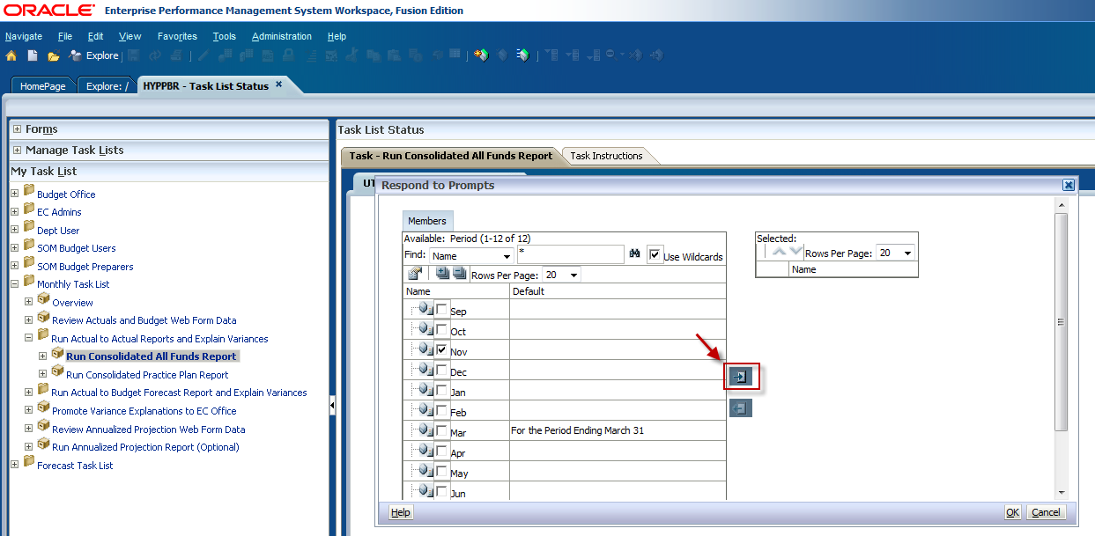

You will see that the month you selected now appears in the Selection list. Click OK
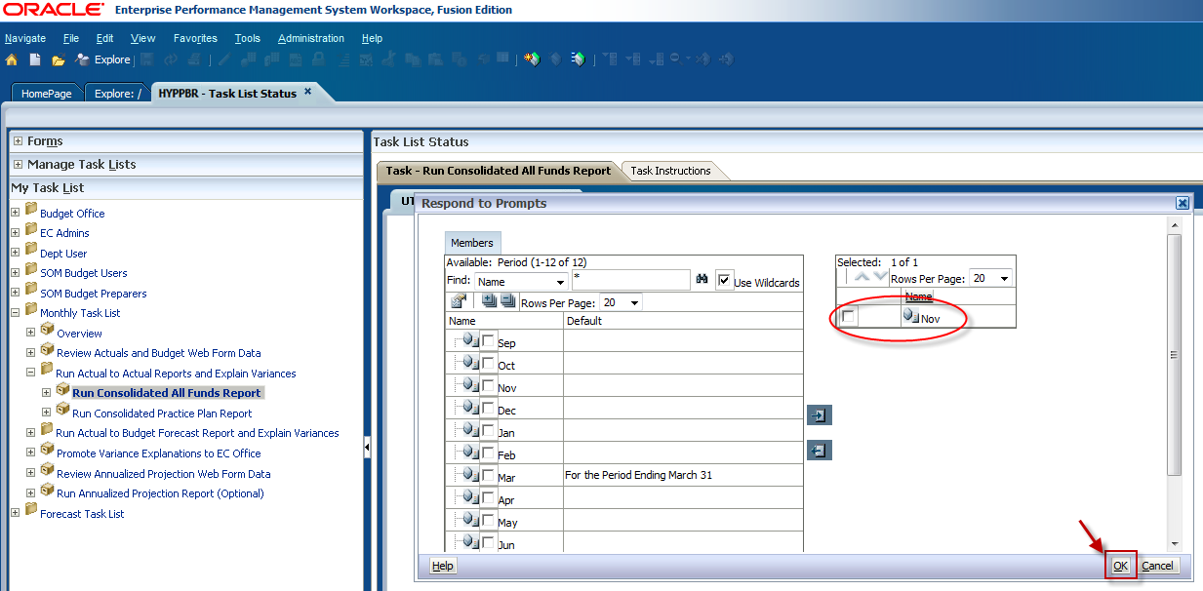

You will then be taken back to the Respond to Prompts window. Confirm that the correct reporting period is selected and click OK.
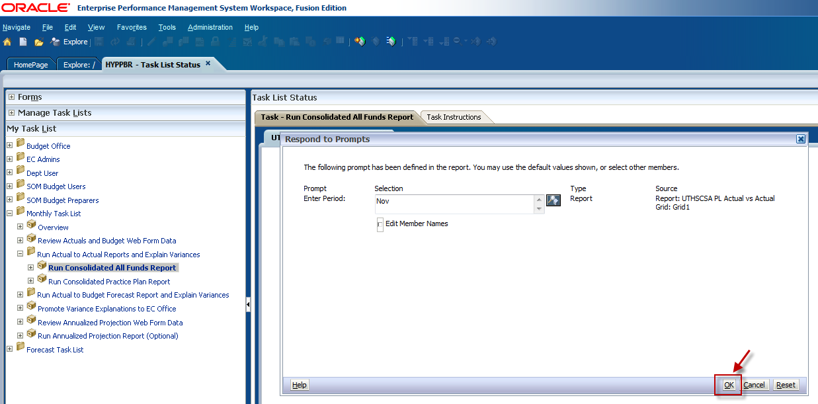

The All Funds Actual to Actual report will then appear on your screen in the HTML format.
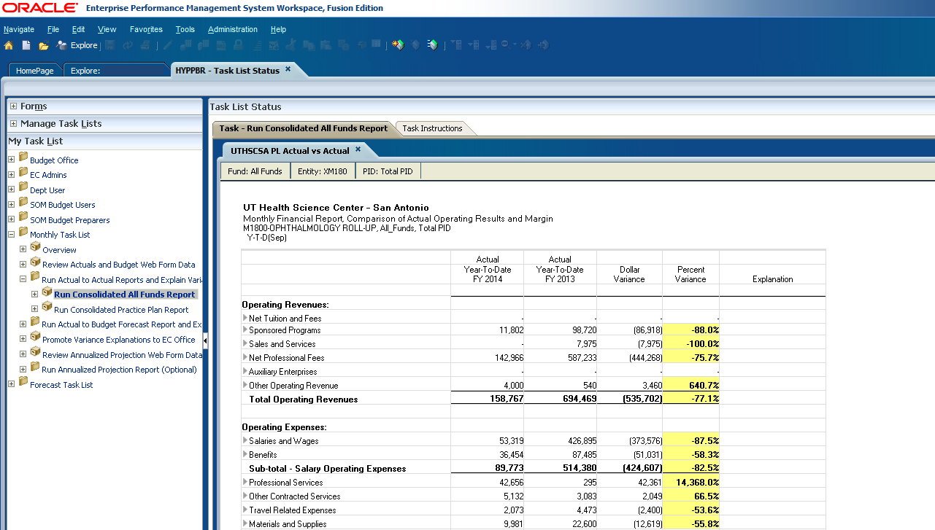

The HTML report has drill down capabilities that will allow users to see the account detail which make up individual report line items. To drill down, click on the arrows facing to the right next to the report line items. This will expand the line item to show the embedded sub-levels of account data. Each sub-category will appear listed above the line item as shown below. At this point the HTML report can be exported to Excel by following the steps in the Export a report to Excel section. Keep in mind that for detail to be exported to Excel it must first be expanded in the HTML format.

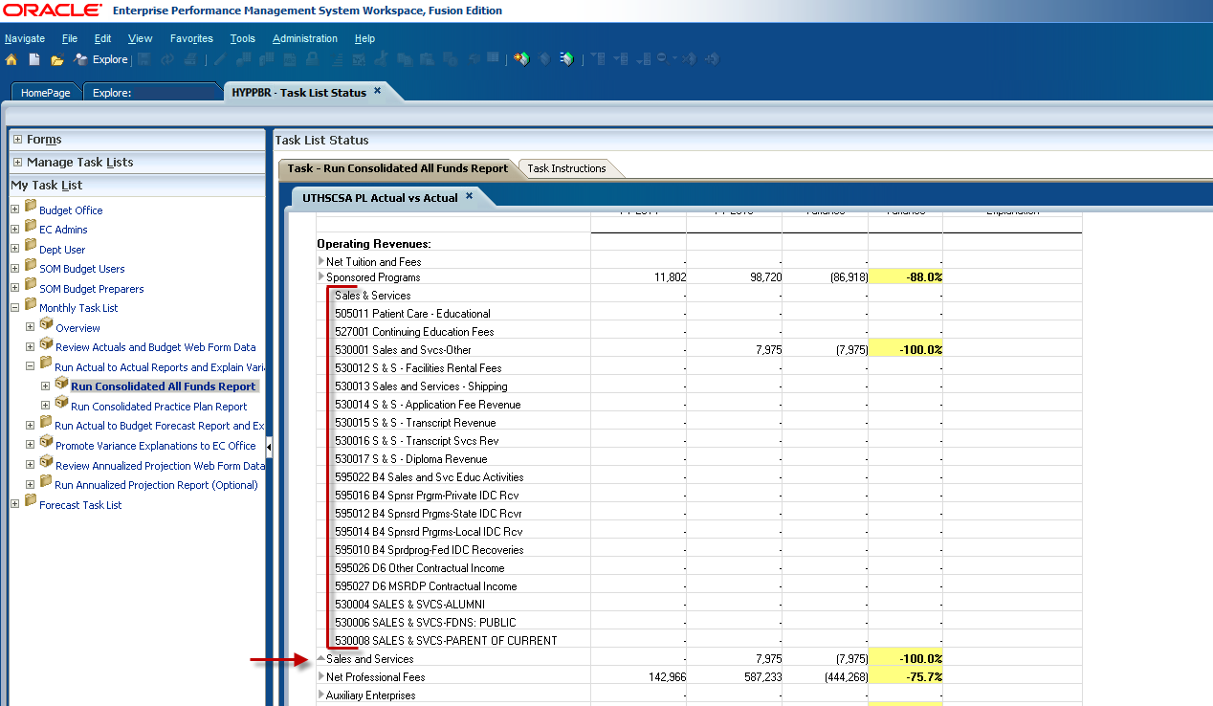

Steps to run the Actual to Actual Practice Plan Report

Log in to Hyperion and click on Explore.
This will open a new tab labeled Explore.

Expand the HYPPBR folder by clicking on the plus sign.

Then expand the Financial Reports folder.

Expand the Institution folder.

And double click on the Reporting folder.

Be sure to leave this tab open with the Reporting folder expanded as you work in Hyperion. You will later navigate back to this tab to export reports to Excel. Refer to the Exporting a Report to Excel section for step by step instructions.

Navigate back to the HomePage tab and click on HYPPBR.
Navigate to the Monthly Task List by first clicking the plus sign next to My Task List.
Expand the Monthly Task List

Click on the plus sign next to Run Actual to Actual Reports and Explain Variances to further expand the task list.

Double click on Run Consolidated Practice Plan Report.
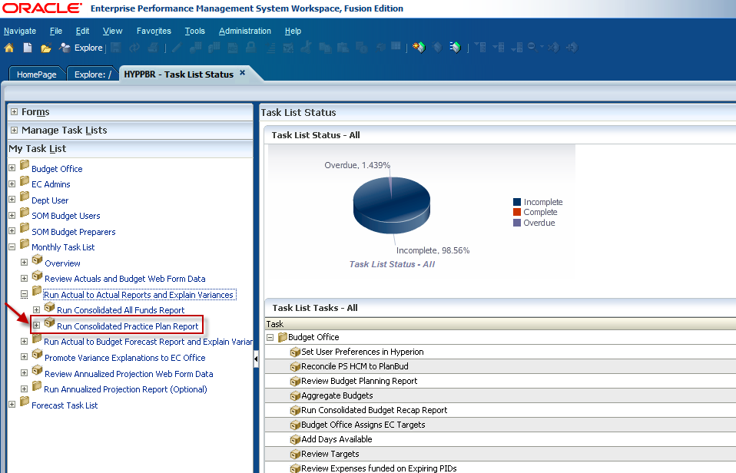

The Point of View window will appear and allow users to input the member selection criteria. Notice that there is NOT an option to select a fund. This report defaults to return data for Practice Plan funds only. Click on the Select button next to the Entity member box to begin selecting your Entity and PID members.
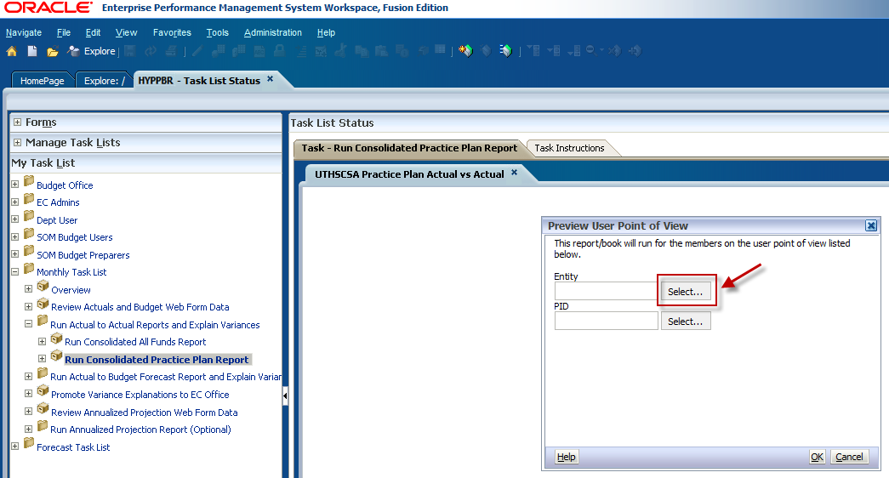

First, select the maximum amount of Rows Per Page using the dropdown menu. This will allow for all information to be visible when you to expand the folders.
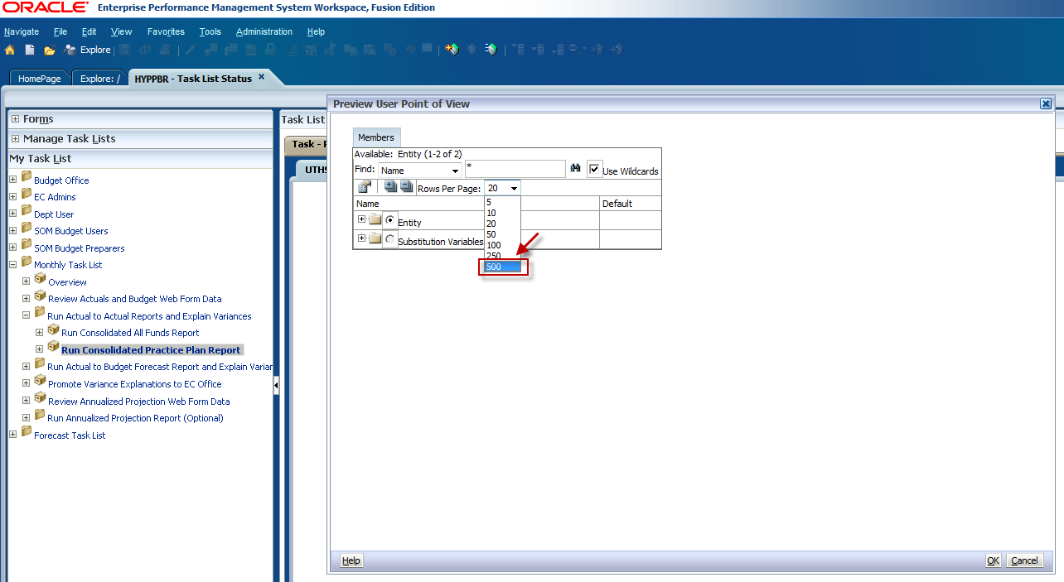

Expand the Entity folder by clicking on the plus sign.
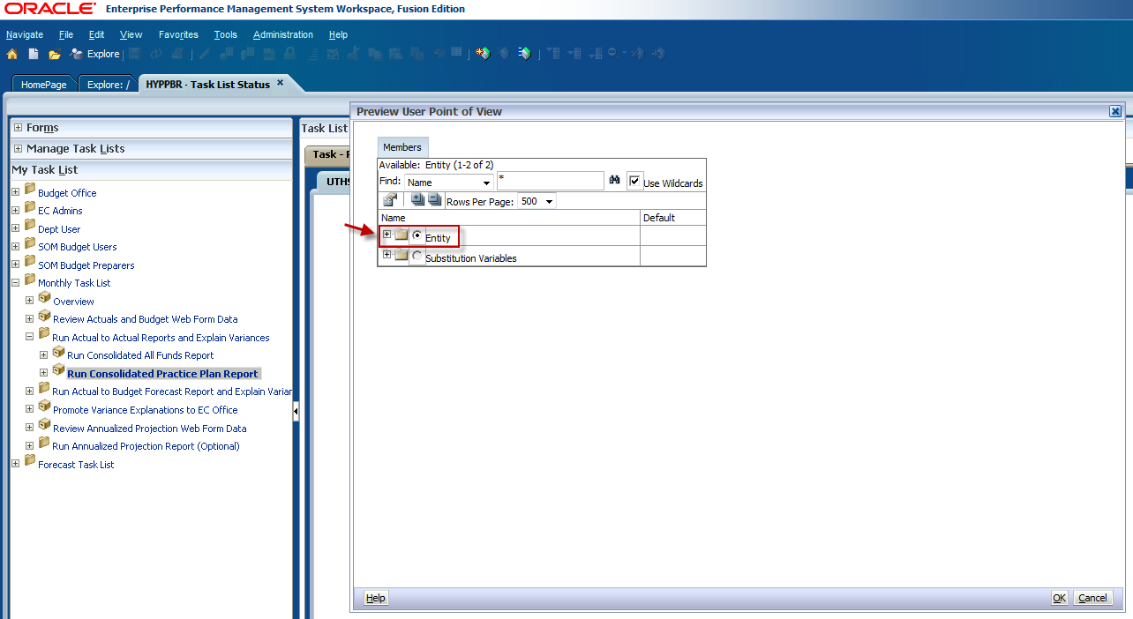

Expand the X9999- UTHSCSA Roll-Up folder.
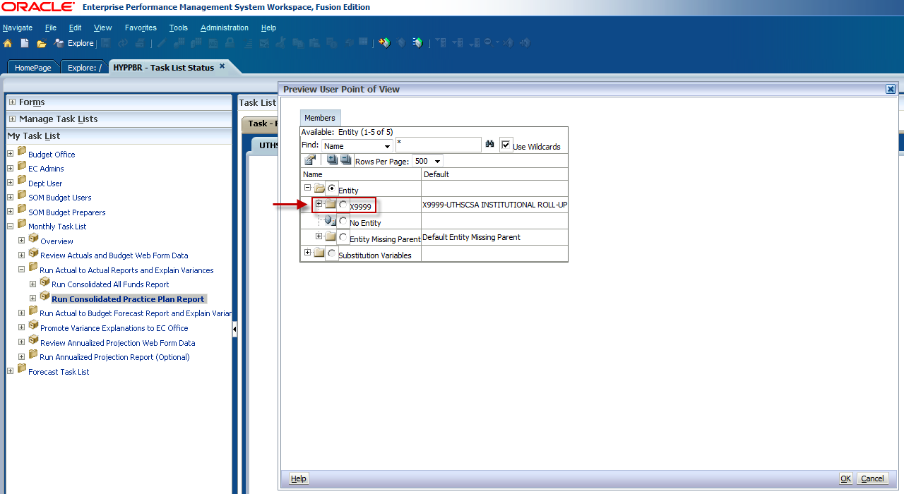

This will open the next Entity hierarchy level which is the Executive Committee (EC) roll-up level. Again, we will run the report for the M1800 Roll-Up. M1800 will be nested in the M1000-SOM Roll-Up folder. Expand the XM100 folder by clicking on the plus sign.
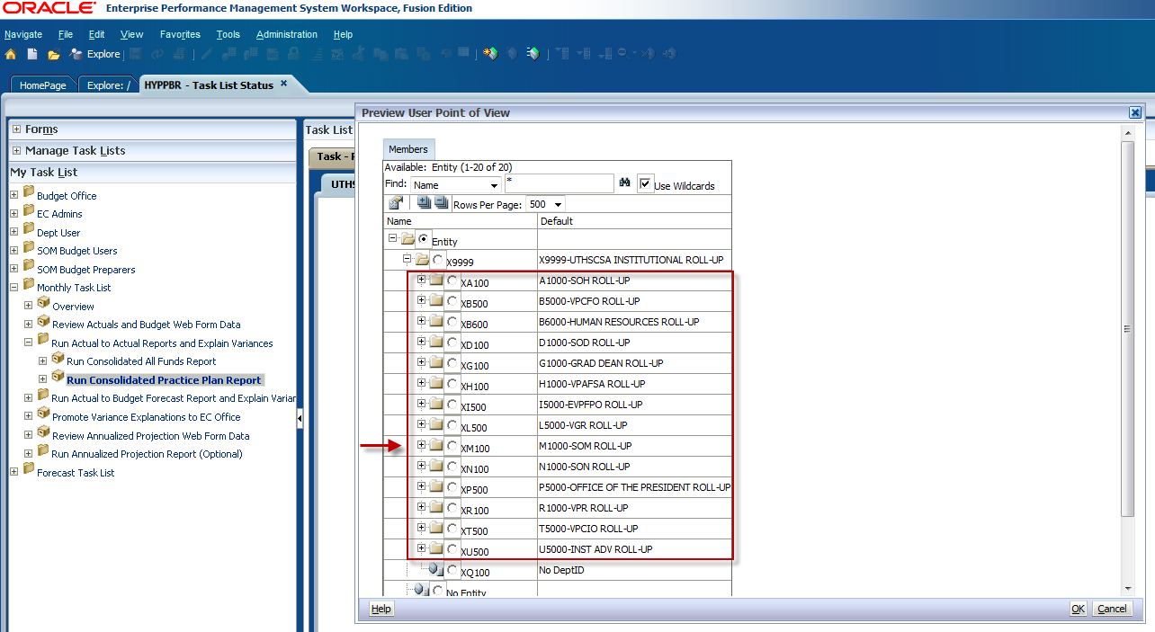

Use the scroll bar to navigate through the list. When you have found the intended Entity, click the radio dial button to make your selection and click OK.
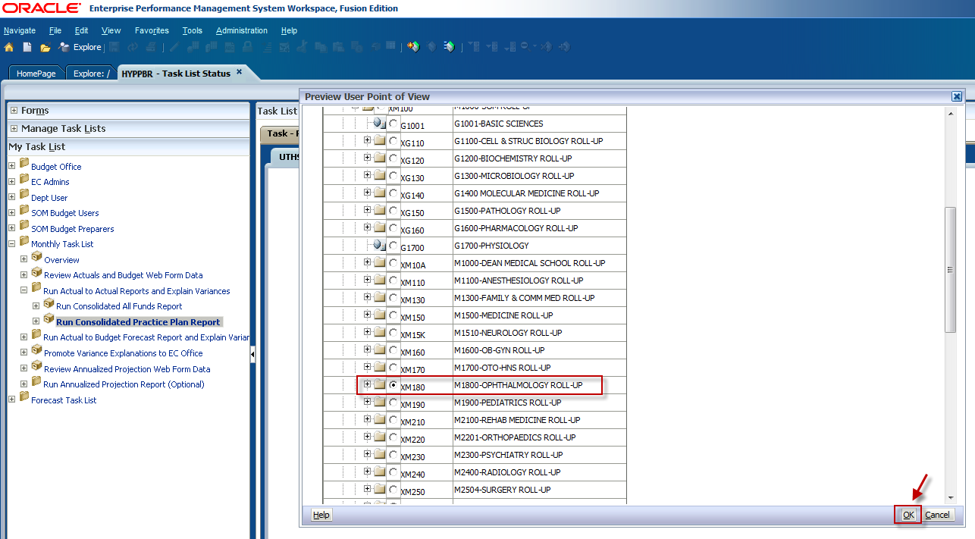

If you would like to run the report for an individual department, continue expanding the folders to see the lowest entity level. Use the scroll bar to find the intended entity, click the radio dial button to make your selection, and click OK.
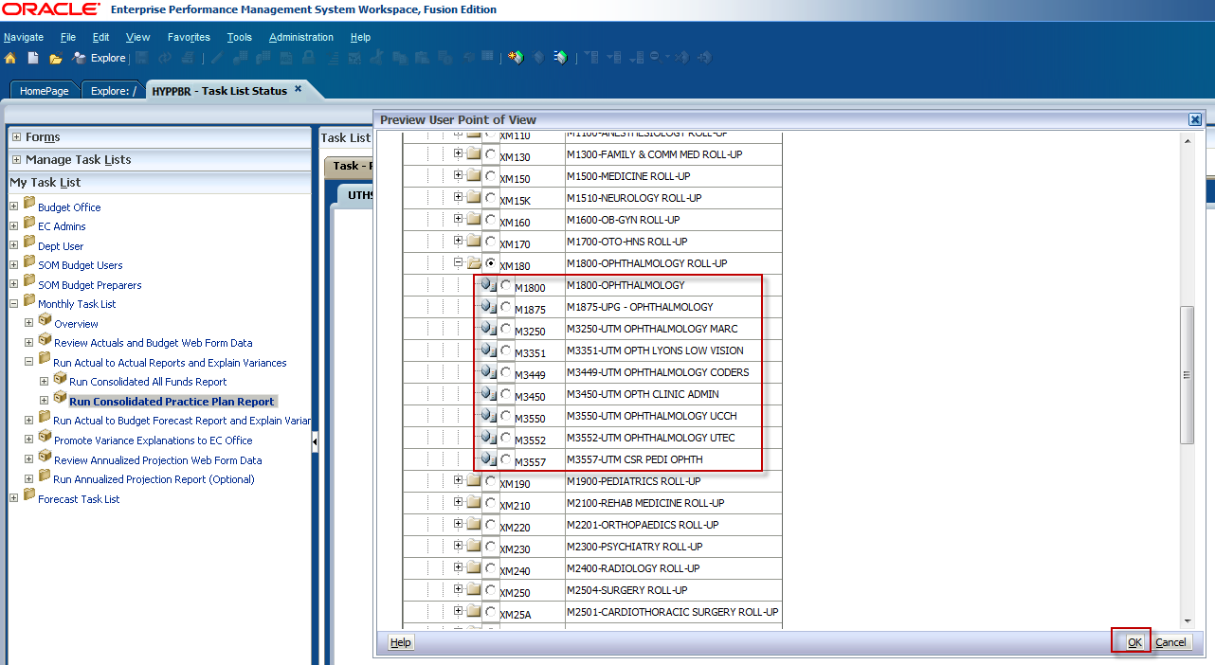

You will be directed back to the Point of View window. Next, make a Project ID selection by clicking on the Select button next to the PID member box.
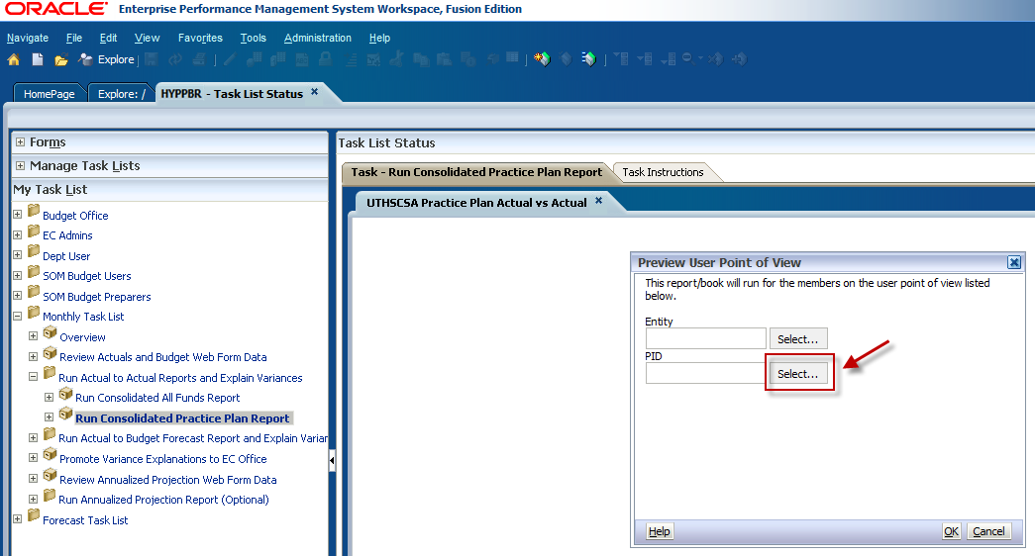

Select the maximum amount of Rows Per Page using the dropdown menu. This will allow for all information to be visible when you to expand the folders.
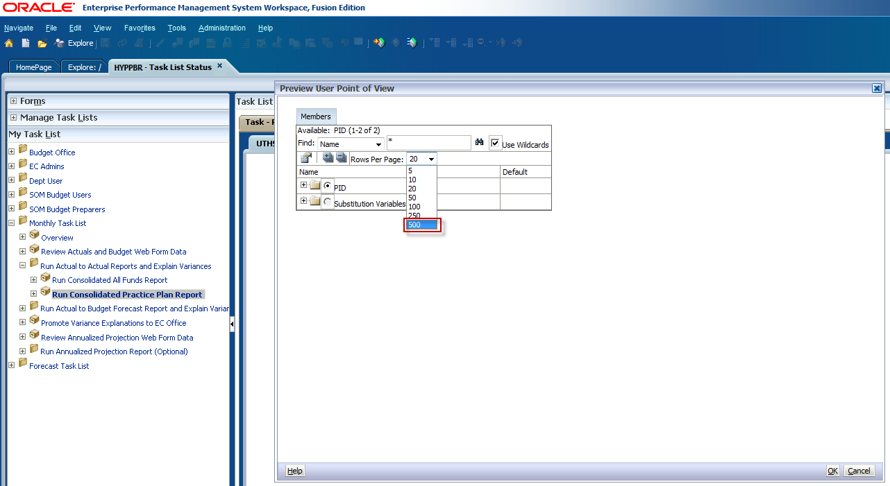

Click on the plus sign to expand the PID folder.
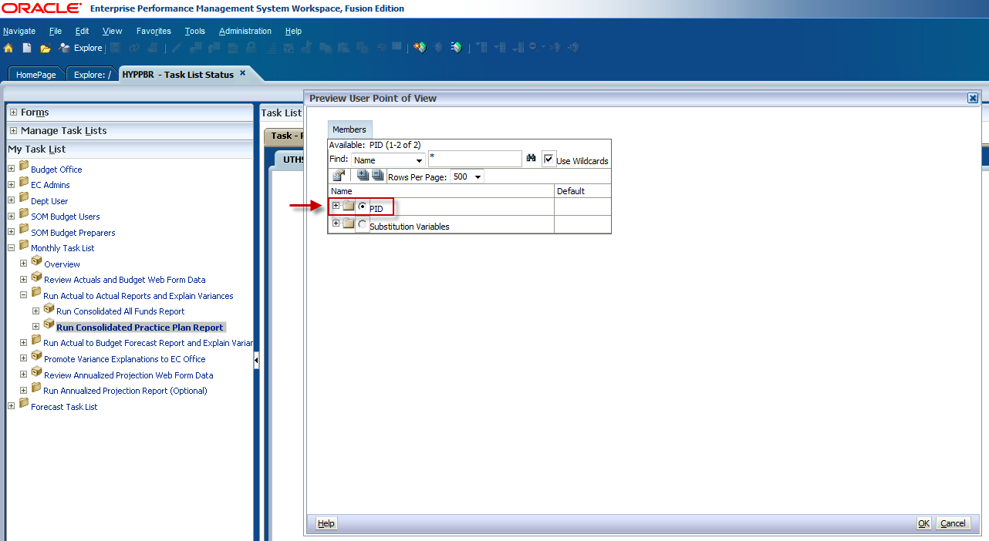

To run the report for ALL PIDs select the radio dial button next to Total PID and click OK.
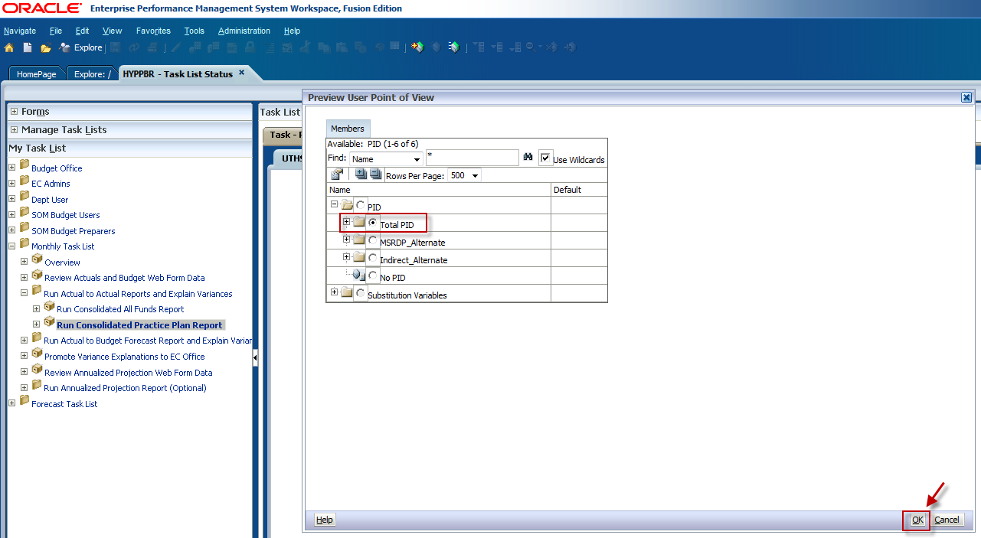

To run the report for a specific Project ID expand the Total PID folder and use the scroll bar to locate the PID. Click the radio dial button to select it, and click OK.
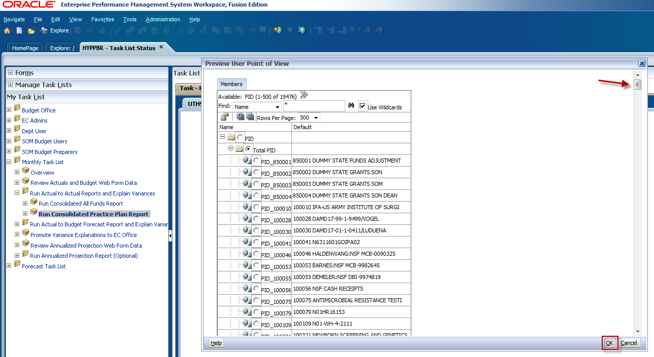

You will be directed back to the Point of View Window. Confirm that your member selections are correct and click OK.
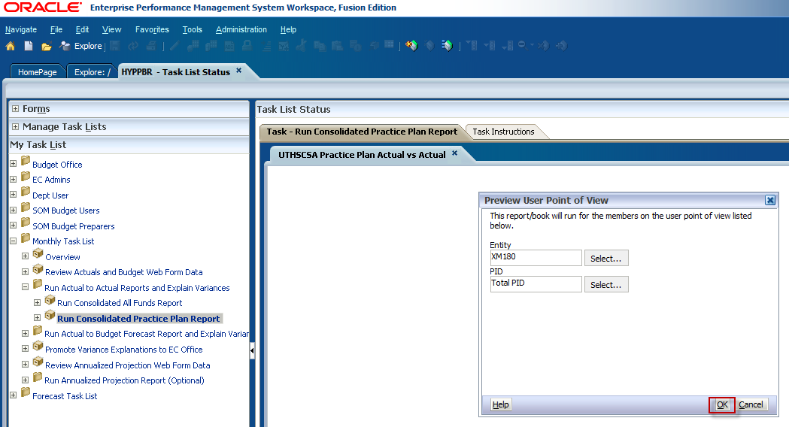

A new window will appear prompting you to select a Practice Plan group and a reporting period. The report defaults to run for ALL practice plan funds, and for the most recent closed reporting period.
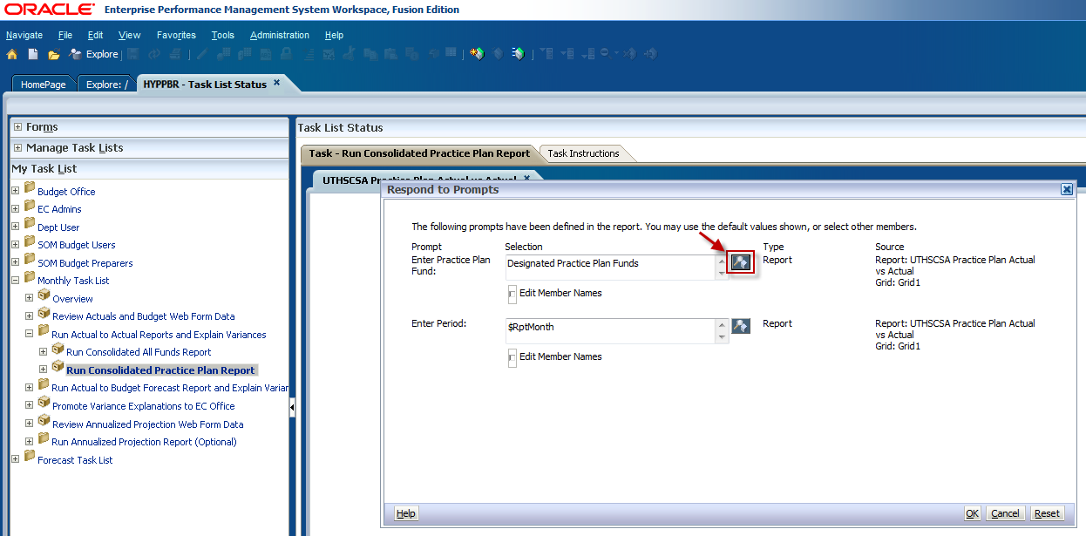

To change the fund criteria, click on the icon to the right of the fund member box.

Use the arrows to remove Practice Plans from the selection box. Then check the box for the desired practice plan group. Use the arrow button to move it to the selection box and click OK.
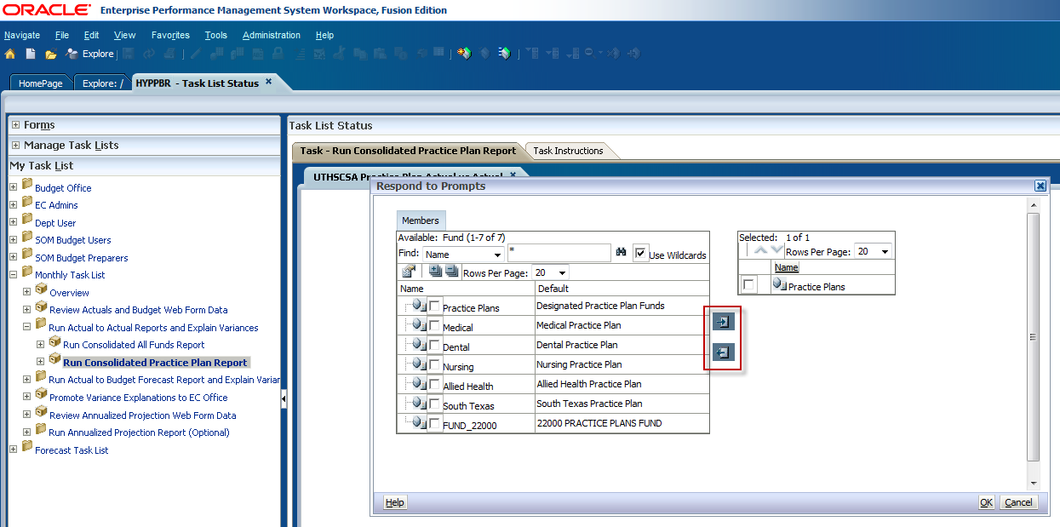

To change the reporting period, click on the icon next to the Period box.
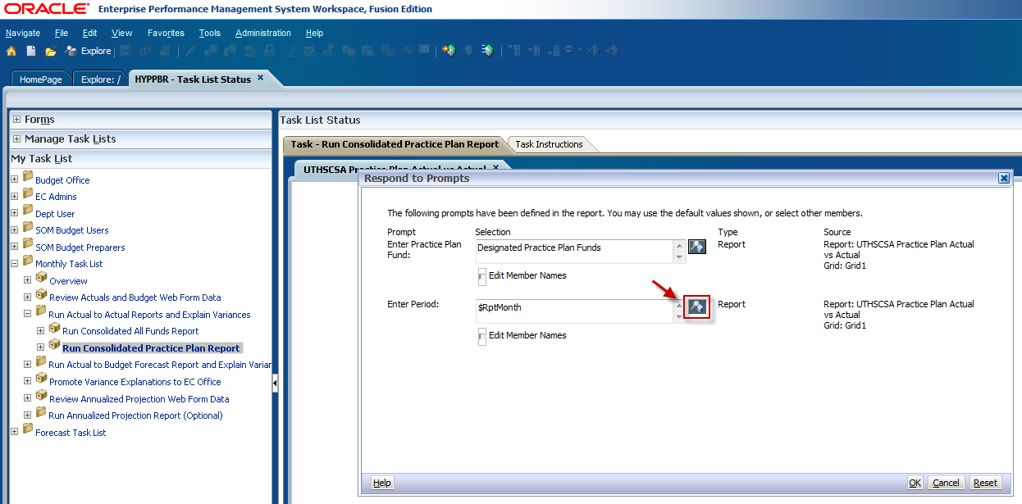

Use the arrow button to remove the default reporting period from the selection box. Then select the intended reporting period and use the arrow button to move it to the selection box. Click OK.
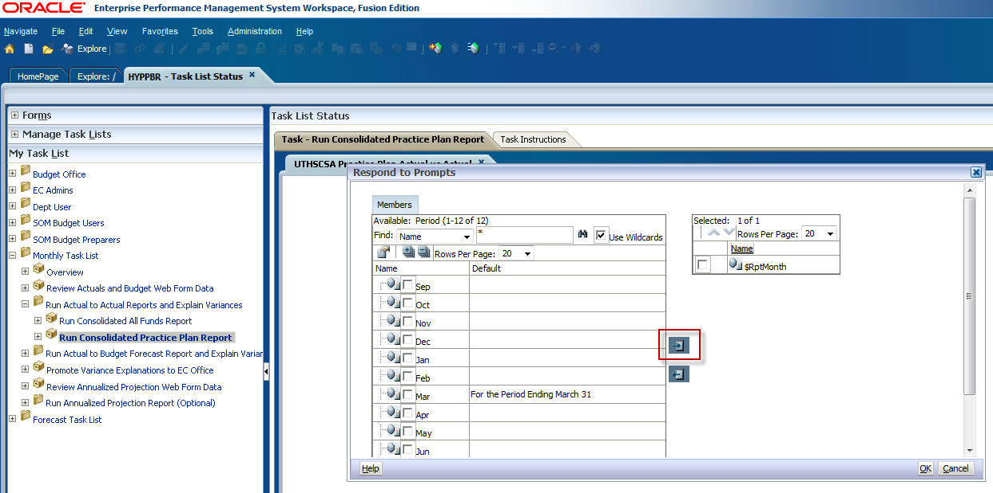

You will then return to the Respond to Prompts window. Confirm that the criteria are correct and click OK.
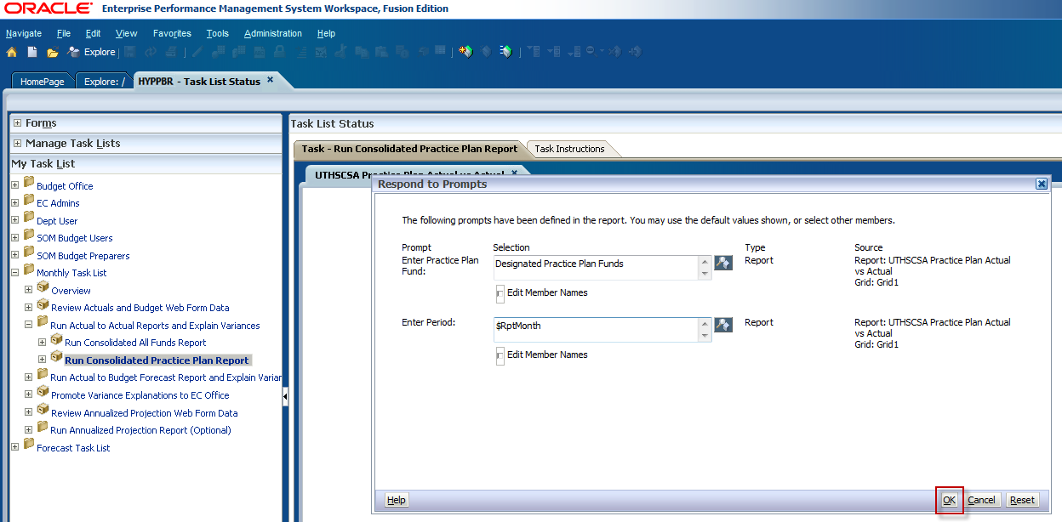

The HTML version of the Actual to Actual Practice Plan report will appear in your window. Like the All Funds Actual to Actual report, click on the arrows next to the line item categories to drill-down to supporting detail. You will see that the Practice Plan report is very similar to the All Funds report. The same data is being pulled in, and the variances are calculated the same way. The only difference with this report is the way the accounts are grouped. The categorization of the Practice Plan report is required by UT System. At this point the HTML report can be exported to Excel by following the steps in the Export a report to Excel section. Keep in mind that for detail to be exported to Excel it must first be expanded in the HTML format.
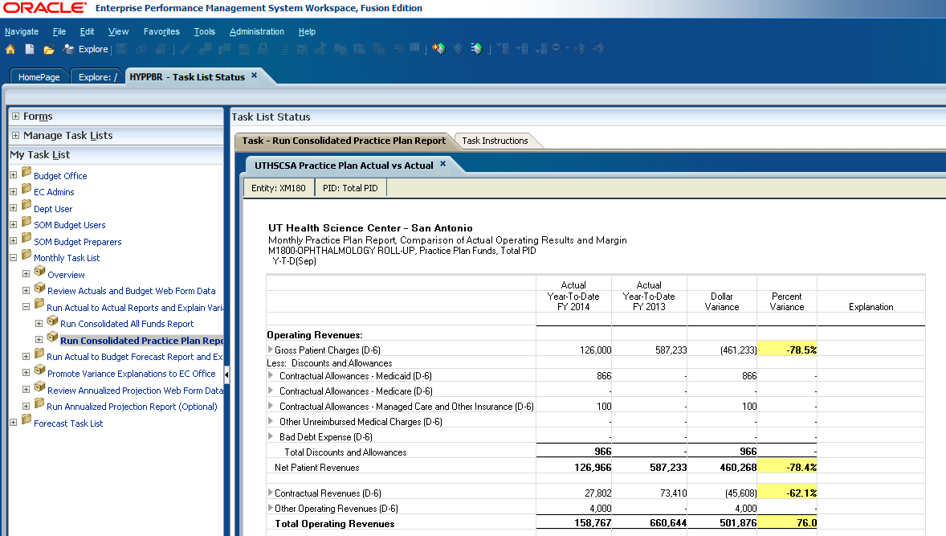

Interpreting the Actual to Actual reports

The Hyperion reports present information in a profit and loss format in accordance with Generally Accepted Accounting Principles, or GAAP. All PeopleSoft general ledger account codes for revenues and expenses have been grouped into one of these line item categories. Refer to the Hyperion SharePoint site for a listing of the P&L account code groupings.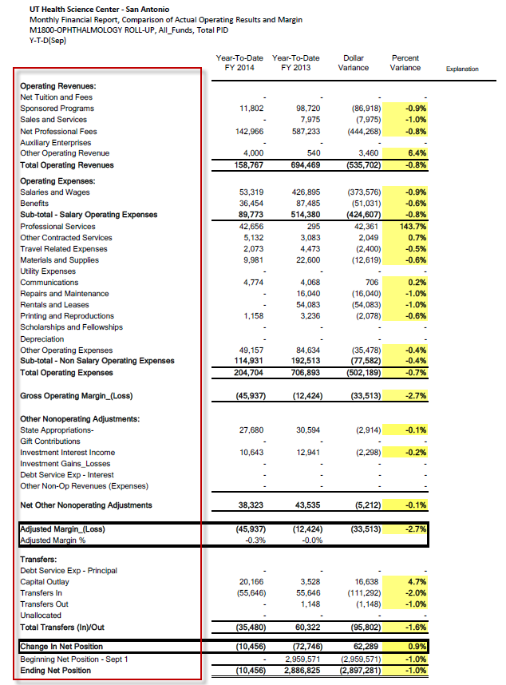

The financial data presented on the Actual-to-Actual report come directly from PeopleSoft Financials. It consolidates the year-to-date activity for the current and prior fiscal year based on the selected reporting period criteria.
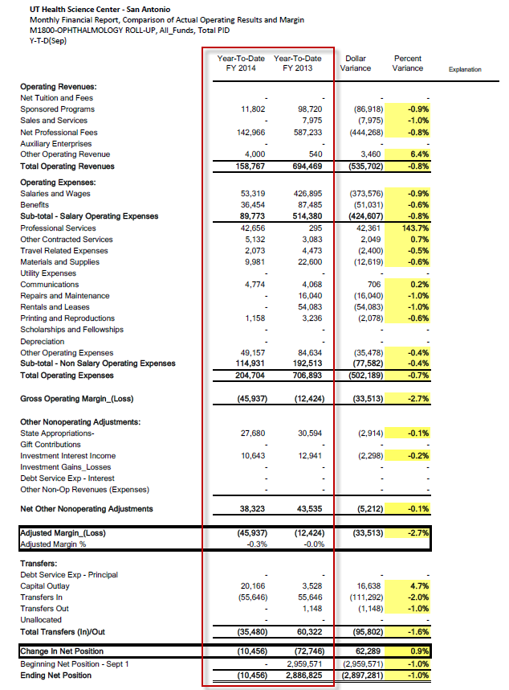

Finally, we see variance calculations presented in both dollar amounts and percentages. Lines that exceed the 10% threshold will be highlighted in yellow to signify a variance explanation is required.
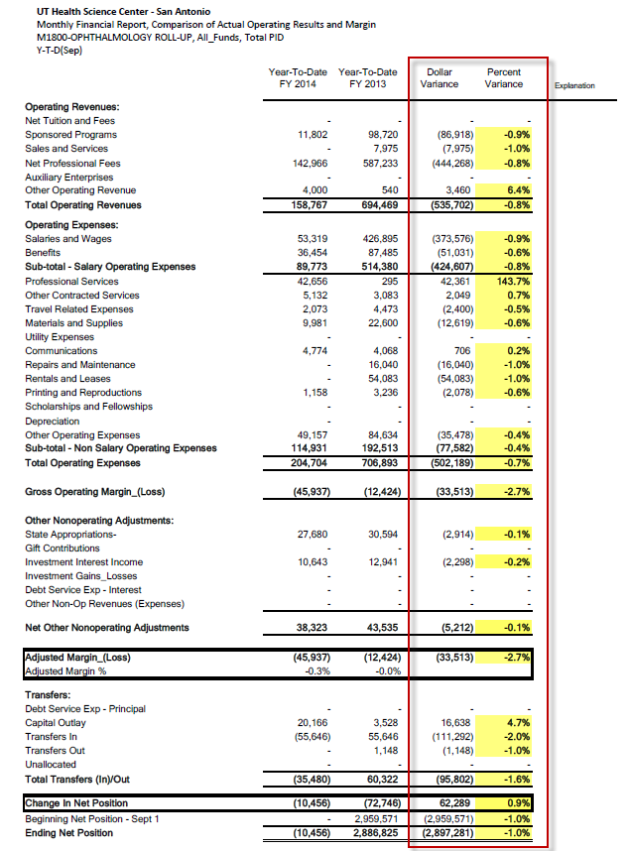

While it is important to investigate significant variances for individual revenue and expense lines, it is imperative that users understand the driving forces causing the resulting Adjusted Margin and Change in Net Position. A positive Adjusted Margin, which is calculated simply as Revenues less Expenses, indicates that your revenue collections are sufficient to cover your current operating costs. Conversely, a negative Adjusted Margin indicates current expenses are outpacing revenue generation.
However, this may not necessarily be the case without considering the impact of Transfers since operations are often partially subsidized by other departments, deans and vice presidents, and the President’s office. So it’s important to look further down the P&L report and look at the Change in Net Position.
A positive Change in Net Position , which is calculated as Adjusted Margin plus or minus Transfers In and Out, indicates you can cover the cost of your operations through independent revenue generation and/or funding agreements with other areas. If, however, a sizable portion of your costs are being supported by transfers or commitments, you need to consider how long this funding stream will last in order to develop and implement appropriate action plans prior to the time in which the funding streams have ceased.
A negative Change in Net Position indicates that your current revenue and subsidy streams are insufficient to cover your current operations, and is almost always indicative that an immediate behavioral action plan is warranted.
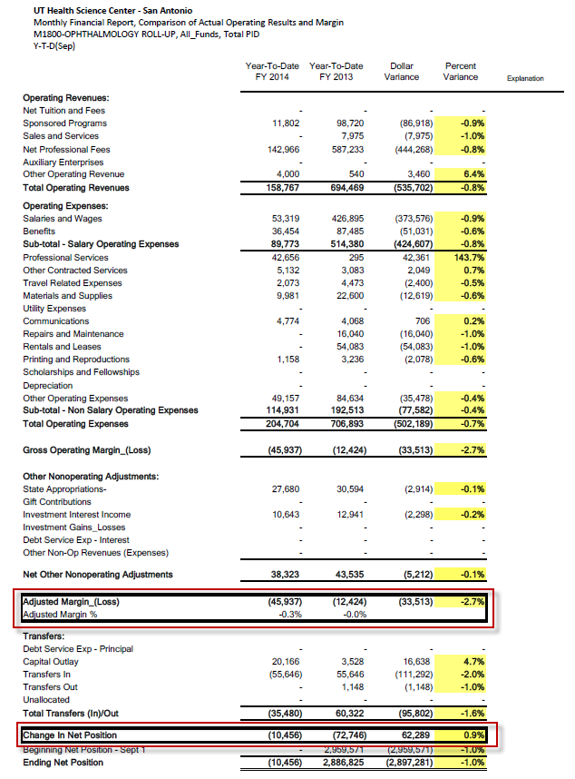
Interpreting the Actual to Actual Practice Plan Report:
The Practice Plan report is very similar to the All Funds Actual to Actual report. The same data is pulled in, and the variances are calculated the same way. The only difference with this report is the way the accounts are grouped. The categorization of this report is required by UT System. The same attention and considerations need to be given to the Adjusted Margin and the Change in Net Position as was given to the previously discussed All Funds report.
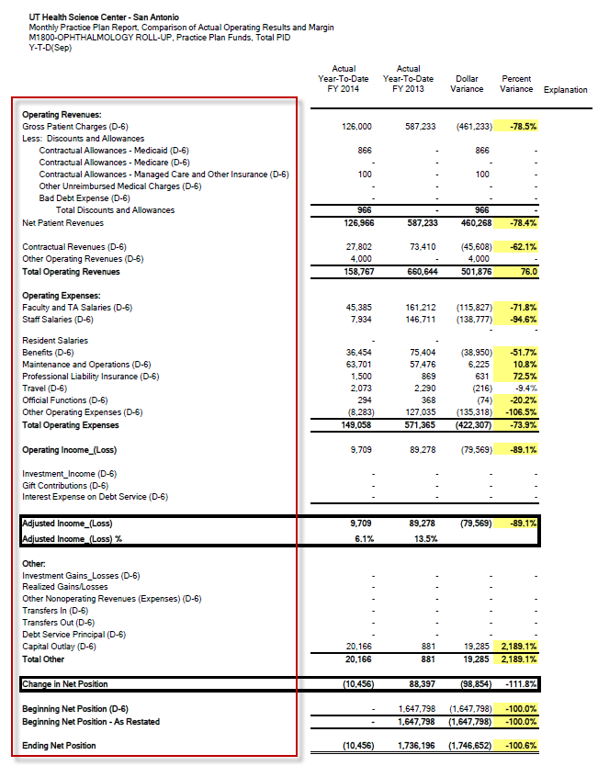

Actual to Budget Forecast report:

- The Actual to Budget Forecast report compares the adjusted budget to activity that has actually occurred as of a certain time period and calculates a variance.
- A variance is calculated and will be presented as a dollar amount and as a percent.
- Variances are calculated based on the adjusted budget, but departments will be held accountable to their original budget submission entries.
- Variance explanations will be required based on pre-defined threshold levels (+/-10% change).

Steps to run the Actual to Budget Forecast All Funds report

Log in to Hyperion and click on Explore.

This will open a new tab labeled Explore.

Expand the HYPPBR folder.

Expand the Financial Reports folder.

Expand the Institution folder.

Double click on the Reporting folder.

Be sure to leave this tab open with the Reporting folder expanded as you work in Hyperion. You will later navigate back to this tab to export reports to Excel. Refer to the Exporting a Report to Excel section for step by step instructions.

Navigate back to the HomePage tab and click on HYPPBR.
Navigate to the Monthly Task List by first clicking the plus sign next to My Task List.
Expand the Monthly Task List

Click on the plus sign next to Run Actual to Budget Forecast Report and Explain Variances to further expand the task list.
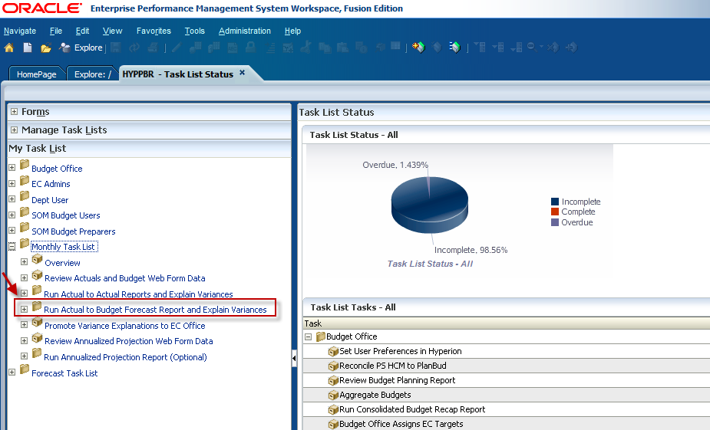

Double click on Run Consolidated All Funds Report.
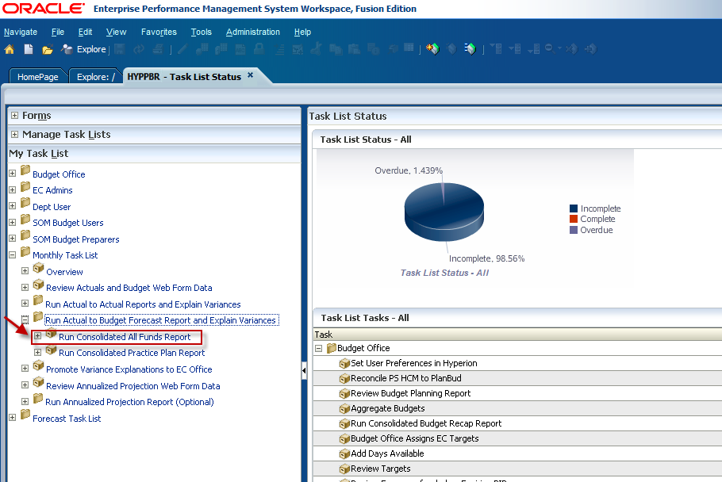

The Point of View window will appear. Click the Select button next to the Fund member box to select a fund group.
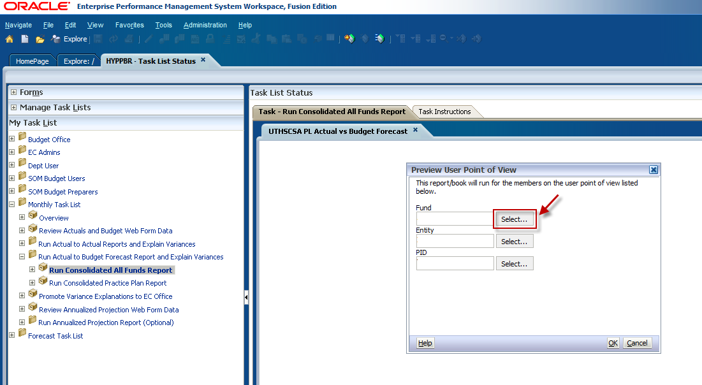

Click on the plus sign to expand the Fund folder.
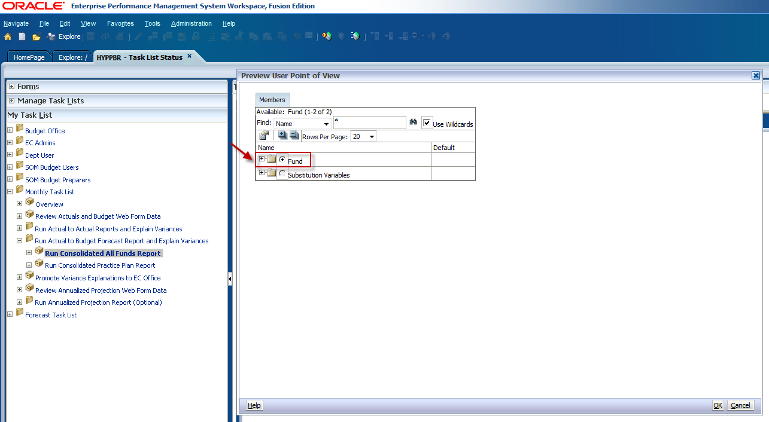

To run the report for ALL fund groups, click on the radio dial button next to All Funds and click OK. If you would like to specify a fund or run the report for a consolidated fund group click the plus sign to expand the All Funds folder.
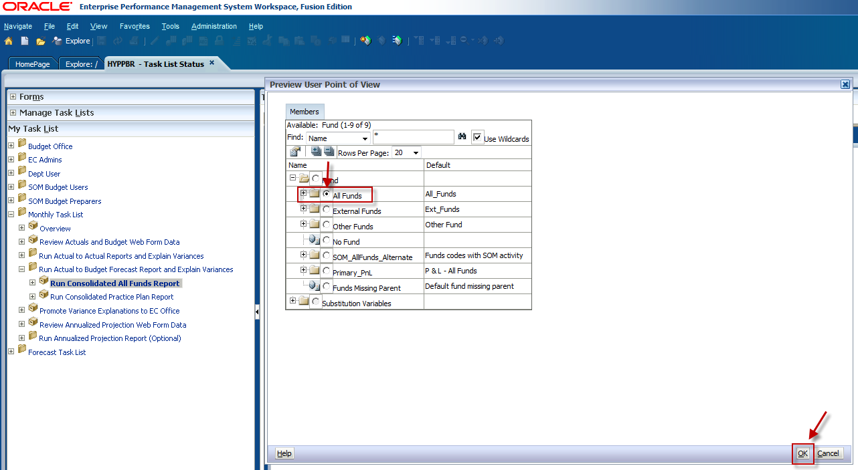

You will see the first level of consolidated fund groupings nested under All Funds. If you would like to run a report for a specific fund group, for example Practice Plans, expand the Designated Funds folder.
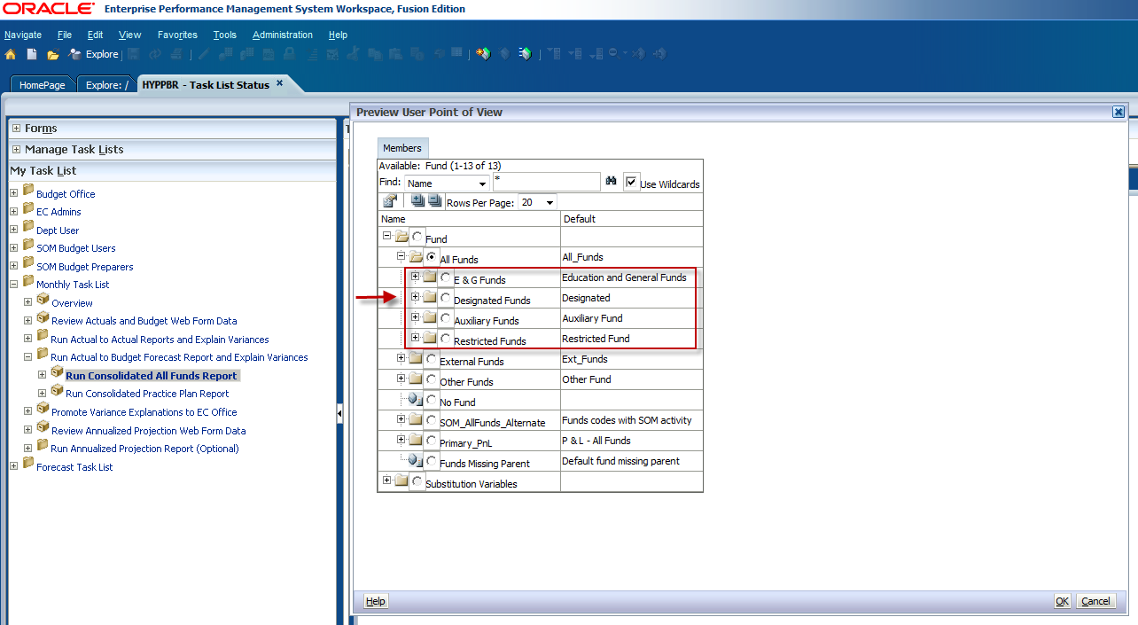

When the folder has been expanded, you will see the next level of consolidated fund groupings nested under Designated Funds.
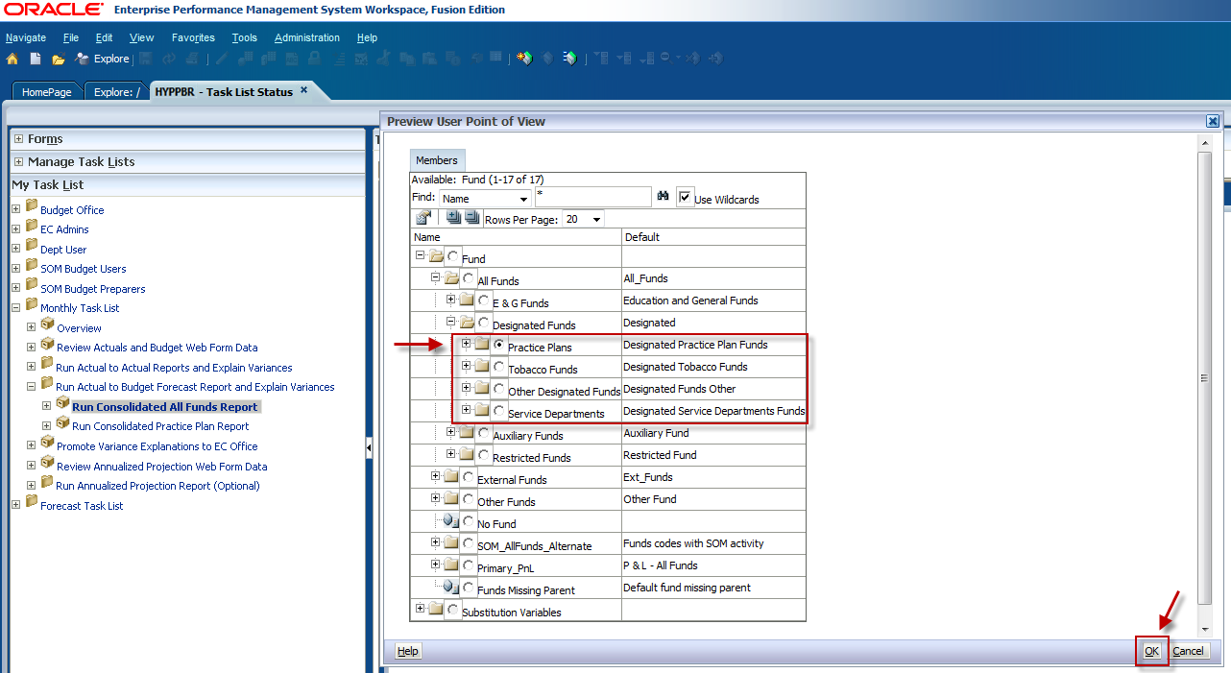

If you would like to run the report for a specific fund, continue expanding the folders until you see the lowest fund level. Make your selection and click OK.
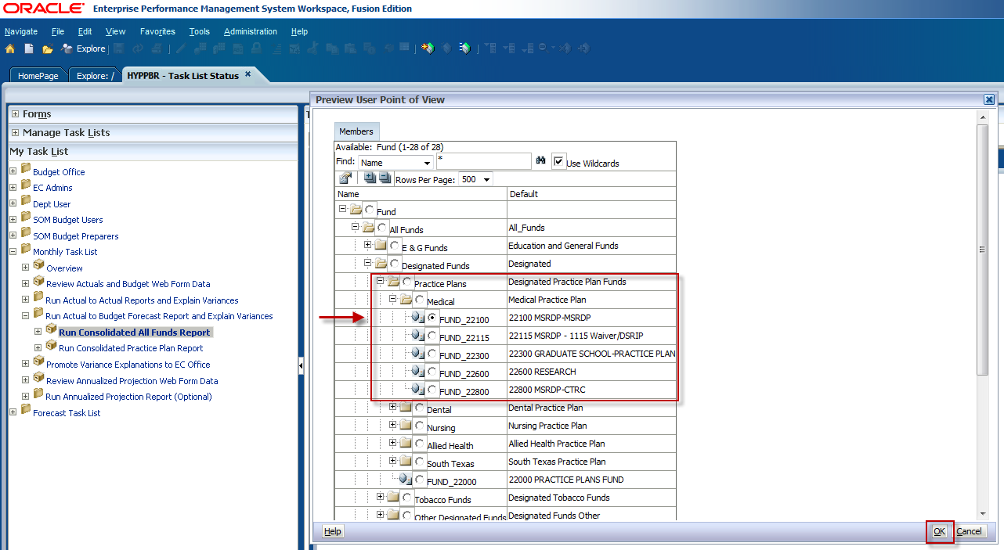

To select an individual fund group you can also utilize the search box. Type FUND_ and the fund group you would like to search, for example, FUND_22100. The asterisk must appear first in order to complete the fund search. Click the binocular icon to the right of the search box.
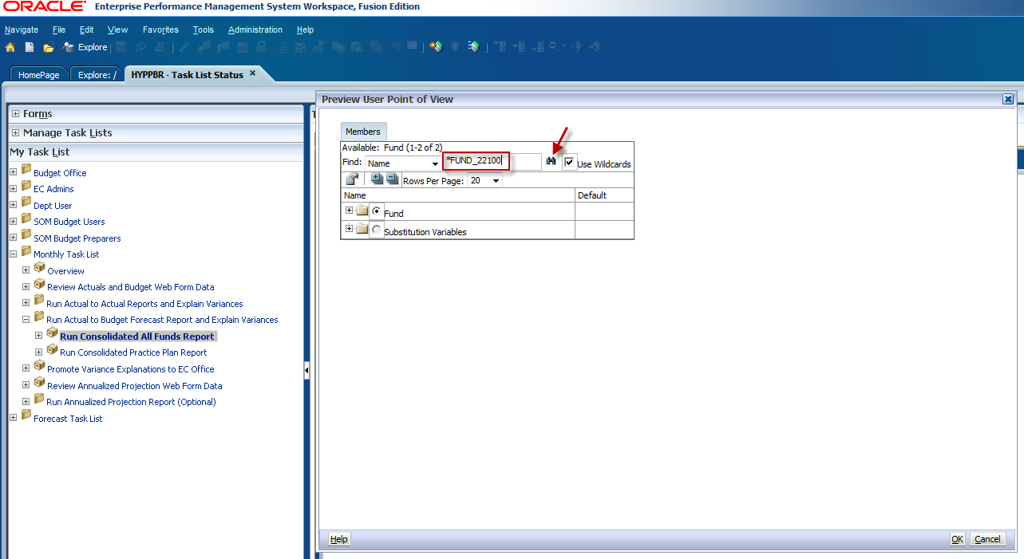

Click OK.
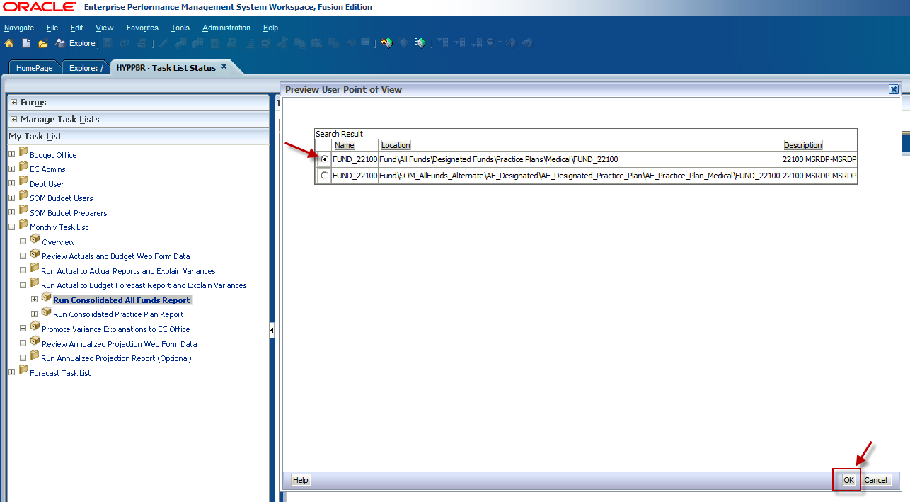

The fund group will be automatically selected in the list. Click OK.
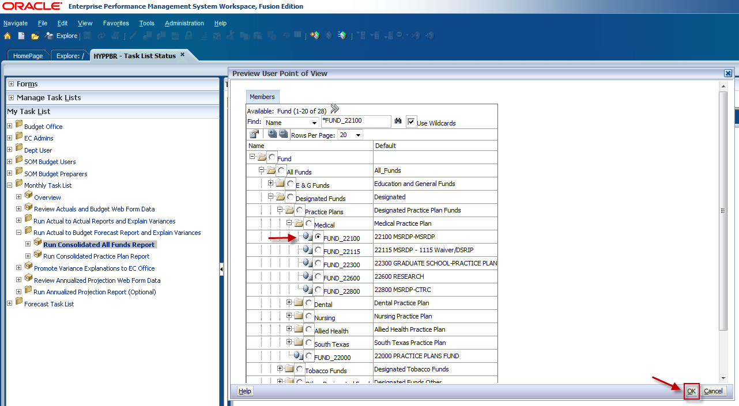

Select an Entity by first clicking on the Select button next to the Entity member box.
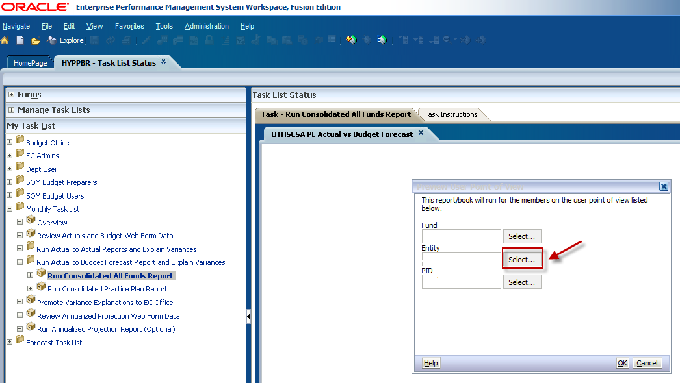

Expand the Entity folder.
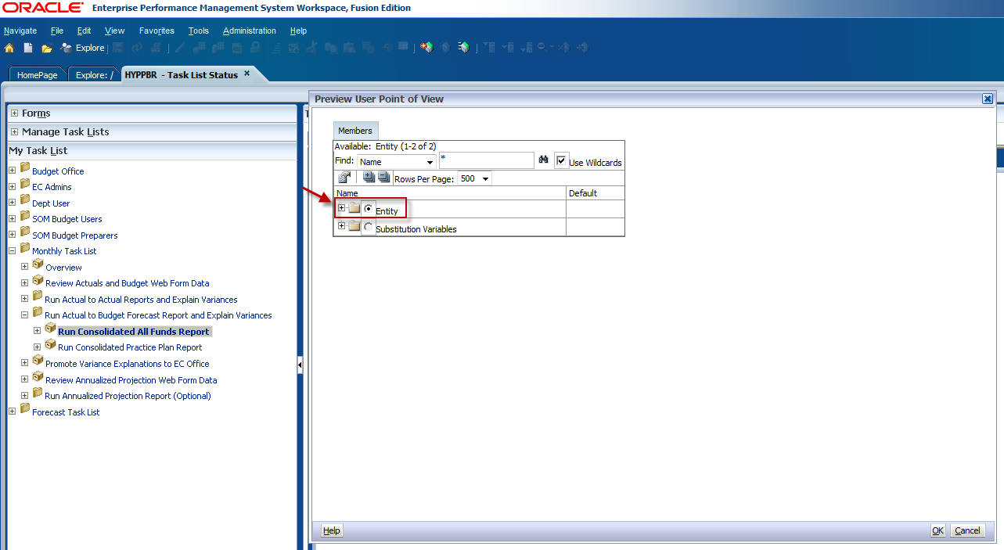

Then expand the X9999-UTHSCSA ROLL-UP folder.
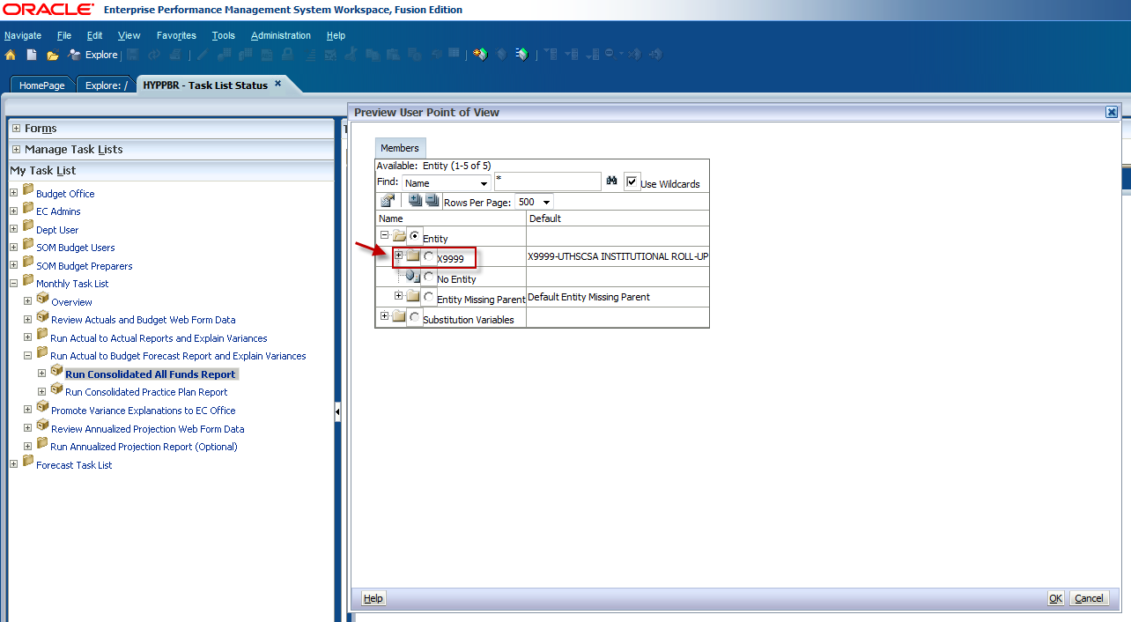

The next Entity hierarchy level is the Executive Committee (EC) roll-up level. Expand the EC roll-up folder to see the next Entity roll-up level. Using the same member criteria as the previous examples, we can locate the M1800 roll-up option by expanding the EC M1000 roll-up folder.
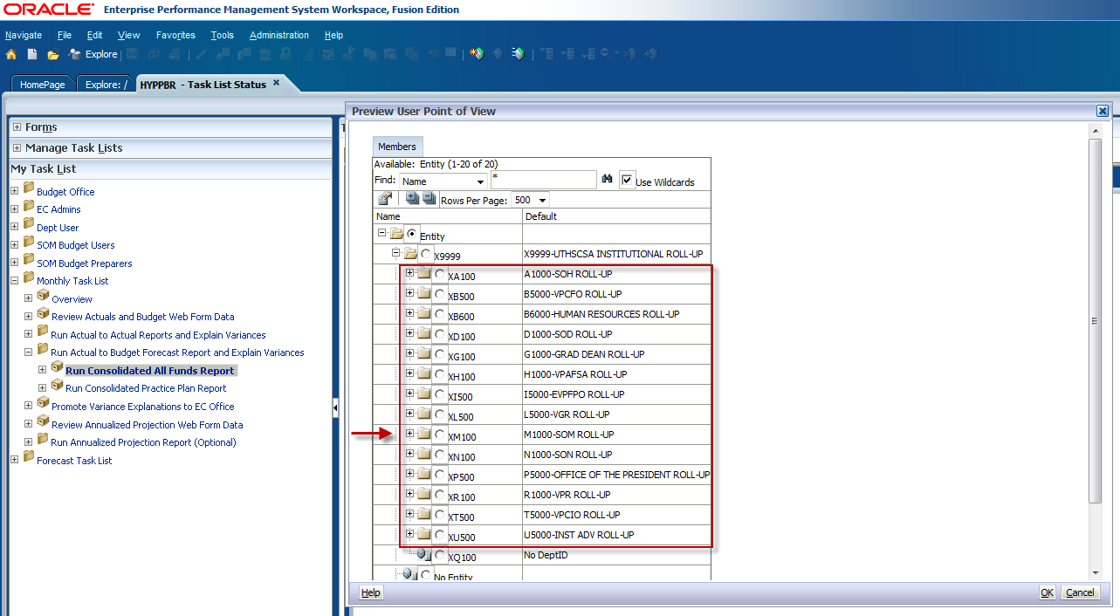

To run the report at the department roll-up level, make your selection and click OK. To select an individual department ID, expand the folder again to see the lowest Entity level.
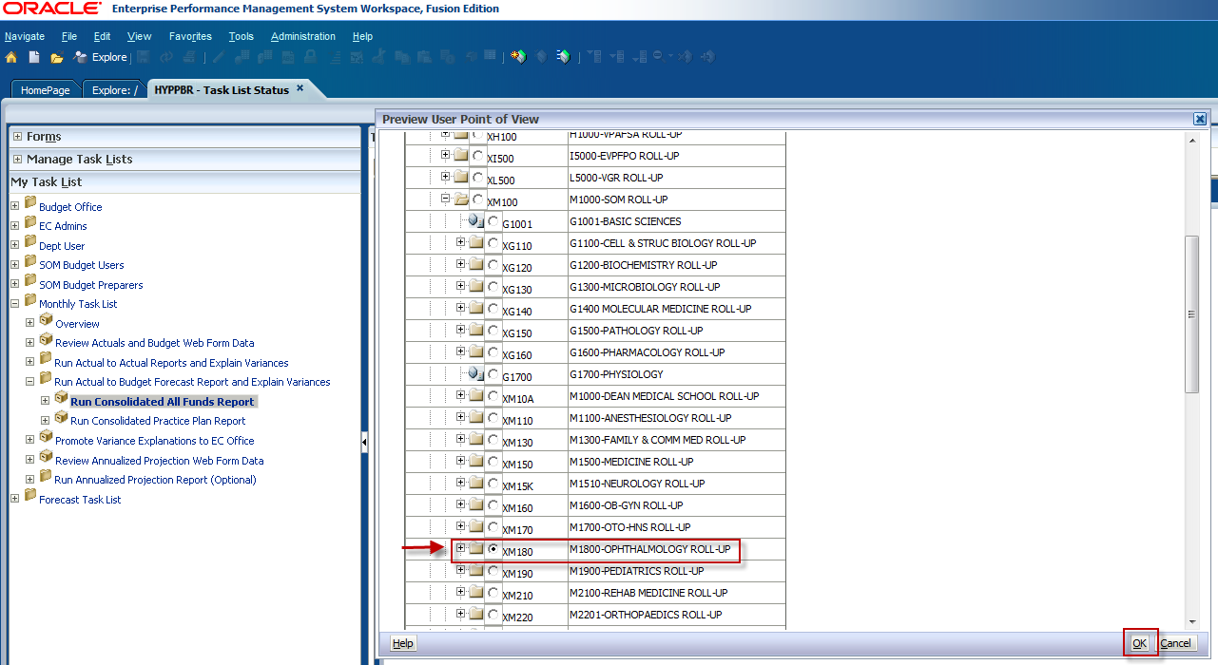

Use the scroll bar to locate the intended entity, click the radio dial button to make your selection, and click OK.
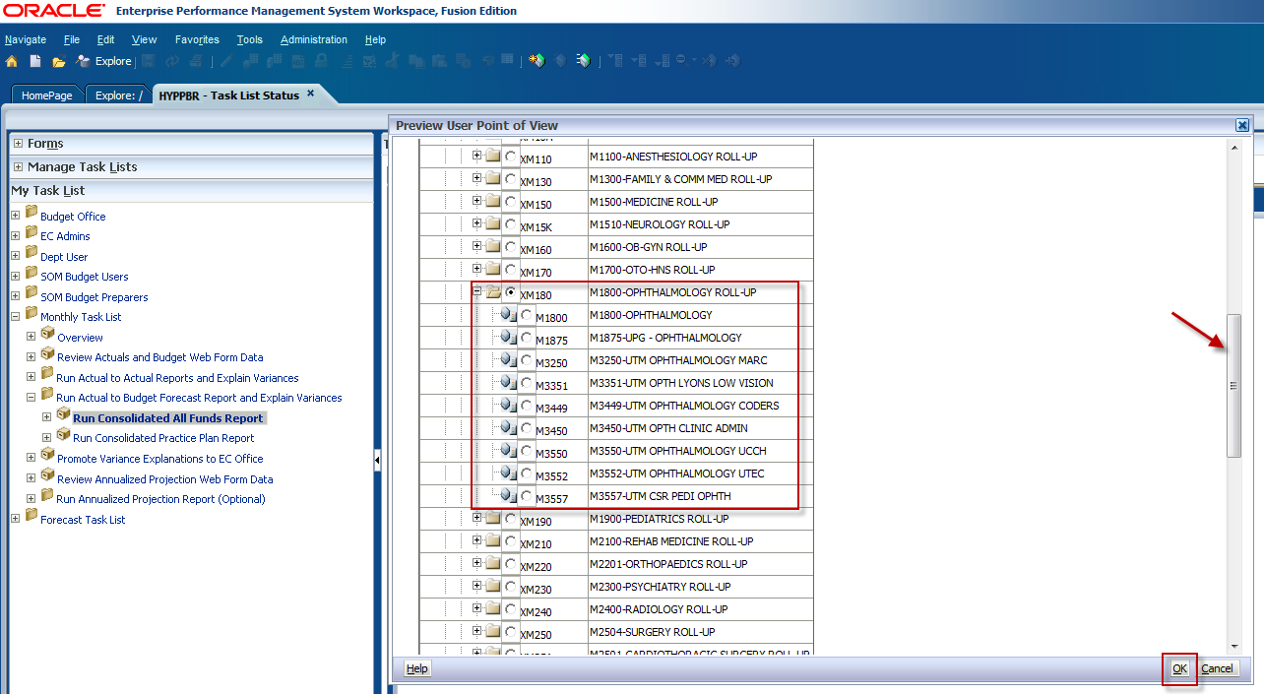

Finally, make a Project ID selection by clicking on the Select button next to the PID member box.
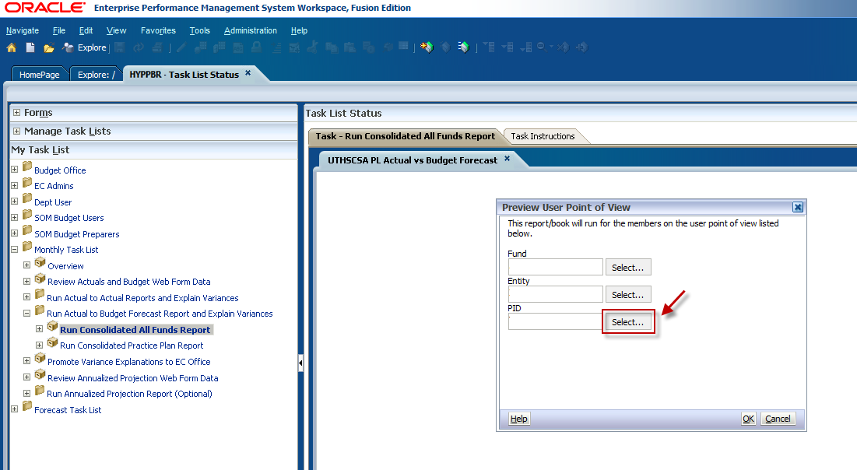

Expand the PID folder.
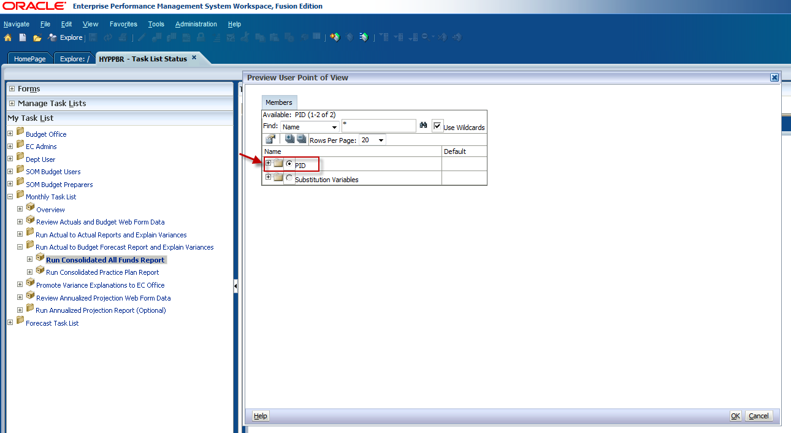

To run the report for ALL PIDs select Total PID and click OK.
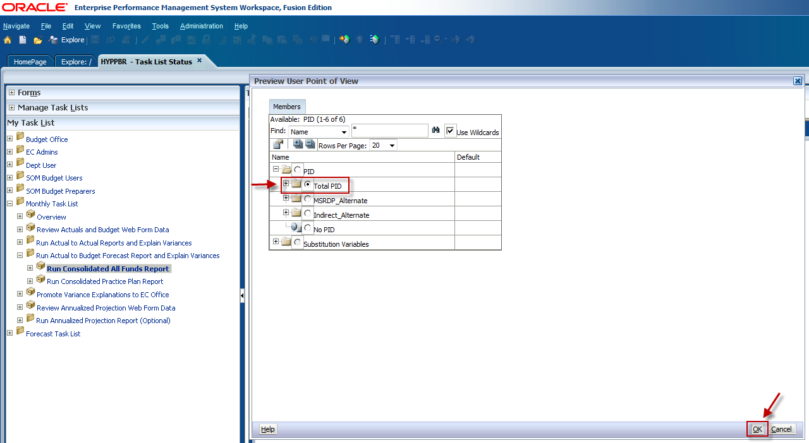

If you would like to run the report for a specific Project ID, expand the Total PID folder and use the scroll bar to locate the intended PID. Keep in mind that the number of rows per page may need to be increased for all projects to be visible.
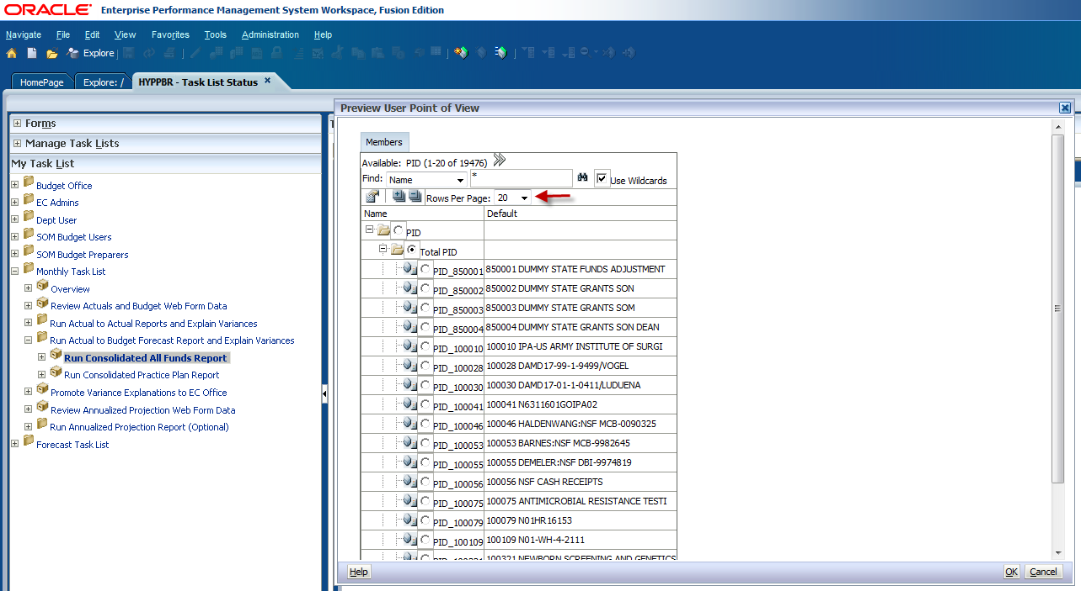

Confirm that the member criteria are correct and click OK on the Point of View window.
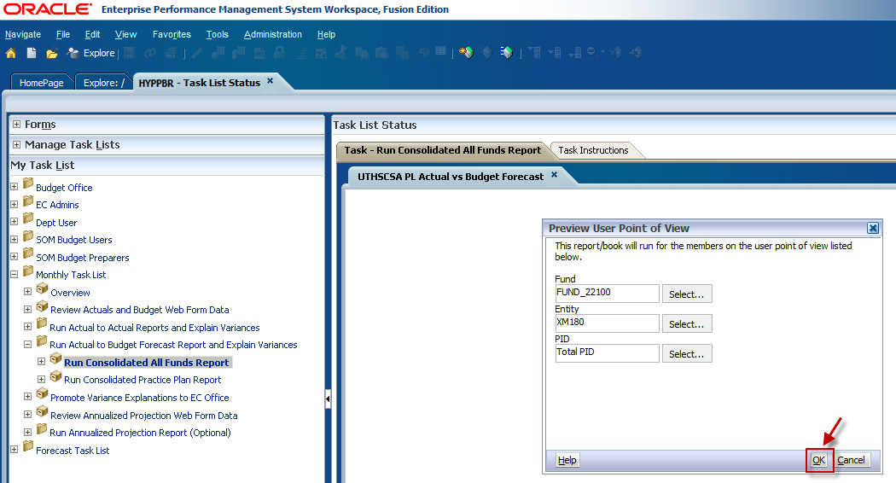

A new window will appear and prompt you to enter a Budget Forecast Quarter and a Reporting Period. The most recent closed reporting period is selected by default. Use the icons to change the criteria if necessary. When the desired criteria are confirmed, click OK.
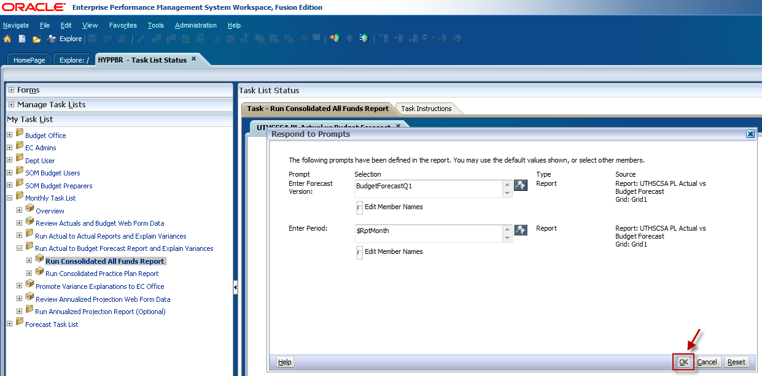

The HTML version of the All Funds Actual to Budget Forecast report will appear in your window.
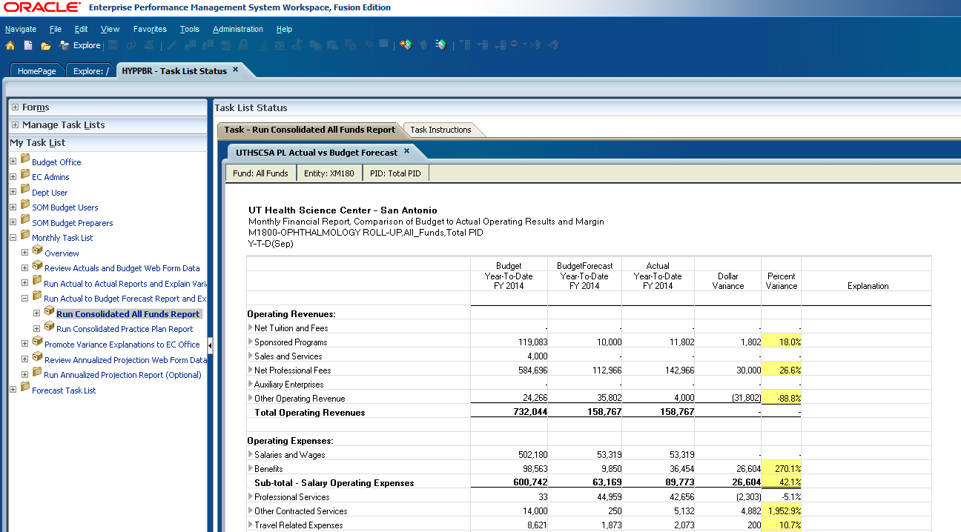

The Actual to Budget Forecast HTML report has drill down capabilities that allow users to see the account detail which make up report line items. To drill down, click on the arrows facing to the right next to the report line items. This will expand the line item to show the embedded sub-levels of data. Each sub-category will appear listed above the line item as shown below. Continue expanding the arrows to see the levels of data. The lowest level will show detail by account code. At this point the HTML report can be exported to Excel by following the steps in the Export a report to Excel section. Keep in mind that for line item detail to be exported to Excel it must first be expanded in the HTML format.
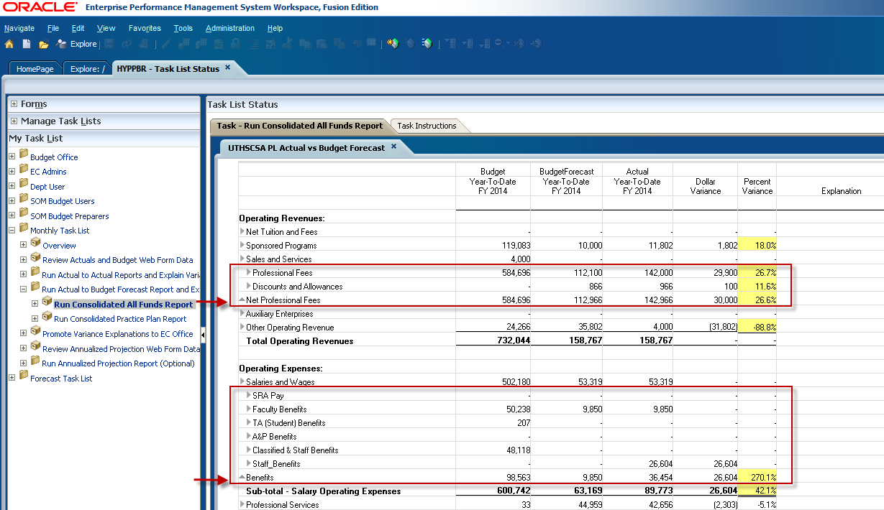

Steps to run the Actual to Budget Forecast Practice Plan report

Log in to Hyperion and click on Explore.

This will open a new tab labeled Explore.

Click on the plus sign to expand the HYPPBR folder.

Expand the Financial Reports folder.

Expand the Institution folder.

Double click on the Reporting folder.

Be sure to leave this tab open with the Reporting folder expanded as you work in Hyperion. You will later navigate back to this tab to export reports to Excel. Refer to the Exporting a Report to Excel section for step by step instructions.

Navigate back to the HomePage tab and click on HYPPBR.
Navigate to the Monthly Task List by first clicking the plus sign next to My Task List.
Expand the Monthly Task List

Click on the plus sign next to Run Actual to Budget Forecast Report and Explain Variances to further expand the task list.
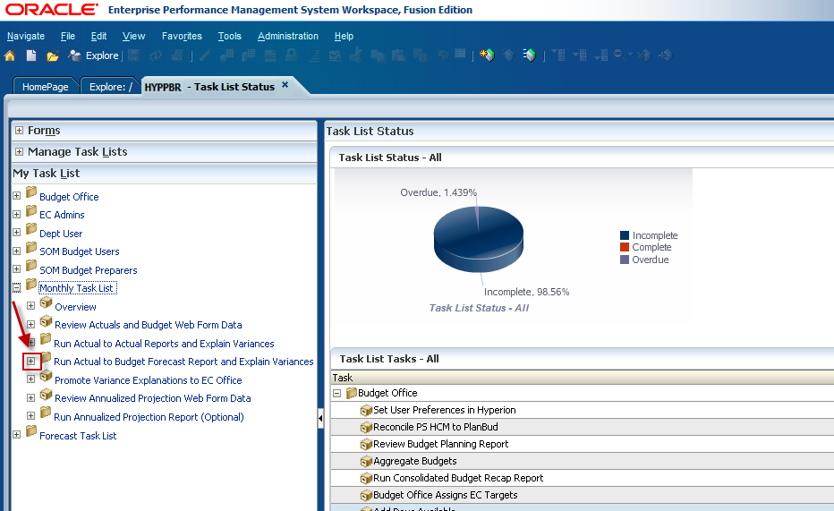
Double click on Run Consolidated Practice Plan Report.
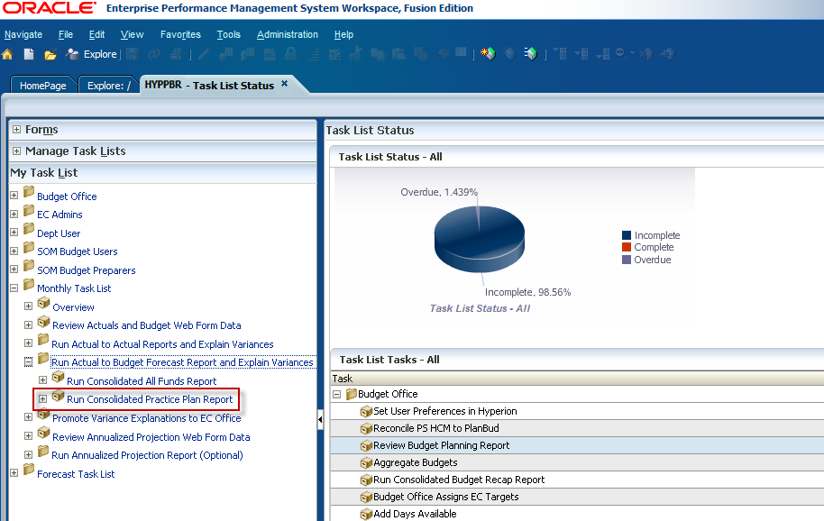

The Point of View window will appear and allow users to input the member selection criteria. Notice that there is NOT an option to select a fund. This report defaults to return data for Practice Plan funds only. Click on the Select button next to the Entity member box to begin selecting your Entity and PID members.
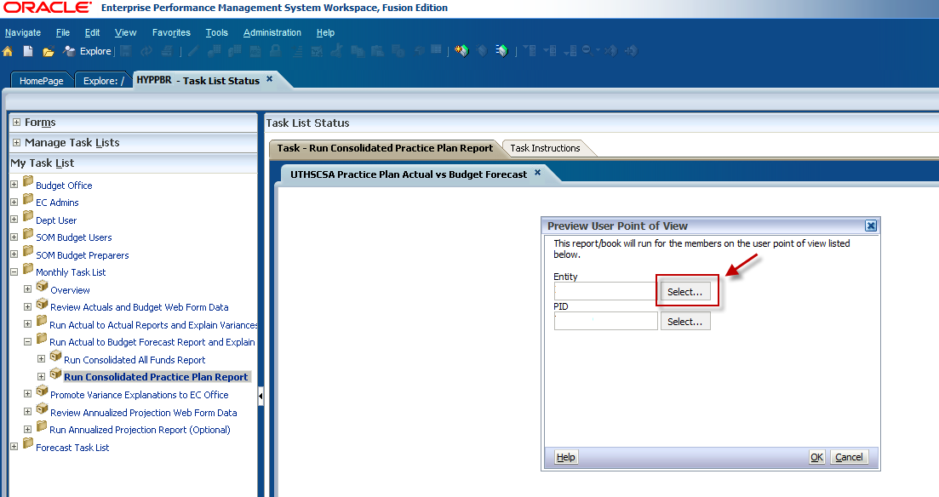

First, select the maximum amount of Rows Per Page using the dropdown menu. This will allow for all information to be visible when you to expand the folders.

Expand the Entity folder by clicking on the plus sign.

Expand the X9999- UTHSCSA Roll-Up folder.

This will open the next Entity hierarchy level which is the Executive Committee (EC) roll-up level. Again, we will run the report for the M1800 Roll-Up. M1800 will be nested in the M1000-SOM Roll-Up folder. Expand the XM100 folder by clicking on the plus sign.

Use the scroll bar to navigate through the list. When you have found the intended Entity, click the radio dial button to make your selection and click OK.

If you would like to run the report for an individual department, continue expanding the folders to see the lowest entity level. Use the scroll bar to find the intended entity, click the radio dial button to make your selection, and click OK.

You will be directed back to the Point of View window. Next make a Project ID selection by clicking on the Select button next to the PID member box.

Select the maximum amount of Rows Per Page using the dropdown menu. This will allow for all information to be visible when you to expand the folders.

Click on the plus sign to expand the PID folder.

To run the report for ALL PIDs select the radio dial button next to Total PID and click OK.

To run the report for a specific Project ID expand the Total PID folder and use the scroll bar to locate the PID. Click the radio dial button to select it, and then click OK.

You will be directed back to the Point of View Window. Confirm that your member selections are correct and click OK.

A new window will appear prompting you to select a Practice Plan group and a reporting period. The report defaults to run for ALL practice plan funds, and for the most recent closed reporting period.
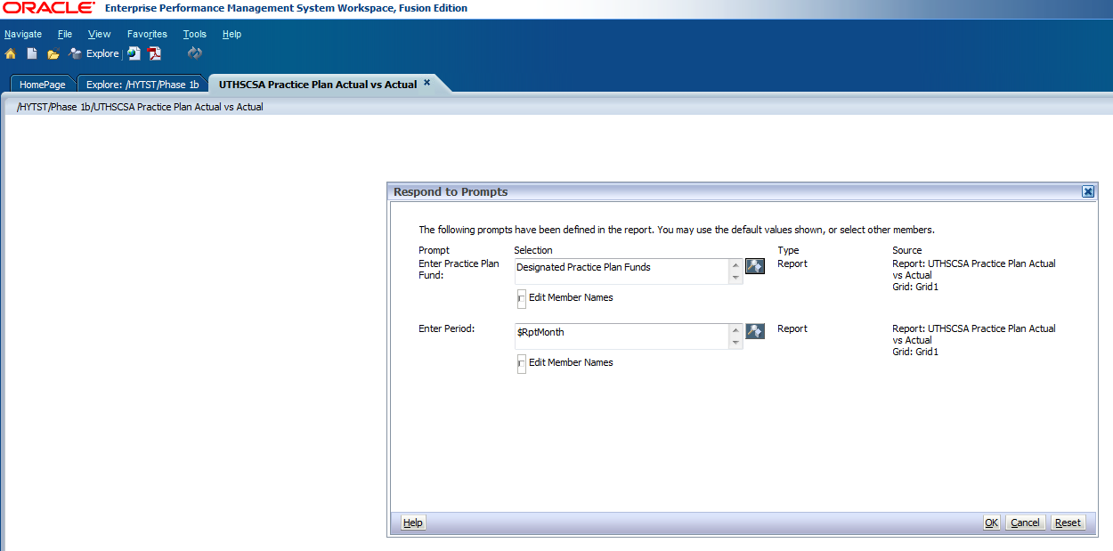

To change the fund criteria, click on the icon to the right of the fund member box.

Use the arrows to remove Practice Plans from the selection box. Then check the box for the desired practice plan group. Use the arrow button to move it to the selection box and click OK.

To change the reporting period, click on the icon next to the Period box.

Use the arrow button to remove the default reporting period from the selection box. Then select the intended reporting period and use the arrow button to move it to the selection box. Click OK.

You will then return to the Respond to Prompts window. Confirm that the criteria are correct and click OK.

The HTML version of the Actual to Budget Forecast Practice Plan report will appear in your window. Like the All Funds Actual to Budget Forecast report, click on the arrows next to the line item categories to drill-down to see the supporting detail. The only difference between the Practice Plan report and the All Funds report is the way the accounts are grouped. As previously mentioned, the categorization of the Practice Plan report is required by UT System. At this point the HTML report can be exported to Excel by following the steps in the Export a report to Excel section. Keep in mind that for detail to be exported to Excel it must first be expanded in the HTML format.

Interpreting the Actual to Budget Forecast reports

The Budget-to-Actual report is presented in the same Profit and Loss (or P&L) format displaying the same revenue and expenses categories, and calculating Margin and Change in Net Position similar to the Actual-to-Actual report. In addition, all of the PeopleSoft general ledger account codes for revenues and expenses have been grouped into one of these line items. Refer to the Hyperion SharePoint site for a listing of the P&L account code groupings.
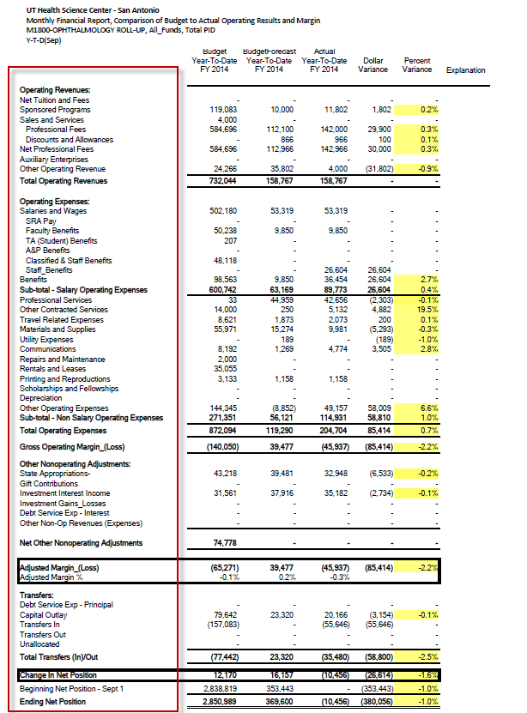

The information in this report consists of both budget and actual data. The data in the Budget column feeds from the ORIGINAL budget entries recorded during the budget cycle by budget category as of the month close for a given reporting period.
The second column shows the ADJUSTED budget by category for the same reporting period. This data feeds from entries recorded during the Forecasting Process which will be discussed in detail in a separate training document.
The third column shows actual activity that feeds from PeopleSoft by category and for the same reporting period.
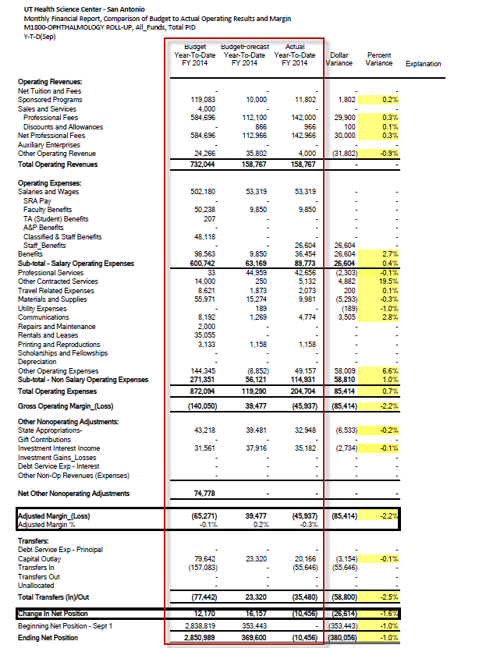

Variances are calculated by comparing actual activity to the adjusted budget. Variances are presented in both dollar amount and percentage, with those exceeding the 10% threshold and requiring explanation being highlighted in yellow.
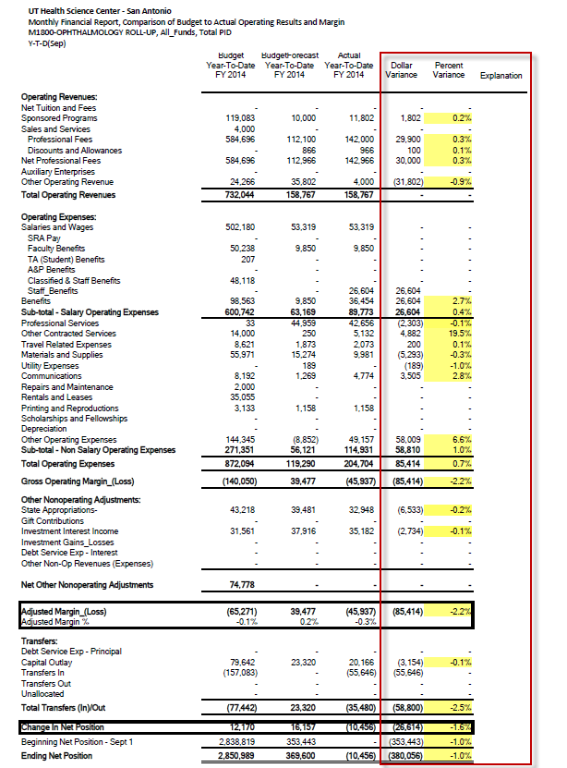

While it is important to investigate significant line item variances, it’s imperative to understand how the information from this report is different from and can be used in conjunction with the Actual-to-Actual report in analyzing financial outcomes.
The Actual-to-Actual report compares your financial performance to the prior year. But how you operated last year may not be relevant to how you planned to operate in the current year. The Budget-to-Actual report will indicate whether you are on track towards meeting your financial goals.
Analyzing the Adjusted Margin and Change in Net Position are just as critical so that management can fully identify the driving forces propelling them beyond their goals, which will allow for unplanned investments, or the obstacles that may require behavioral changes, like reducing expenses.
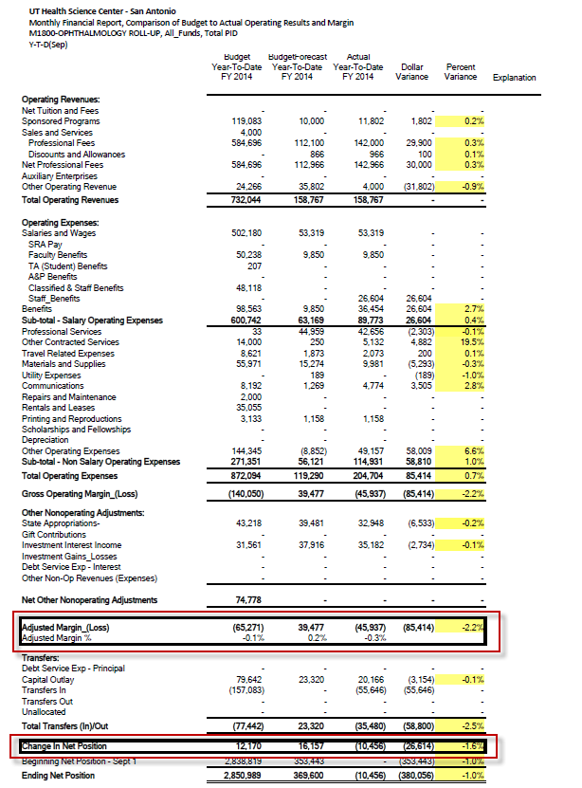

Interpreting the Actual to Budget Forecast report for Practice Plan Funds:
Here is an example of the Budget-to-Actual Practice Plan report. You will see that it is very similar to the All funds Actual-to-Budget Forecast report. The same data is being pulled in, and the variances are calculated the same way. The only difference with this report is the way the accounts are grouped. As previously mentioned, the categorization of the Practice Plan report is required by UT System.
The same attention and considerations should be given to the Adjusted Margin and Change in Net Position as with the previously discussed All Funds report.
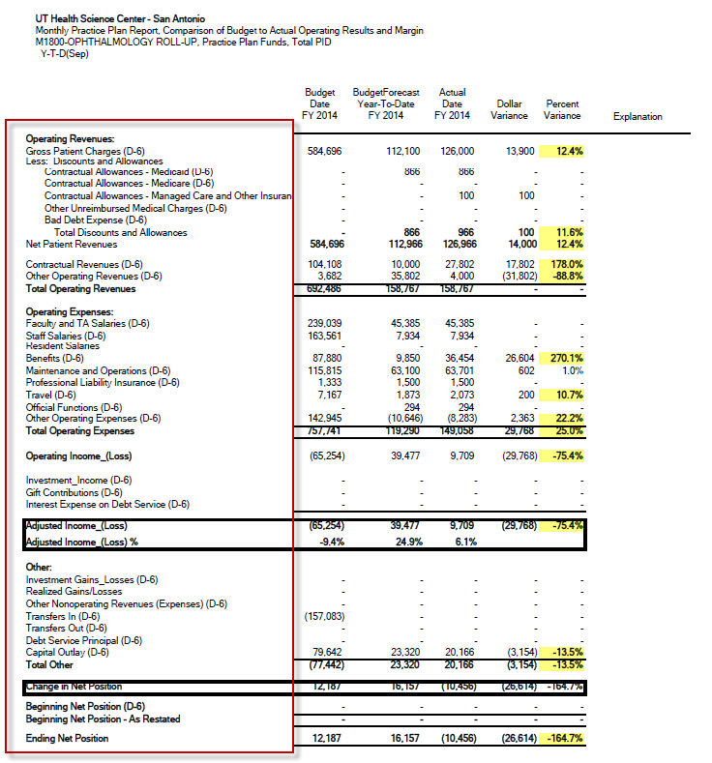

Annualized Projection report

- Annualized projection is a calculated estimate of how balances for a specified criteria will end at the close of the fiscal year based on the collection rate of revenues and the spend rate of expenses at a particular point in time.
- Does not account for known occurrences that may happen between now and fiscal year end.
- No variance is calculated, and no variance explanation is required.

Steps to run the Annualized Projection All Funds report

Log in to Hyperion and click on Explore.

This will open a new tab labeled Explore.

Expand the HYPPBR folder.

Expand the Financial Reports folder.

Expand the Institution folder.

Double click on the Reporting folder to open the list of reports.

Be sure to leave this tab open with the Reporting folder expanded as you work in Hyperion. You will later navigate back to this tab to export reports to Excel. Refer to the Exporting a Report to Excel section for step by step instructions.

Navigate back to the HomePage tab and click on HYPPBR.
Navigate to the Monthly Task List by first clicking the plus sign next to My Task List.
Expand the Monthly Task List

Click on the plus sign next to Run Annualized Projection Report (Optional) to further expand the task list.
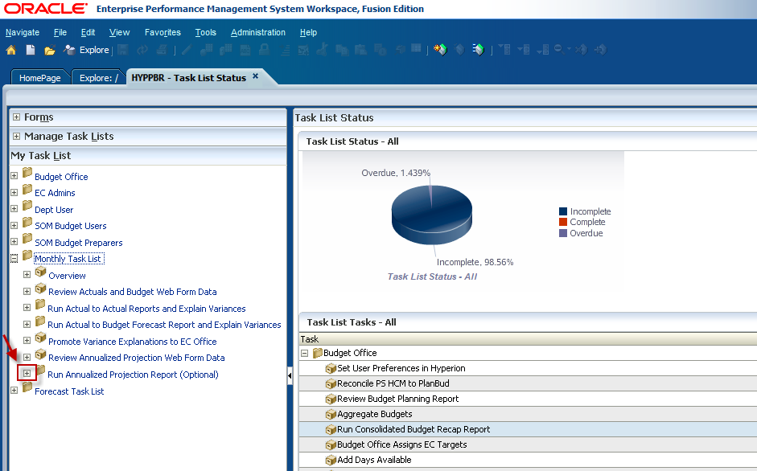
Double click on Run Consolidated All Funds Report.
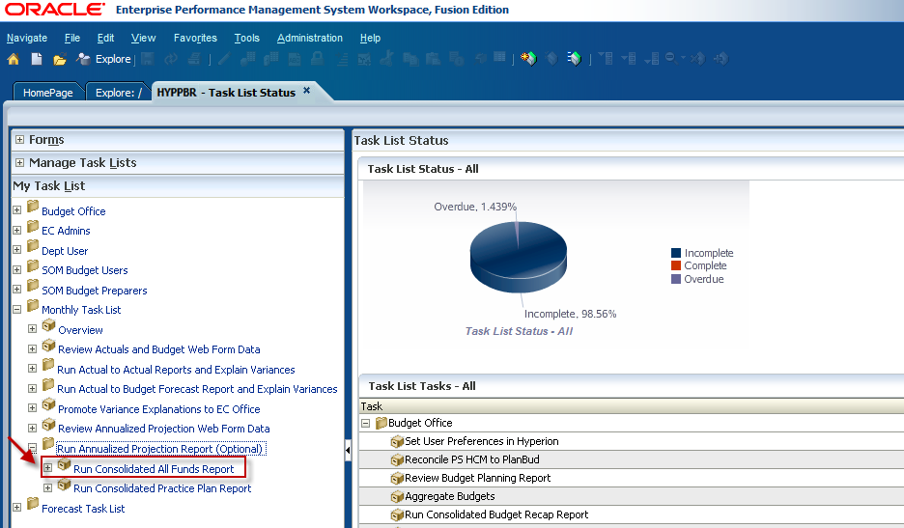

The Point of View window will appear and allow users to input the member selection criteria. Click on the Select button next to the Fund member box.
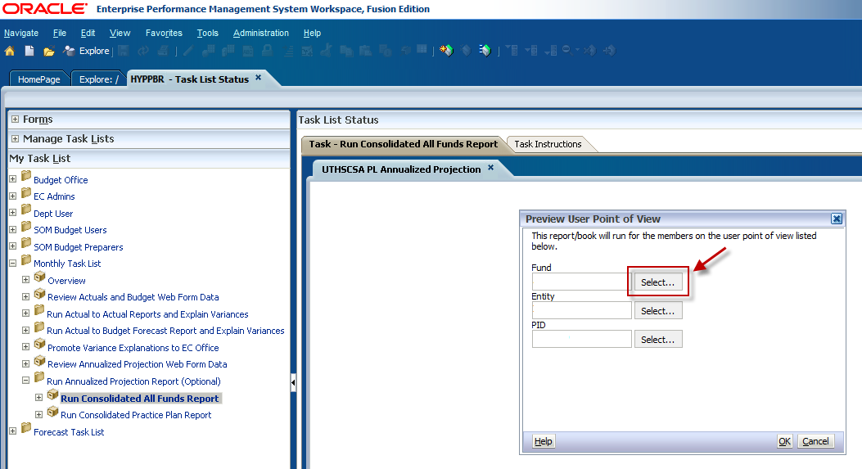

Expand the Fund folder by clicking on the plus sign.
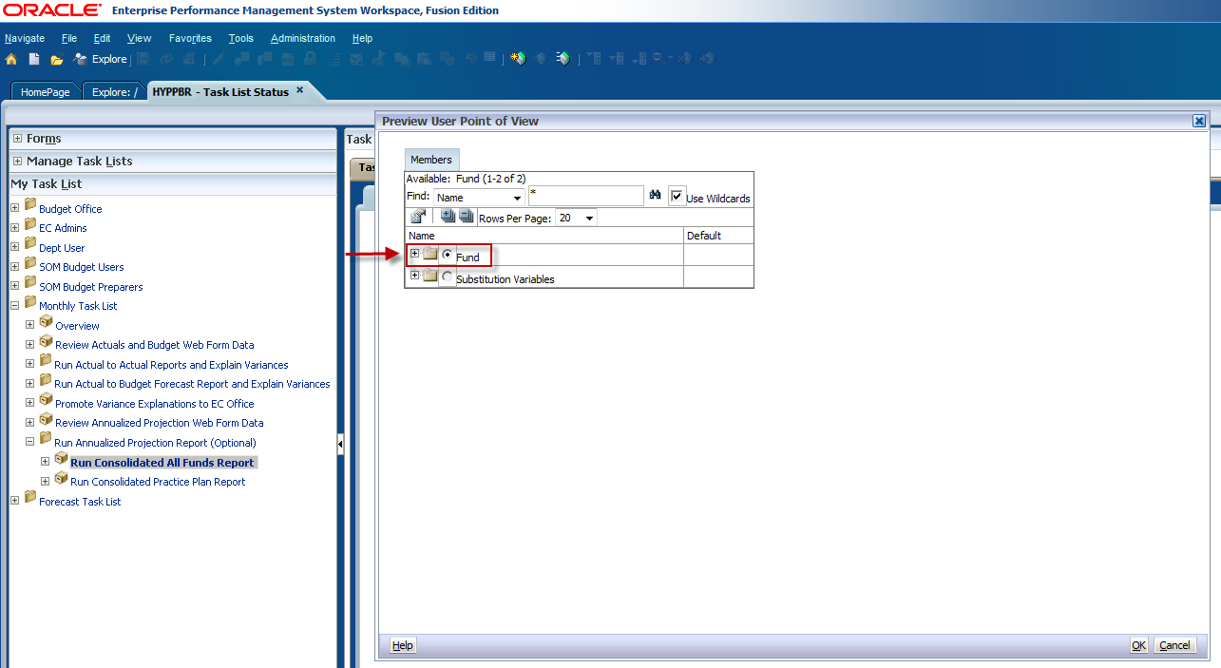

To run the report for all fund groups click the radio dial button next to All Funds and click OK. However; if you would like to specify a fund or run the report for a consolidated fund group, click the plus sign to expand the All Funds folder.
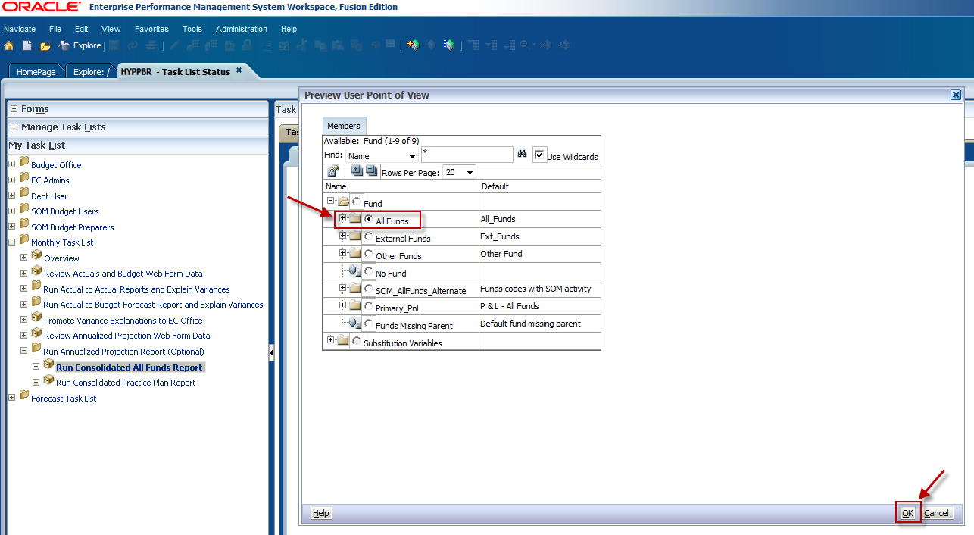

You will see the first level of consolidated fund groupings nested under All Funds. If you would like to run a report for a specific fund group, for example Practice Plans, expand the Designated Funds folder.
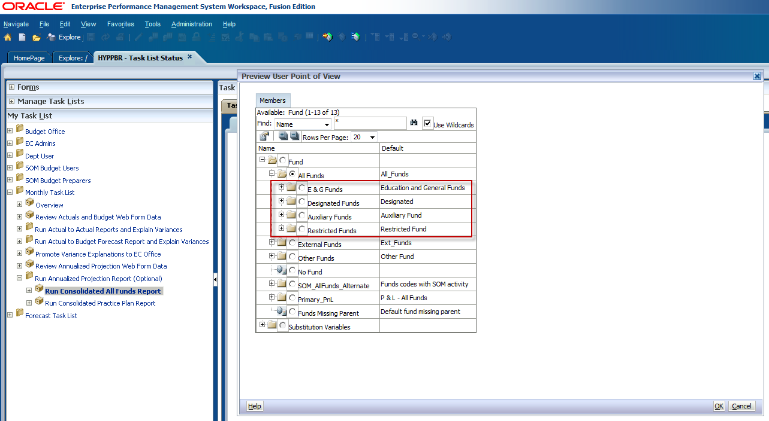

You will see the next level of consolidated fund groupings nested under Designated Funds.
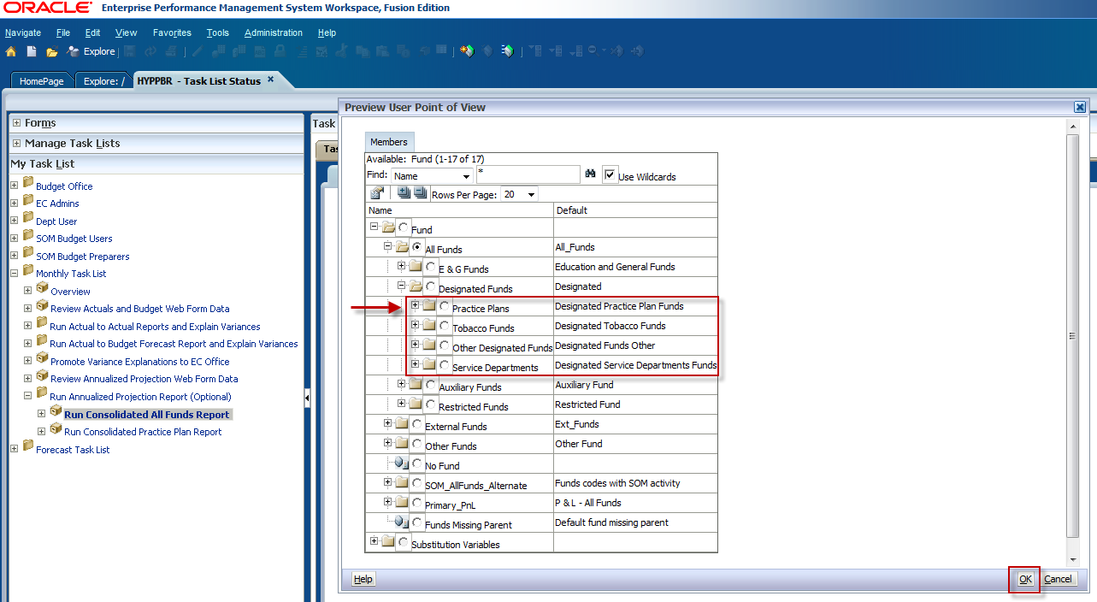

If you would like to run the report for a specific fund, continue expanding the folders until you see the lowest fund level. Make your selection by clicking the radio dial button and click OK.
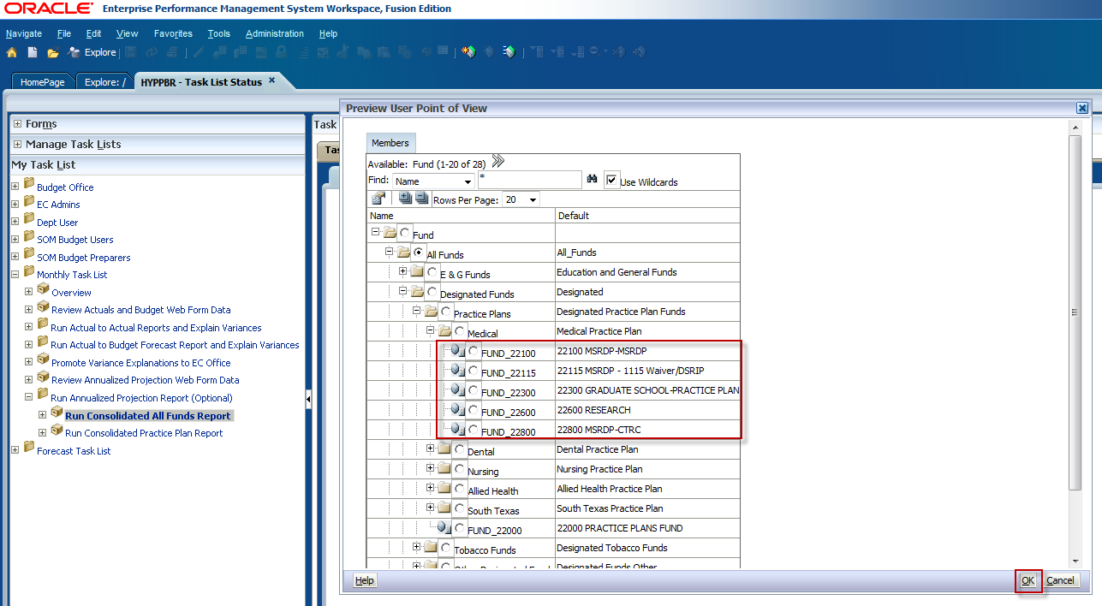
To select an individual fund group you can also utilize the search box. Type FUND_ and the fund group you would like to search, for example, FUND_22100. The asterisk must be first in order to complete the fund search. Then click the binocular icon to the right of the search box.
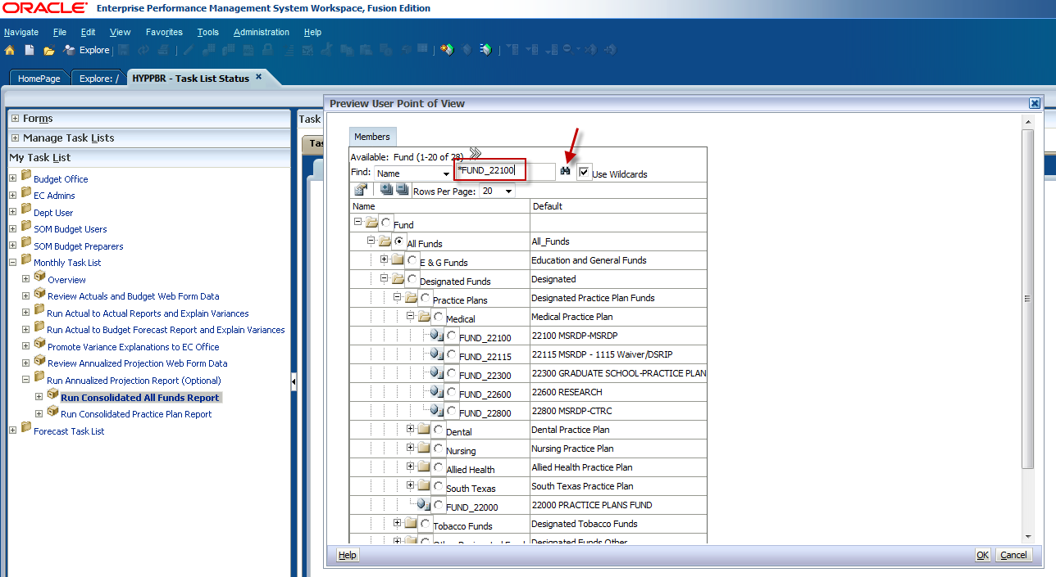

Click OK.
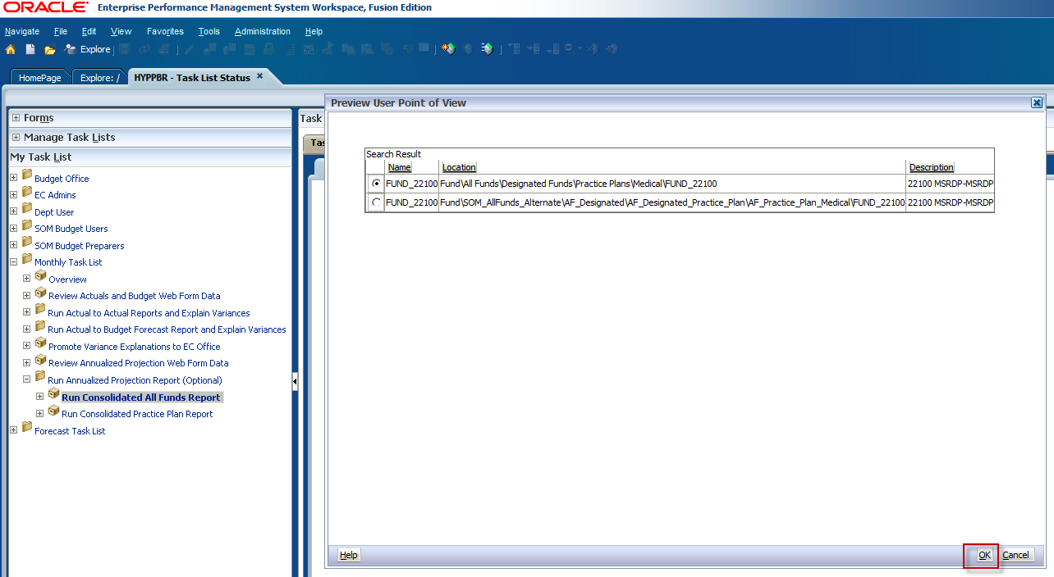

The fund group will be automatically selected. Click OK.
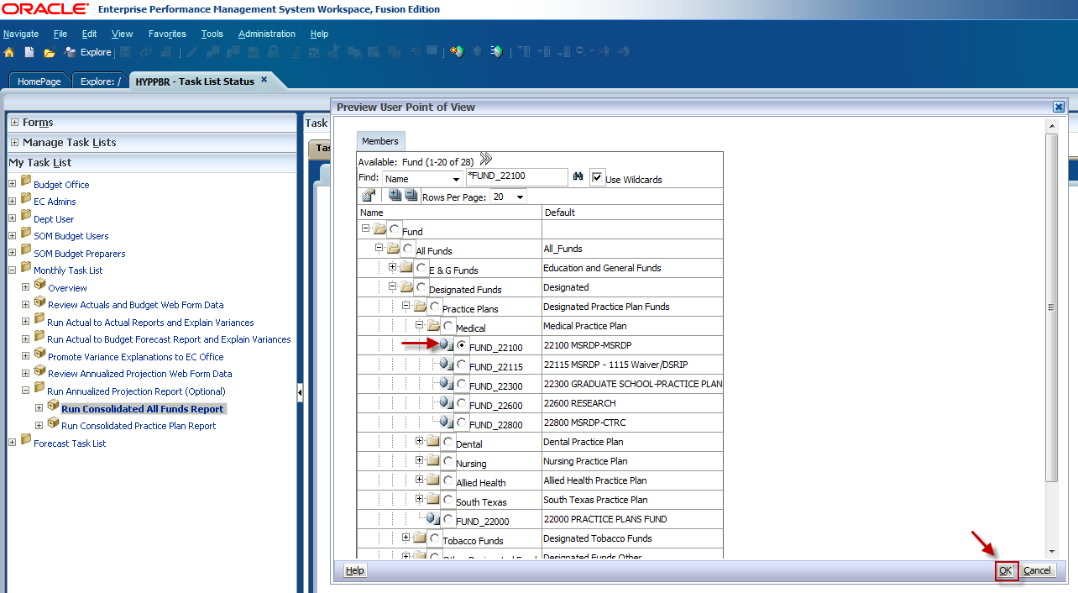

Click the Select button next to the Entity member box.
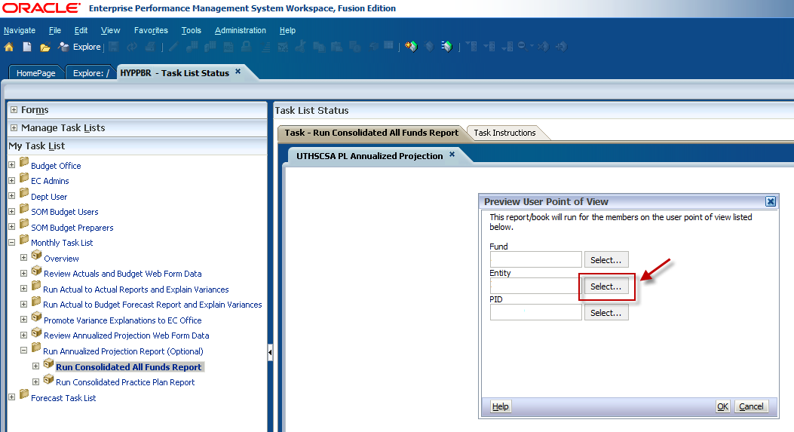

Expand the Entity folder.
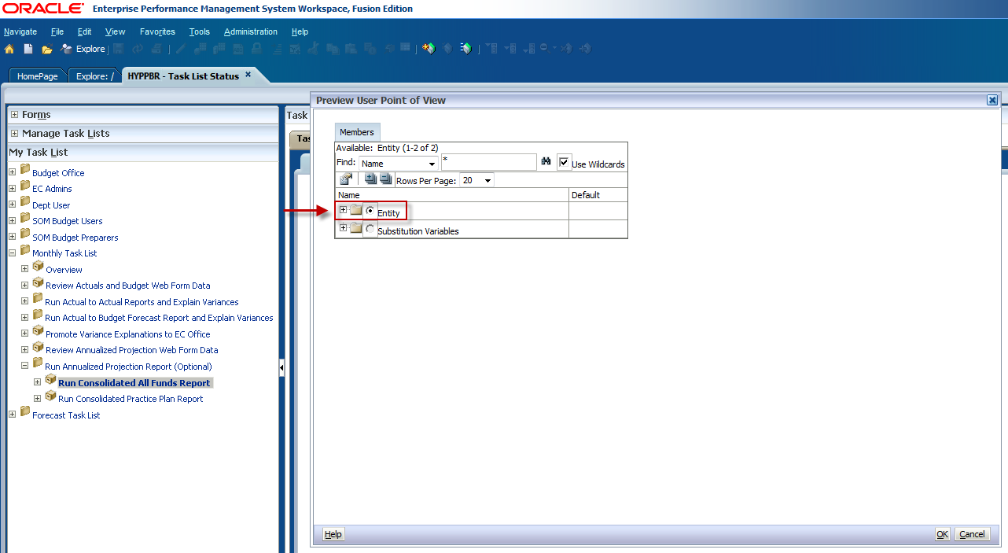

Expand the X9999- UTHSCSA Roll-Up folder.
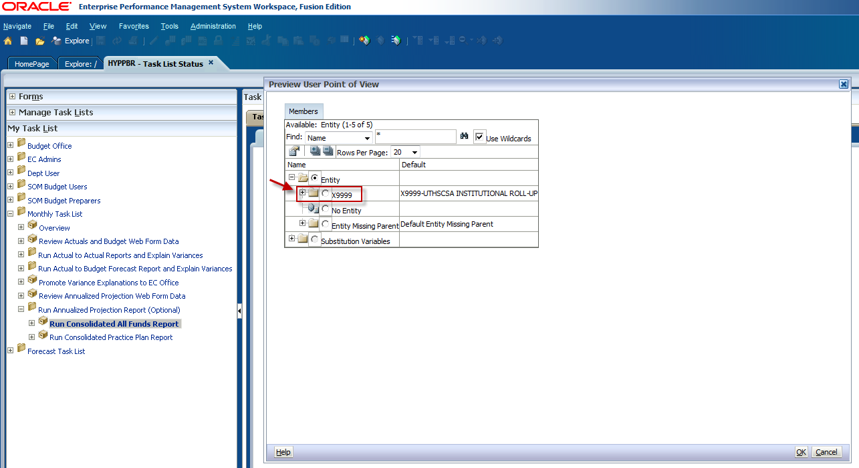

This will open the next Entity hierarchy level which is the Executive Committee (EC) roll-up level.
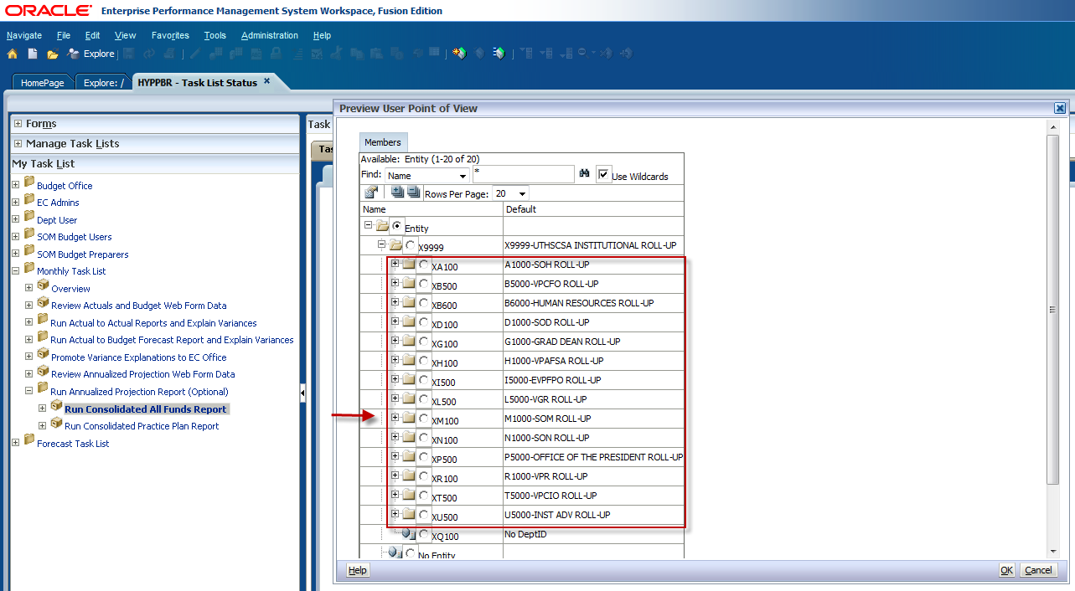

Expand the EC roll-up folder to see the next Entity roll-up level.
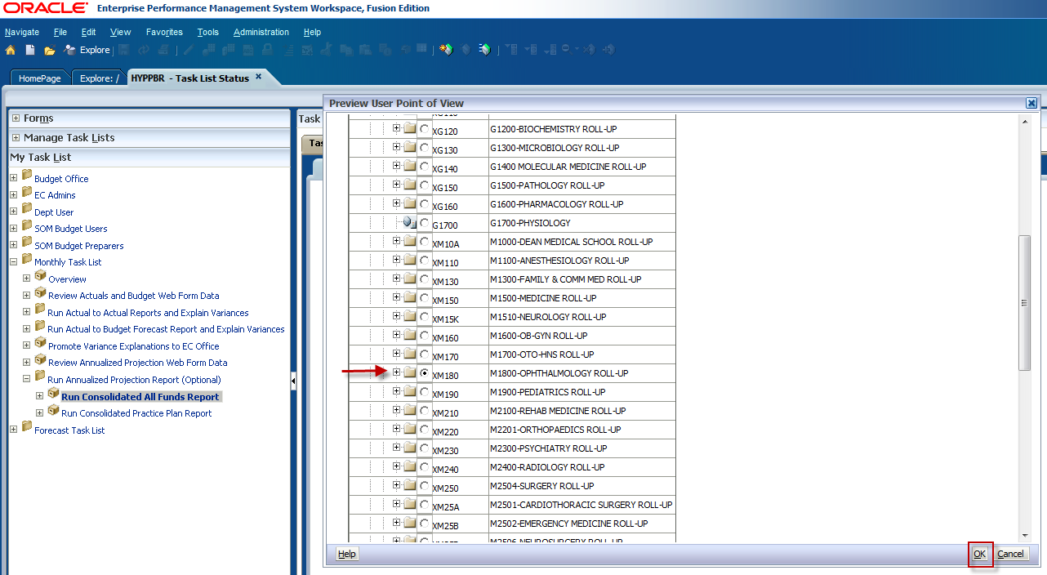

Continue expanding the folders if you would like to run the report for an individual Dept. ID. Use the scroll bar to locate the intended entity, click the radio dial button to make your selection, and click OK.
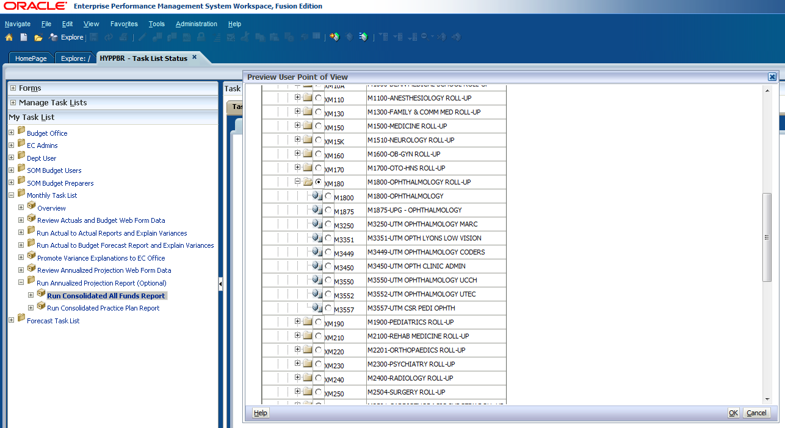

Finally, make a Project ID selection by clicking on the Select button next to the PID member box.
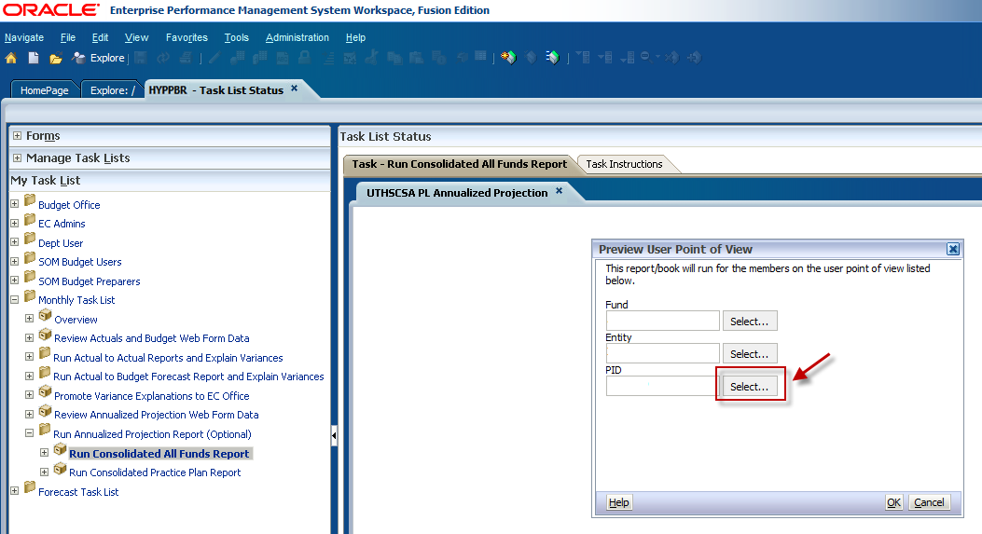

Expand the PID folder.
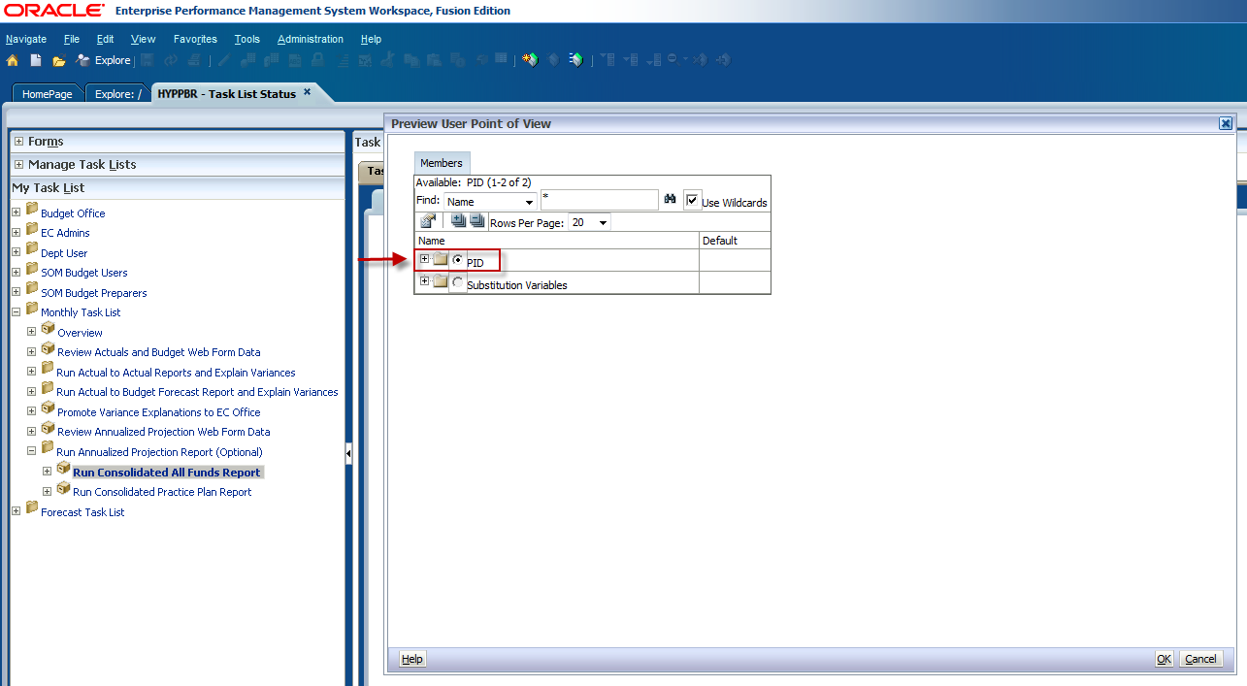

To run the report for ALL PIDs select Total PID and click OK.
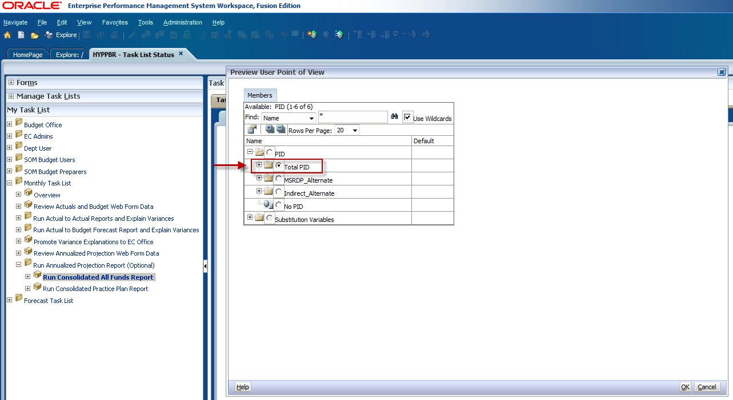

To run the report for a specific Project ID expand the Total PID folder and use the scroll bar to locate the PID. Keep in mind that the number of rows per page may need to be increased for all projects to be visible.
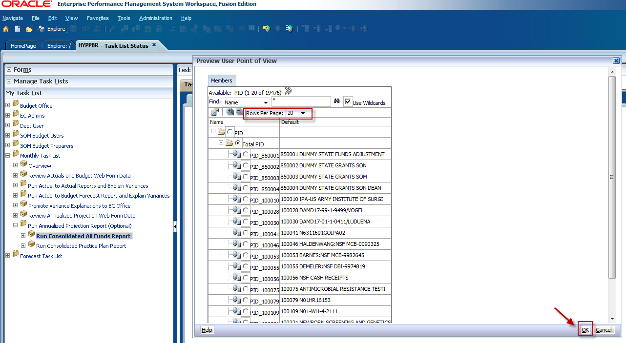

Confirm your member criteria and click OK on the Point of View window.
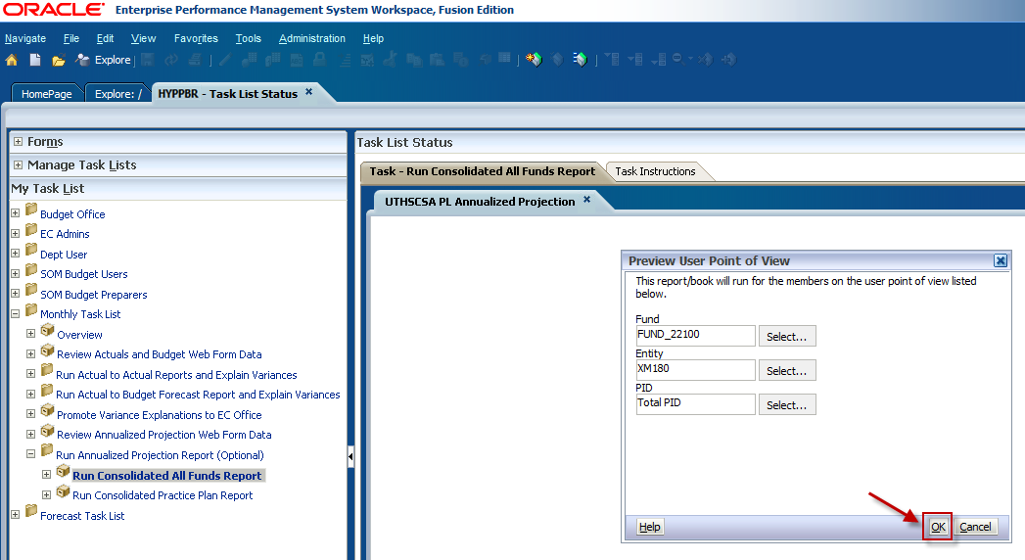

A new window will appear prompting you to confirm the reporting period. The most recent closed reporting period is selected by default. If you would like to run the report for the most recent closed reporting period, click OK. To change the reporting period, click on the icon to the right of the Selection box.
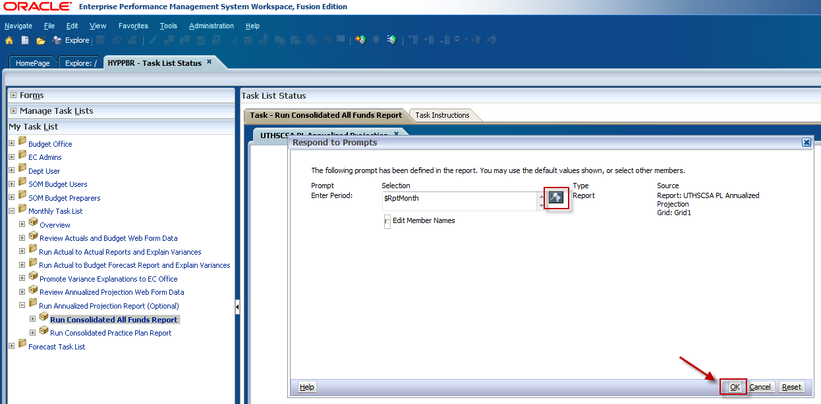

The current reporting period needs to be removed from the Selection list. Click the check box next to $RptMonth. Then click the left facing arrow button.
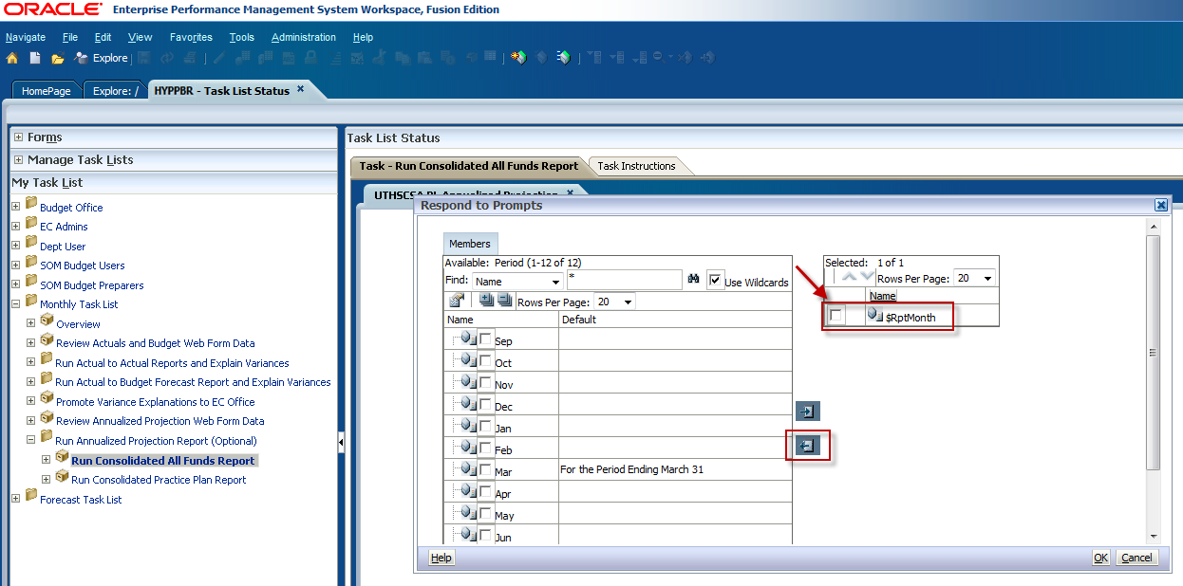

To select a period, click the checkbox to the left of the month abbreviation. In this example we will run the report as of November. Click the icon with the arrow facing right to add it to the Selection list.
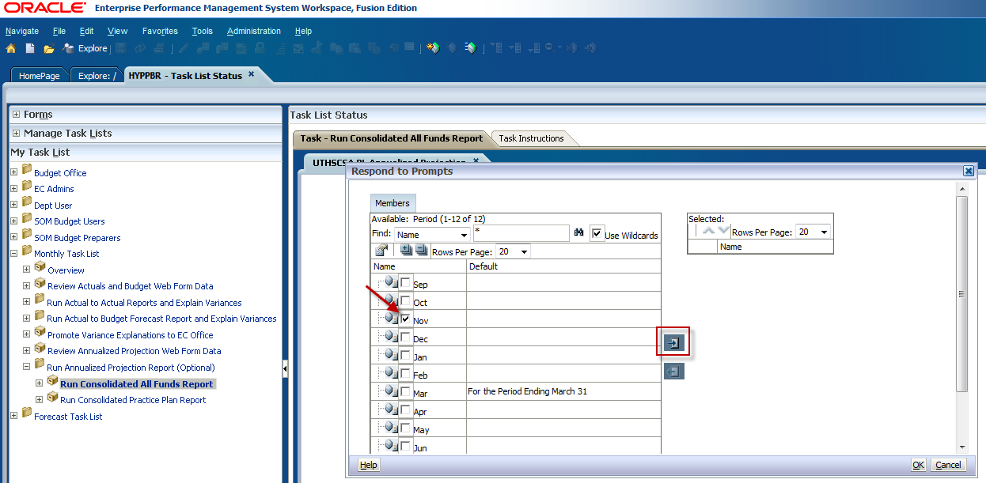

You will see that the month you selected now appears in the Selection list. Click OK
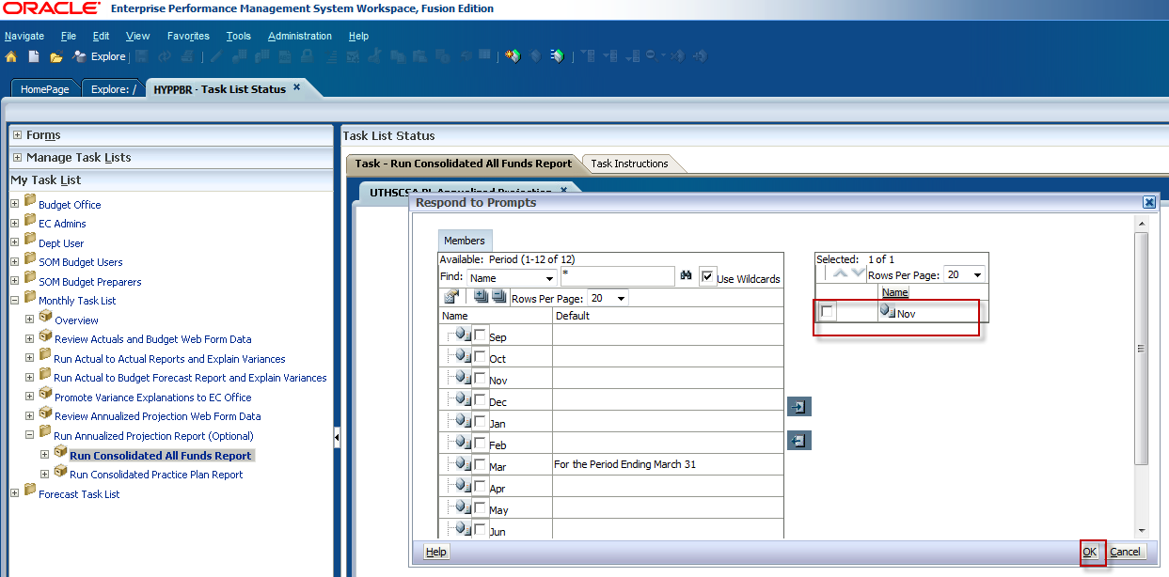

You will be taken back to the Respond to Prompts window. Confirm that the correct reporting period is selected and click OK.
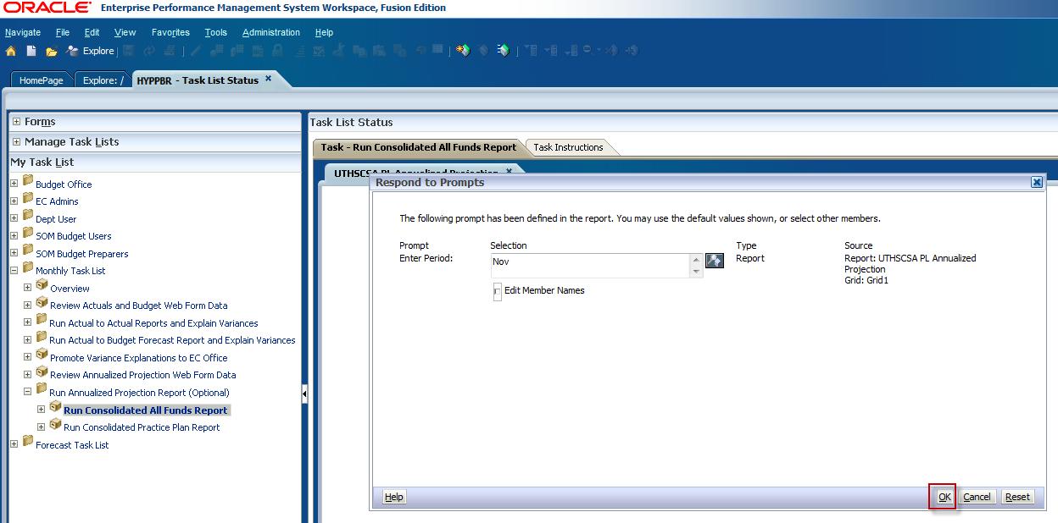

The HTML version of the Annualized Projection report will appear in your window. Like the Actual to Actual and the Budget to Actual reports, click on the arrows next to the line item categories to drill-down to see supporting detail.
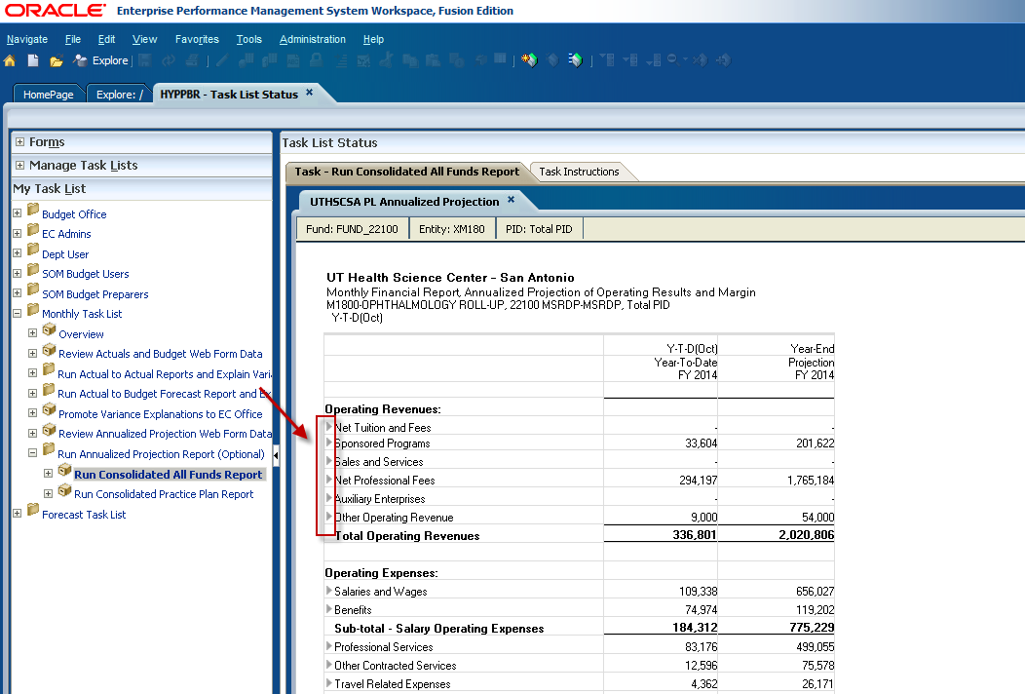
In the below example we have expanded the line item Net Professional Fees to see the supporting detail consisting of Professional Fees and Discounts and Allowances. Continue expanding the arrows to see the sub-levels of detail. At this point the HTML report can be exported to Excel by following the steps in the Export a report to Excel section. Keep in mind that for detail to be exported to Excel it must first be expanded in the HTML format.
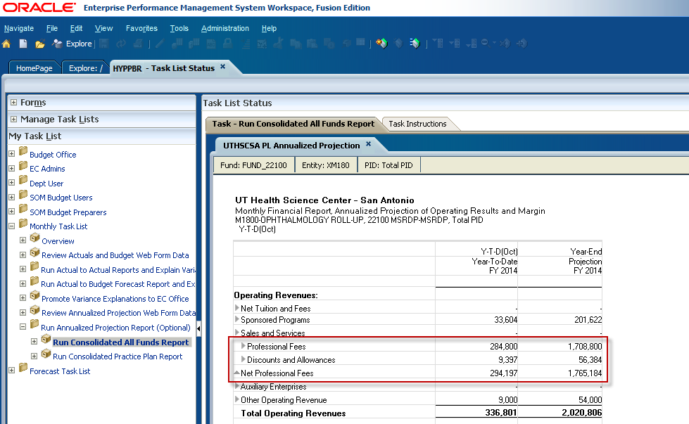

Steps to run the Annualized Projection Practice Plan Report

Log in to Hyperion and click on Explore.
This will open a new tab labeled Explore.

Expand the HYPPBR folder.

Expand the Financial Reports folder.

Expand the Institution folder.

Double click on the Reporting folder to open the list of reports.

Be sure to leave this tab open with the Reporting folder expanded as you work in Hyperion. You will later navigate back to this tab to export reports to Excel. Refer to the Exporting a Report to Excel section for step by step instructions.

Navigate back to the HomePage tab and click on HYPPBR.
Navigate to the Monthly Task List by first clicking the plus sign next to My Task List.

Expand the Monthly Task List

Click on the plus sign next to Run Annualized Projection Report (Optional) to further expand the task list.
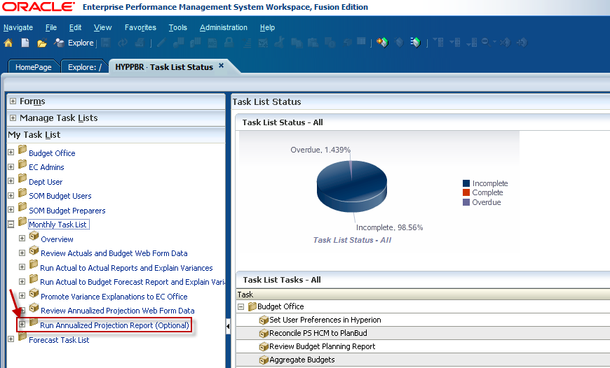

Double click on Run Consolidated Practice Plan Report.
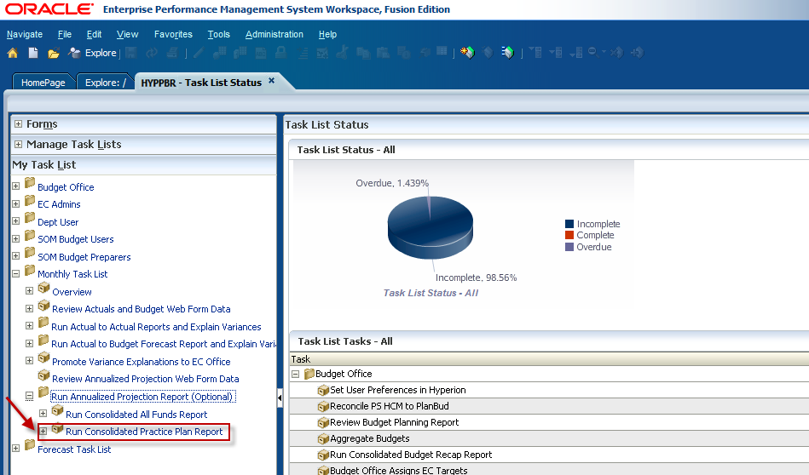
The Point of View window will appear and allow users to input the member selection criteria. Notice that there is not an option to select a fund. This report defaults to return data for Practice Plan funds only. Click on the Select button next to the Entity member box to begin selecting your members.
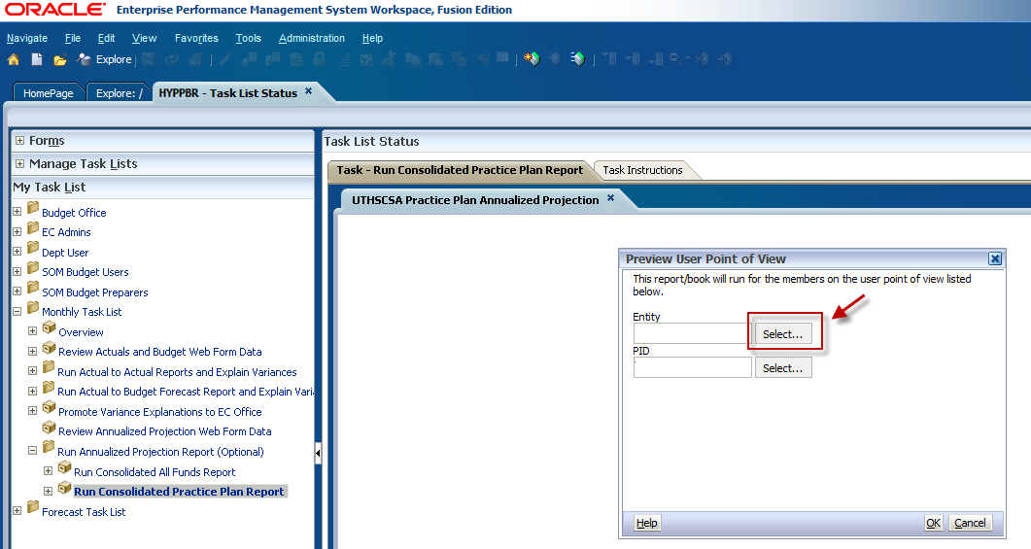

Expand the Entity folder by clicking on the plus sign.
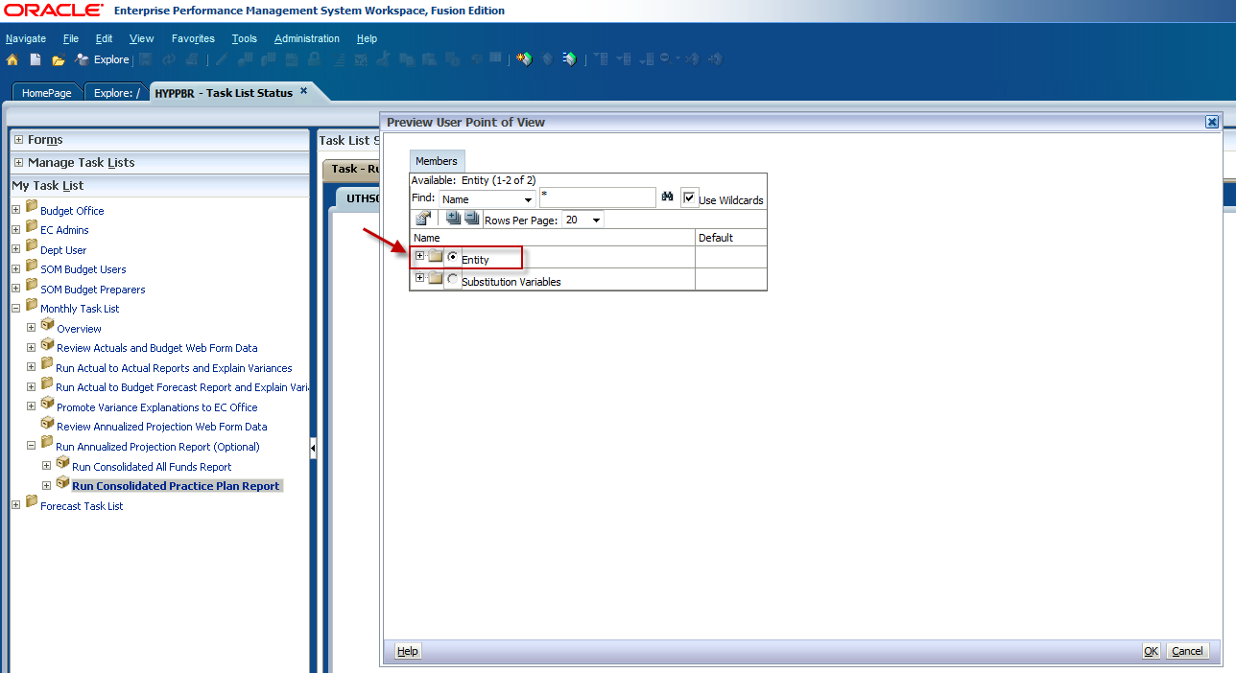

Expand the X9999- UTHSCSA Roll-Up folder.
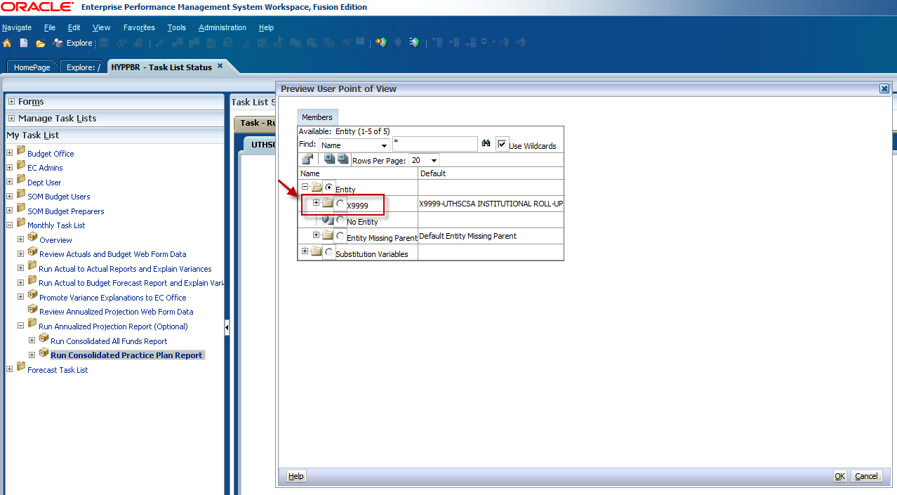

This will open the next Entity hierarchy level which is the Executive Committee (EC) roll-up level. Again, we will run the report for the M1800 Roll-Up. M1800 will be nested in the M1000-SOM Roll-Up folder. Expand the XM100 folder by clicking on the plus sign.
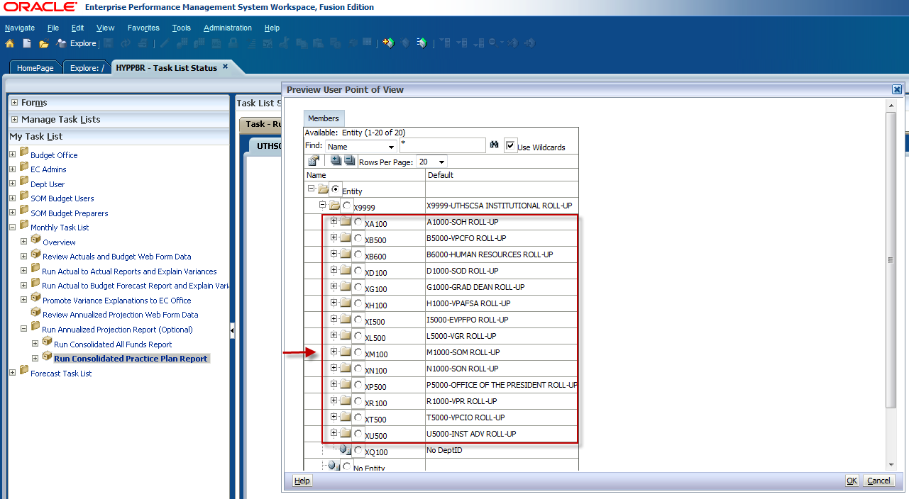

Use the scroll bar to navigate through the list. When you have found your Entity, click the radio dial button to make your selection and click OK. Keep in mind that the amount of rows per page may need to be increased for all information to be visible.
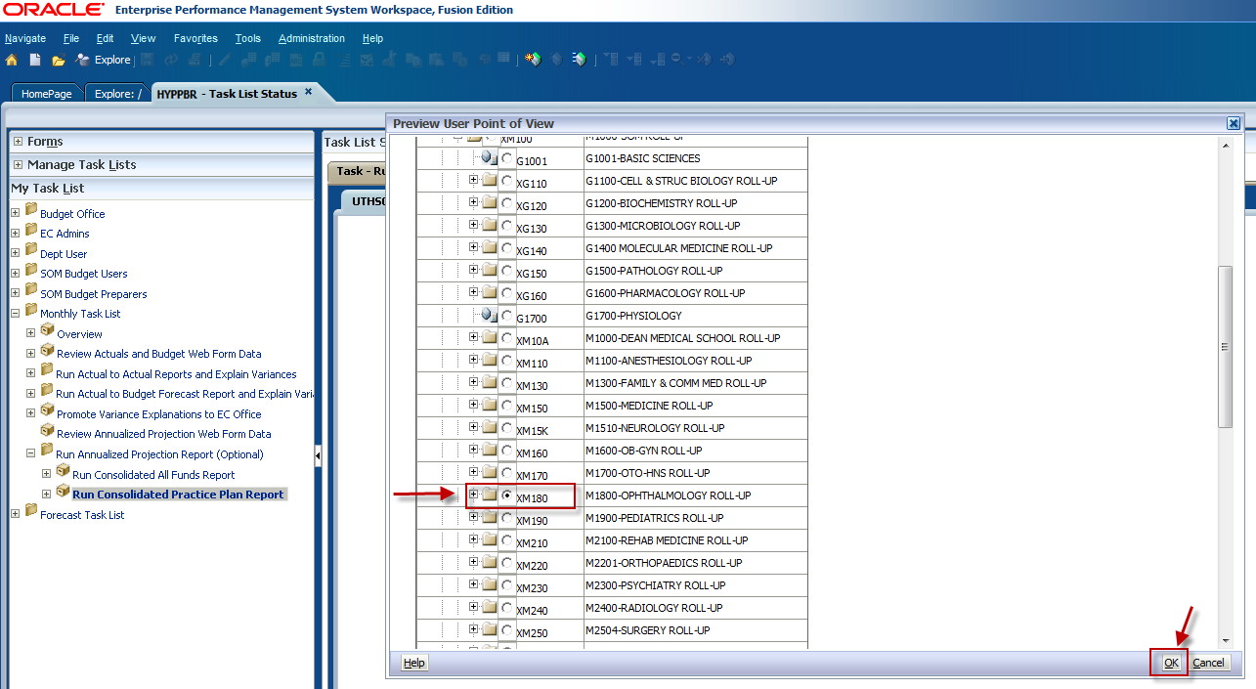
If you would like to run the report for an individual department, continue expanding the folders to see the lowest entity level. Use the scroll bar to find the intended entity, click the radio dial button to make your selection, and click OK.
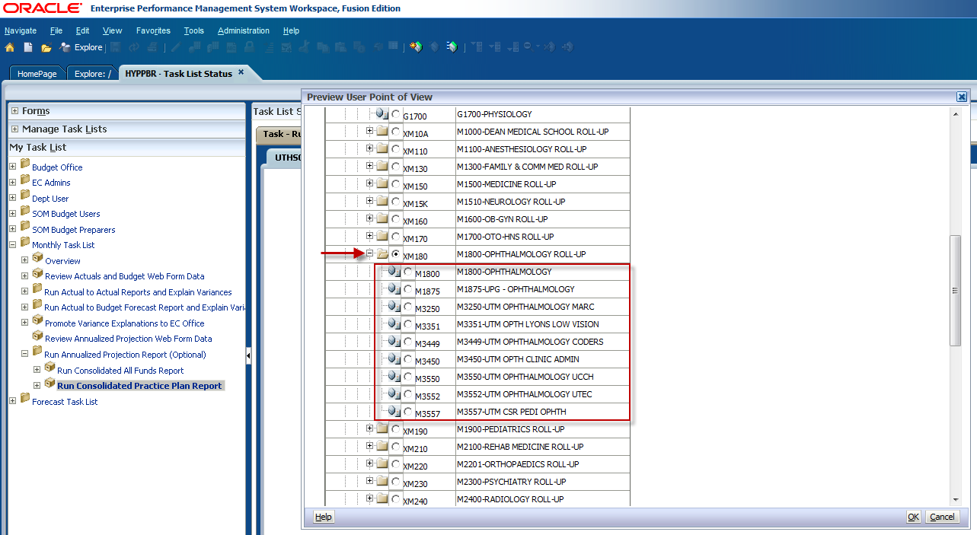

You will be directed back to the Point of View window. Next make a Project ID selection by clicking on the Select button next to the PID member box.
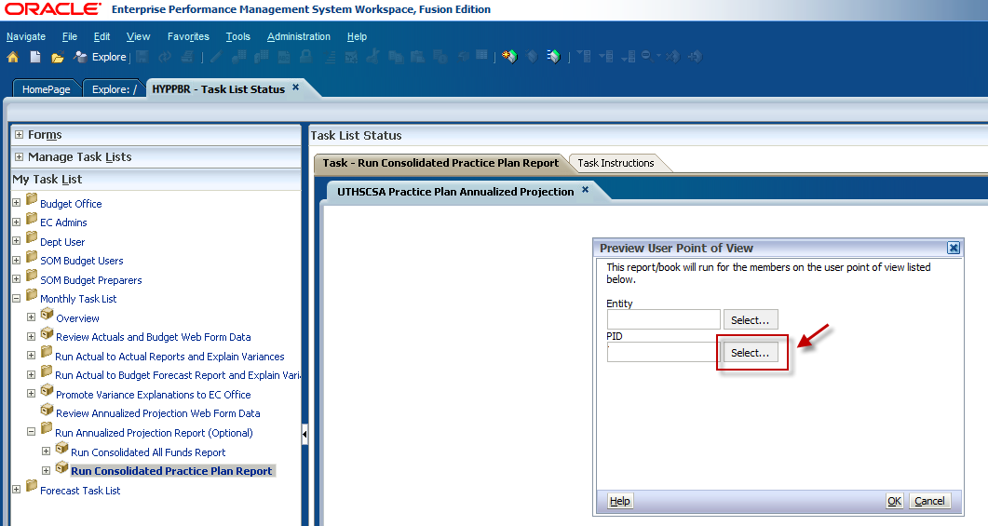

Click on the plus sign to expand the PID folder.
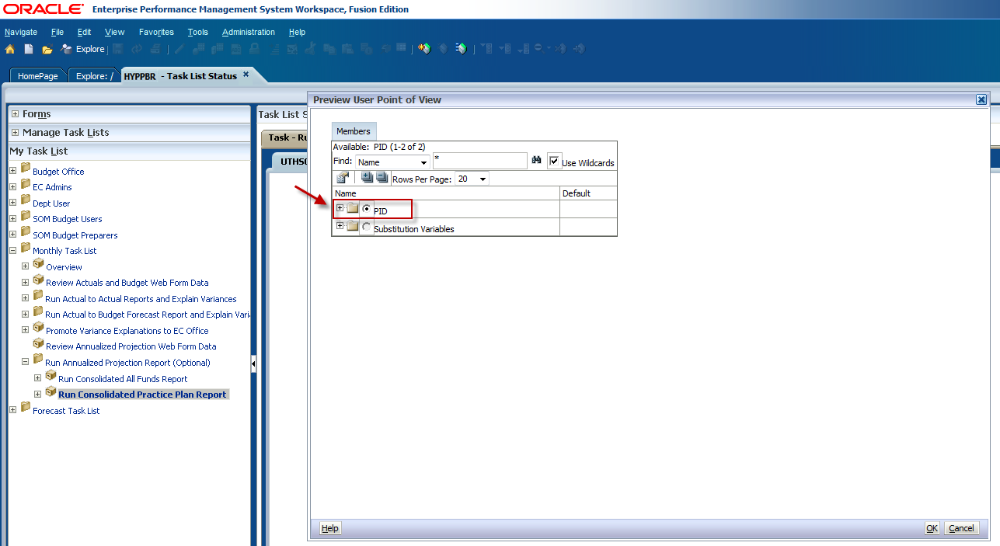

To run the report for ALL PIDs select the radio dial button next to Total PID and click OK.
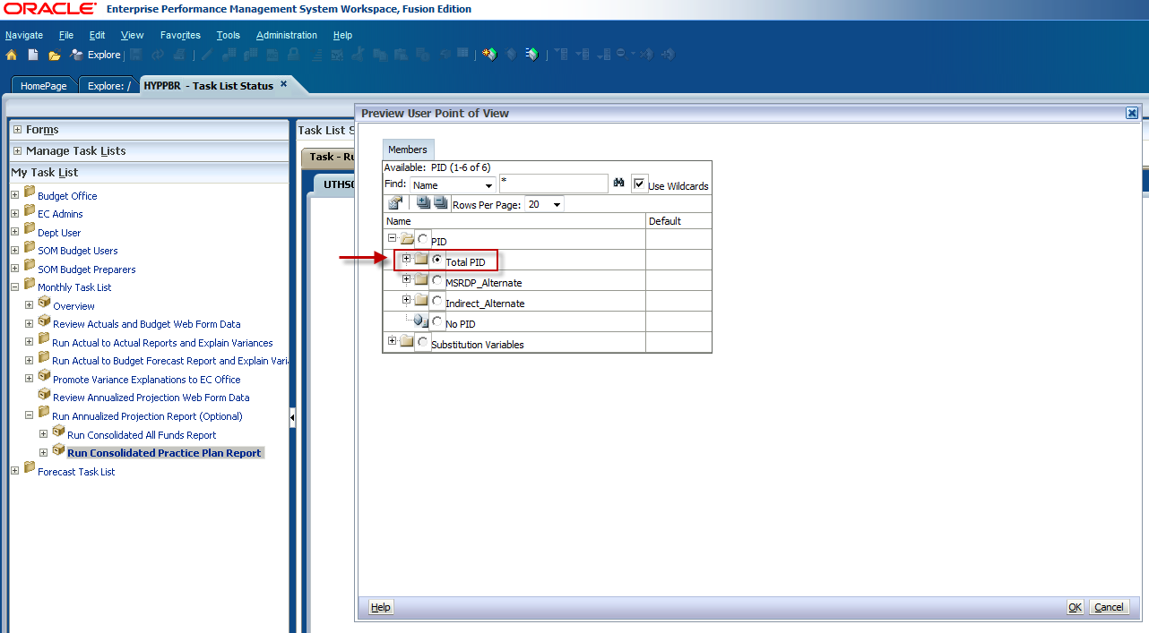

To run the report for a specific Project ID expand the Total PID folder and use the scroll bar to locate the PID. Keep in mind the amount of rows per page may need to be increased for all information to be visible. When you have located your PID, click the radio dial button to select it, and click OK.
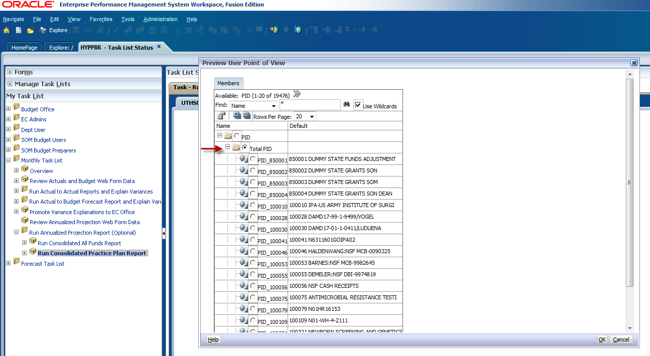

You will be directed back to the Point of View Window. Confirm your member selections and click OK.
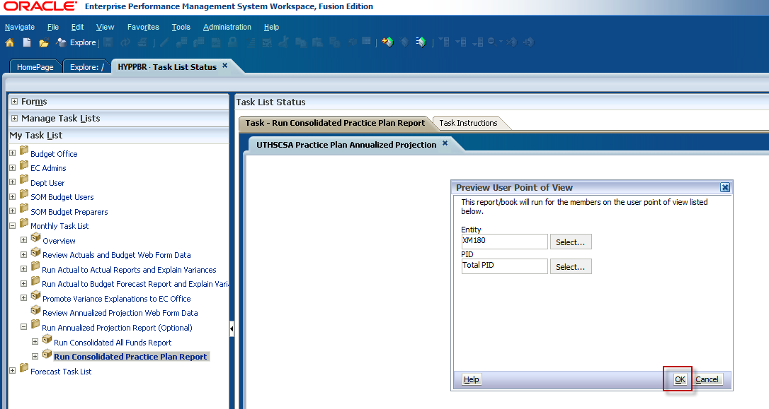

A new window will appear prompting you to select a Practice Plan group and a reporting period. The report defaults to run for ALL practice plan funds, and for the most recent closed reporting period.
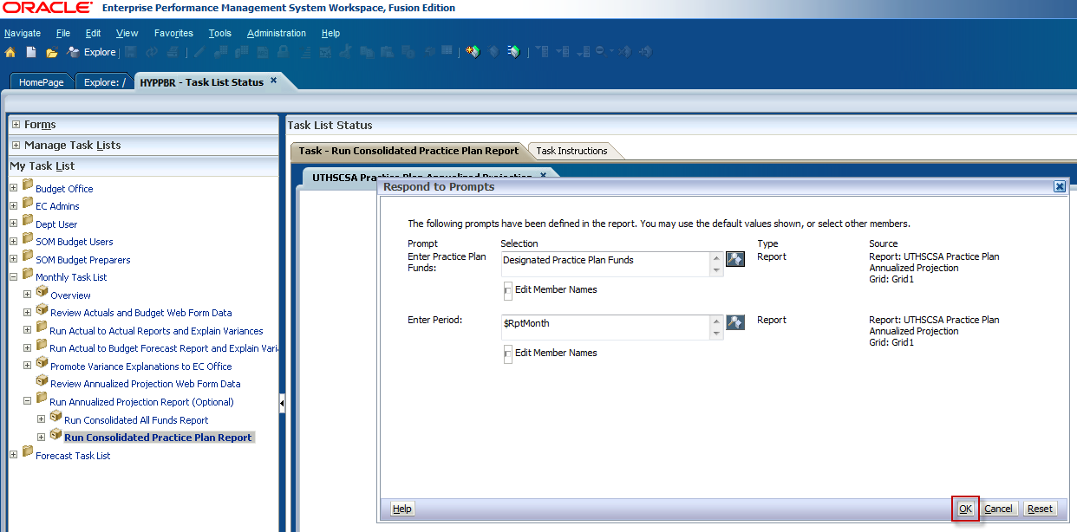

If you need to change the fund criteria, click on the icon to the right of the fund box.
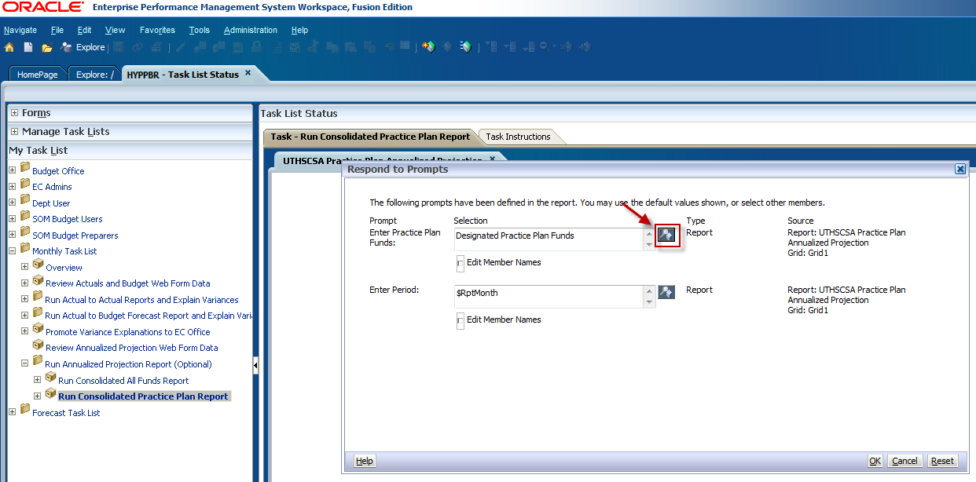

Use the arrows to remove Practice Plans from the selection list.
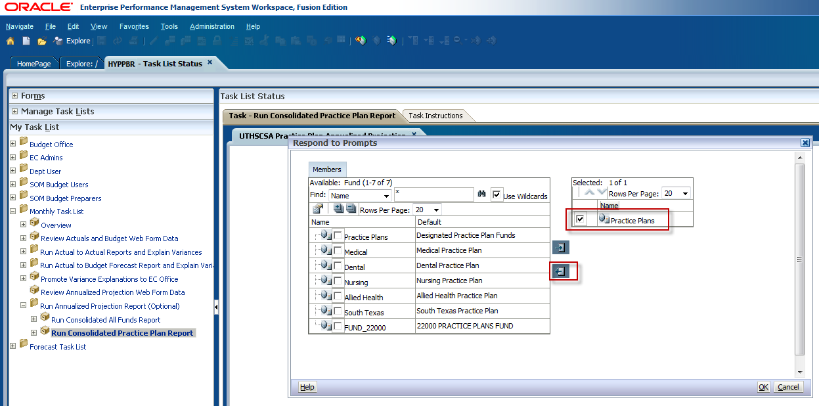

Then check the box for the practice plan you want to select and use the arrow button to move it to the selection list. Click OK.
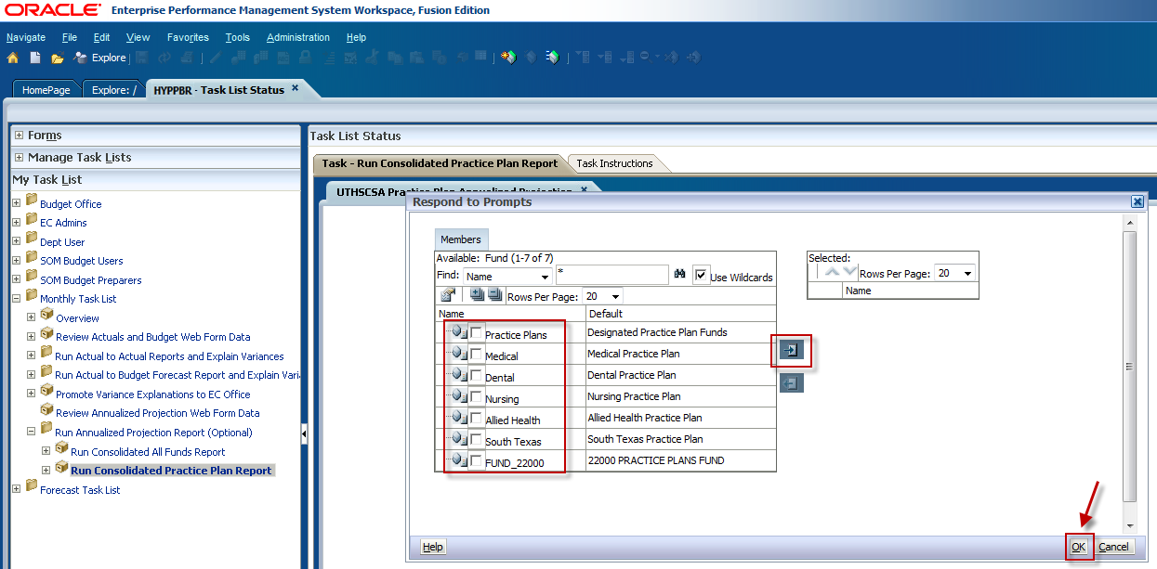

To change the reporting period, click on the icon next to the Period box.
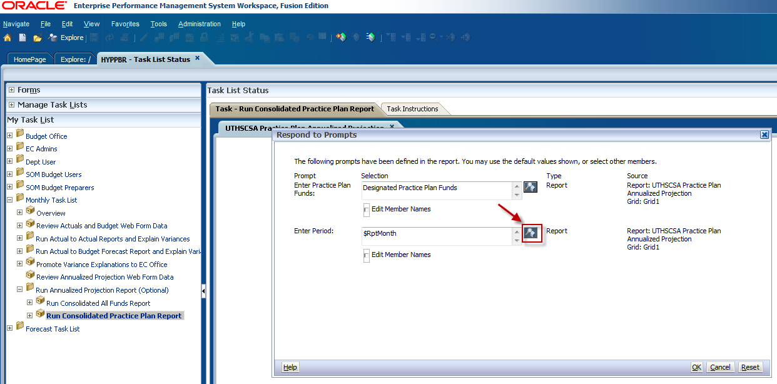

Use the arrow button to remove the default reporting period from the selection list. Then select the intended reporting period and use the arrow button to move it to the selection list. Click OK.
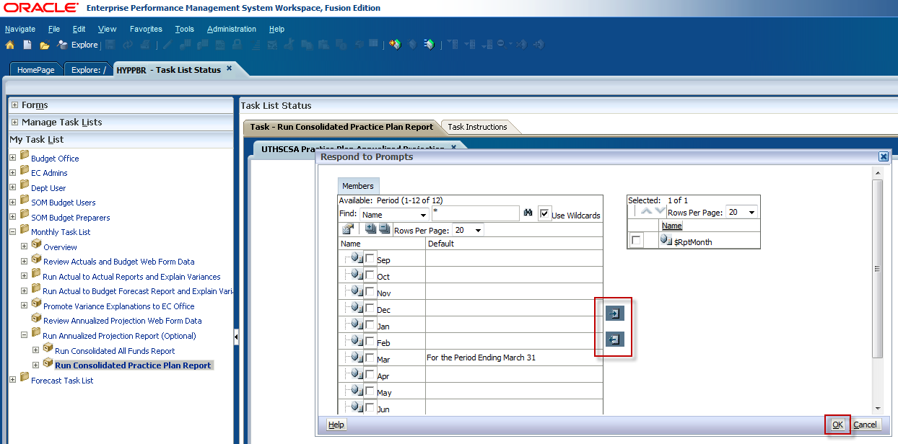

You will be taken back to the Respond to Prompts window. Confirm the criteria and click OK.
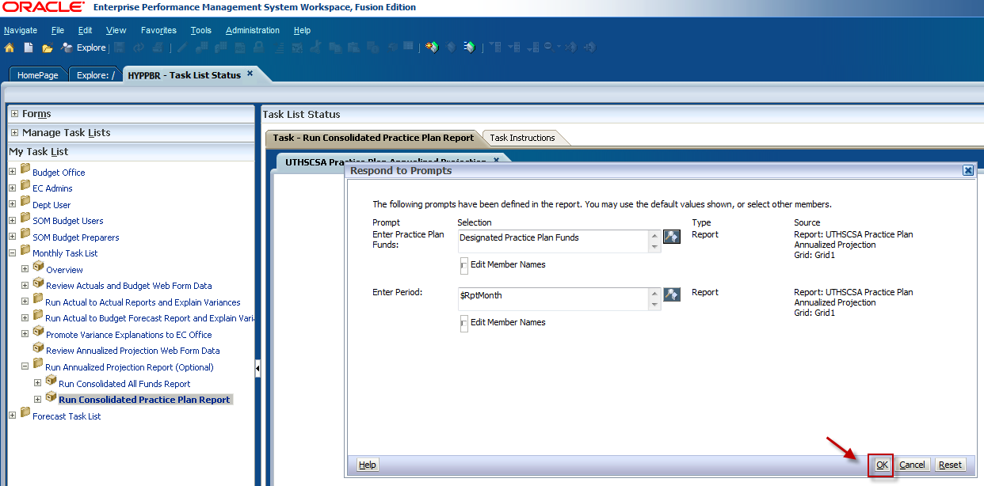

The Annualized Projection Practice Plan report will appear in your window in HTML format. To drill down, click on the arrows facing to the right beside the report line items. The sub-levels of data will appear above the report line item. At this point the HTML report can be exported to Excel by following the steps in the Export a report to Excel section. Keep in mind that for detail to be exported to Excel it must first be expanded in the HTML format.
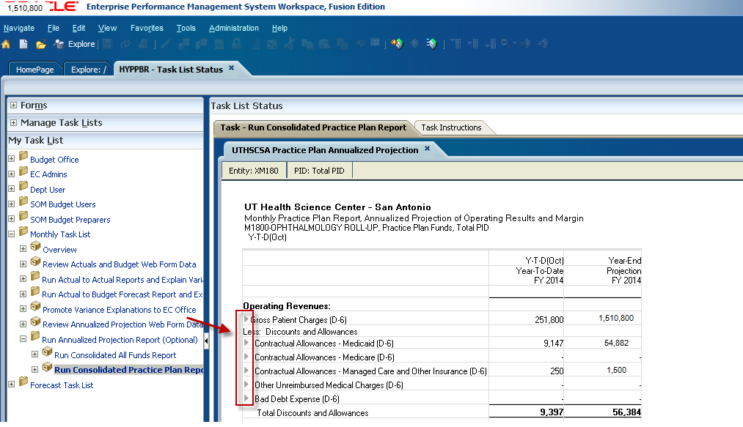

Interpreting the Annualized Projection reports

The Annualized Projection report is presented in the same Profit and Loss format displaying the same revenue and expense categories, and calculating Margin and Change in Net Position. But there are no variances depicted on this report.
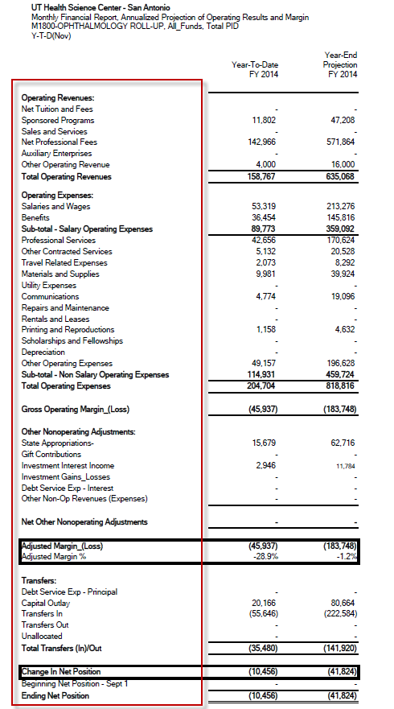

The data in the first column shows the actual year-to-date accumulated activity that is fed from PeopleSoft Financials by category and for all closed reporting periods. The data in the second column shows an annualized estimate of how individual line items will end at the close of the fiscal year. The estimate is calculated by averaging the actual activity from previously closed reporting periods and uses that average to extrapolate activity for future reporting periods in order to derive a projection of year-end operations.
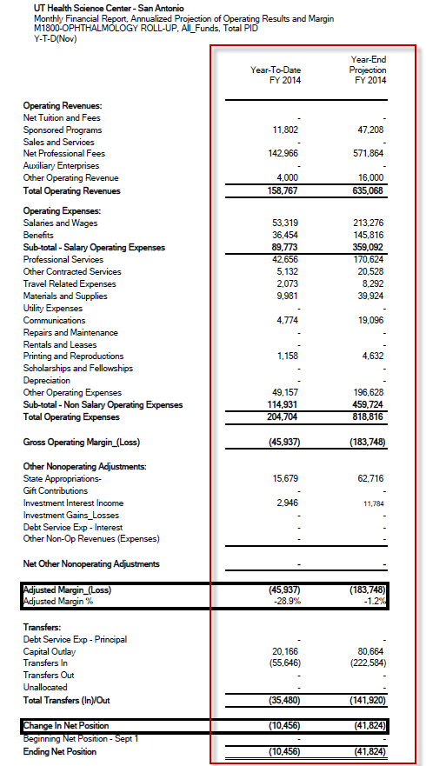

The Annualized Projection report simply predicts how you will end the fiscal year based on monthly trends if you make no changes to your revenue generation and expense pattern behaviors. Thus, attention should be given to the Margin and Change in Net Position to ensure appropriate action is taken to align current operations with budget goals.
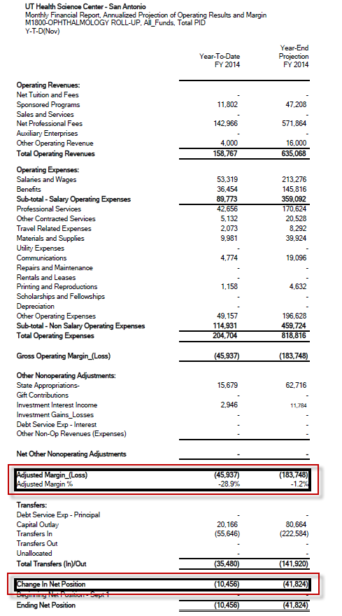
Interpreting the Annualized Projection Practice Plan Report:
Here is an example of the Annualized Projection Practice Plan report. You will see that it is very similar to the All funds Annualized Projection report. The Annualized Projection report does not calculate variances and does not require variance explanations. The only difference with this report is the way the accounts are grouped. As previously mentioned, the categorization of the Practice Plan report is required by UT System.
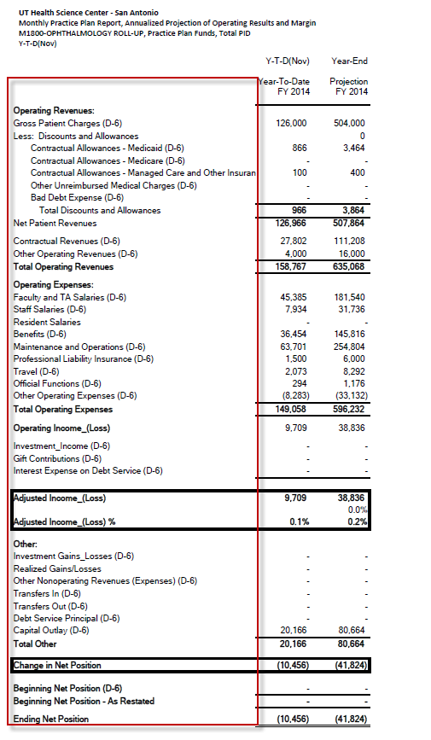

Interpreting Favorable vs. Unfavorable variances

Before you begin analyzing variances, it is important to recognize when variances are favorable and when they are unfavorable. It is not sufficient to state that variances are either positive or negative based on the signage of the amount.
Favorable variances enhance your financial operations, and therefore are good. On the other hand, unfavorable variances adversely impact your financial resources, and therefore are bad.
Whether a variance is favorable or unfavorable depends on if the budget category, or line item, you are analyzing is a revenue or an expense, and if it appears on the Actual to Actual or Budget to Actual report.

Impact of variance on Revenue categories:
With the Actual-to-Actual report, the prior year is used as the benchmark to gauge how operations fared for the current year. Here you see a series of changes for Sales & Services.
- In this first example, you can see that 10,000 dollars more has been received in the current year than was received in the previous year for the same time period. The fact that we received more this year than last year, and not necessarily the positive signage of the variance amount, makes the variance favorable.
- On the other hand, you see that we received 10,000 dollar less in the current year than what was received in the prior year for the same time period. The fact that we received less this year than last year, and not necessarily the negative signage of the variance amount, makes the variance unfavorable.
With the Budget-to-Actual report, the budget estimate is used as the benchmark to gauge how operations fared for the current year.
- In this next example, you can see that 10,000 dollars more has been received in the current year than was estimated for the same time period. The fact that we received more than what was planned, and not necessarily the positive signage of the variance amount, makes the variance favorable.
- Conversely, you see that we received 10,000 dollar less in the current year than was estimated for the same time period. The fact that we received less than what was planned, and not necessarily the negative signage of the variance amount, makes the variance unfavorable.

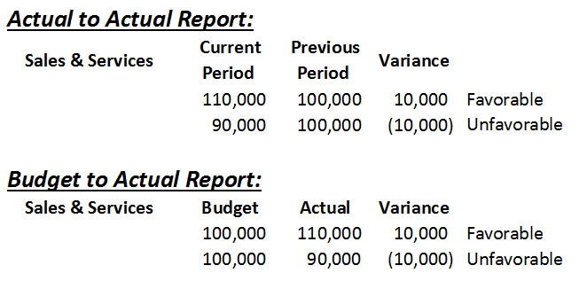

Impact of variance on Expense categories:
With the Actual-to-Actual report, we said that the prior year is used as the benchmark to gauge current operations. Here you see a series of changes for the expense category, Travel.
- In this first example, you can see that 5,000 dollars less has been spent in the current year than was spent in the previous year for the same time period. The fact that we spent less than last year makes the variance favorable even though the signage of the variance calculation is negative.
- Looking at the next example, you see that we spent 5,000 dollar more in the current year than was spent in the previous year for the same time period. The fact that we spent more than last year makes the variance unfavorable even though the signage of the variance calculation is positive.
With the Budget-to-Actual report, we said that the budget estimate is used as the benchmark to gauge current operations.
- In this next example, you can see that 5,000 dollars less has been spent in the current year than was estimated for the same time period. The fact that we spent less than what was planned makes the variance favorable even though the signage of the variance calculation is negative.
- Looking at the last example, you see that we spent 5,000 dollar more in the current year than was estimated for the same time period. The fact that we spent more than what was planned makes the variance unfavorable even though the signage of the variance calculation is positive.

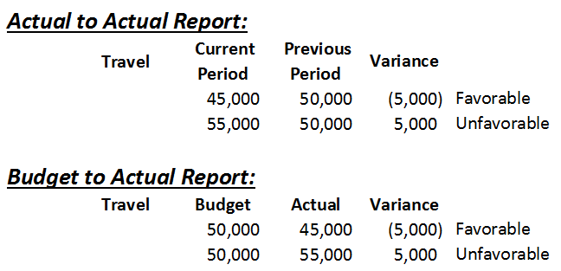

Impact of variances on Margin:
Individual line item variances don’t tell the whole story of your financial performance. You may have collected less revenue in one category only to have significant excesses in another. For example, your faculty may have lost a research grant but made up the difference by doubling the number of patients they saw at their clinics. Likewise, you may have underspent in one expense category in order to cover unplanned cost increases in another. For example, you may have reduced travel and entertainment costs to be able to fund a necessary consulting engagement.
So it’s important to look at the accumulated change of all of your revenue and expense variances to see how they impact your margin as a conglomerate.
With the Actual-to-Actual report you can see in the first example that netting more in the current year than the prior year constitutes a favorable variance and indicates you are contributing more to your reserves than you did last year. It further indicates you are in a better position to save for future strategic investments, or to cover incremental or unplanned costs that may arise. In the second example, netting less in the current year than the prior year constitutes an unfavorable variance and indicates you are reducing your ability to cover costs or build reserves.
With the Budget-to-Actual report you can see that netting more in the current year than what was planned constitutes a favorable variance and indicates you are well on your way toward meeting and exceeding your financial goals. It too indicates you are contributing more to your reserves and are in a better position to save for future strategic investments, or to cover incremental or unplanned costs that may arise. Conversely, netting less in the current year than what was planned constitutes an unfavorable variance and indicates you are veering off track and are in danger of NOT meeting your financial goals.
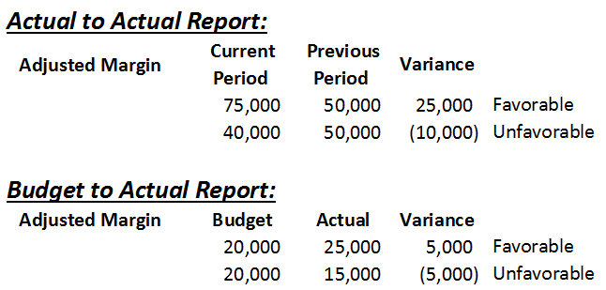

Impact of variances on Net Position:
Margin only accounts for revenues and expenses, so we need to consider how Transfers In (or the commitments we receive from others) and Transfers Out (or our commitments we provide to others) impact our overall financial performance. We can do this by looking at variance for the Change in Net Position .
With the Actual-to-Actual report you can see in the first example that like we saw with Margin, netting more in the current year than the prior year constitutes a favorable variance and indicates you are contributing more to your reserves than you did last year. It further indicates you are in a better position to save for future strategic investments, or to cover incremental or unplanned costs that may arise.
In the second example, netting less in the current year than the prior year – just like Margin – constitutes an unfavorable variance and indicates you are reducing your ability to cover costs or build reserves.
With the Budget-to-Actual report you can see that just like Margin, netting more in the current year than what was planned constitutes a favorable variance and indicates you are well on your way toward meeting and exceeding your financial goals. It too indicates you are contributing more to your reserves and are in a better position to save for future strategic investments, or to cover incremental or unplanned costs that may arise.
Conversely, netting less in the current year than what was planned – just like Margin – constitutes an unfavorable variance and indicates you are veering off track and are in danger of NOT meeting your financial goals.
A word of caution as it relates to Transfers: Unspent commitments will fall to the bottom line and give the appearance of favorable operations in the current year, but will appear as drains or deficits in subsequent years as the commitments are spent. It’s important for operations to not become heavily dependent on transfers. Ideally, operating costs should be covered with regular and recurring operating revenues.

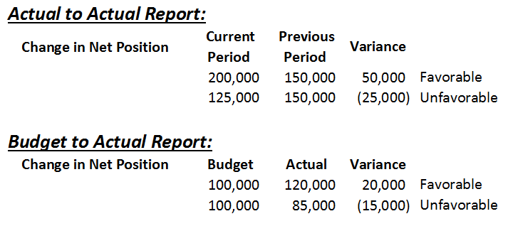

Building Variance Explanations

A well-developed variance explanation answers the following questions:

1. WHAT changed?
2. WHY did it change?
3. By HOW MUCH did it change?
4. WHERE did it change?
5. For HOW LONG is the change anticipated?

Three C’s:
A well-developed variance explanation will also encompass the Three C’s.
It will be:
- Complete: All questions have been answered
- Correct: Research has been completed to validate data
- Concise: Brief paragraph - 5 sentences or less

Writing Variance Explanations

The following are some examples of well-developed variance explanations which incorporate all of the required elements.

Example 1:
The Salaries and Wages expense line item is showing a favorable variance of $410,000 or -12% in the current reporting period compared to the amount reported in the same period of the previous year.

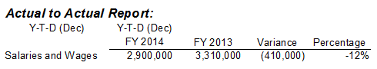

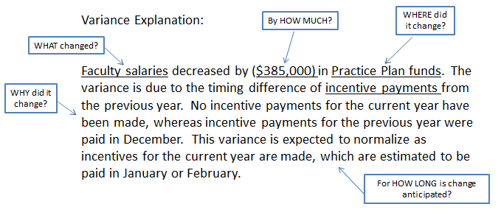

Example 2:
Other Contracted Services expense line item for the current reporting period is showing an unfavorable variance of 25,600, or 15%, over the amount budgeted.

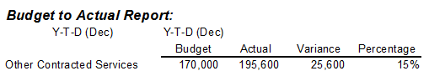

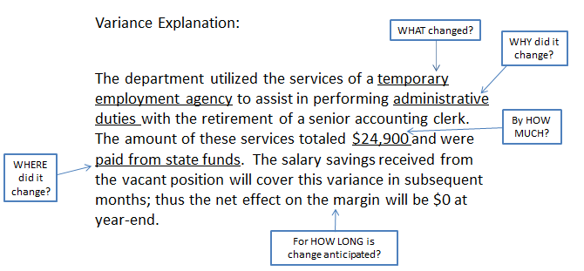

Example 3:
The Sponsored Programs revenue line item for the current reporting period is showing a favorable variance of 400,000 or 42%, over the amount budgeted.

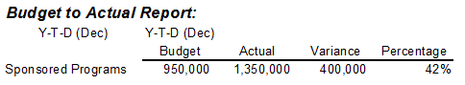

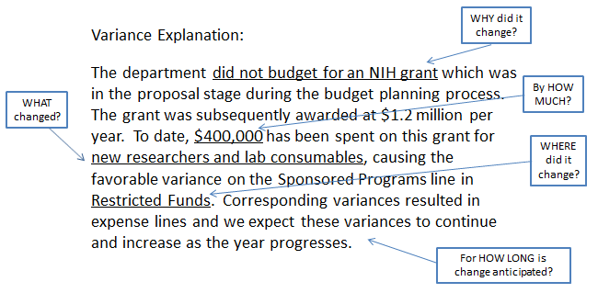

Exporting a report to Excel
Now let’s look at how to export reports to excel and where to enter your variance explanations. For demonstration we will export the All Funds Actual to Actual report to Excel in the following steps.

To export a report to Excel, navigate to the Explore tab and double click on the HYPPBR folder.

Double click on the Financial Reports folder.

Double click on the Institution folder.

Double click on the Reporting folder.

A list of reports will then appear. Double click on the report you would like to export. In this case the UTHSCSA PL Actual vs Actual.
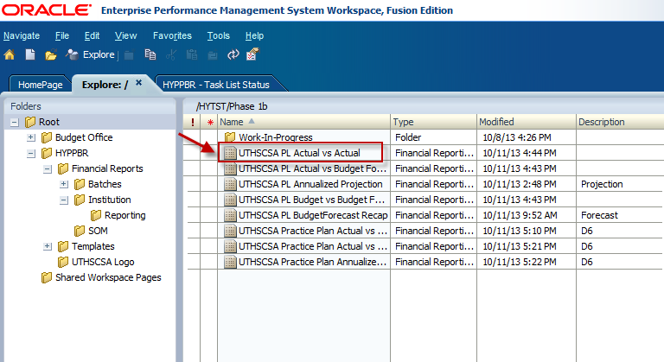

The Point of View window will appear prompting you to re-enter your member selections.
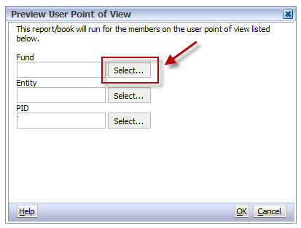

When you have made your member selections, click OK.
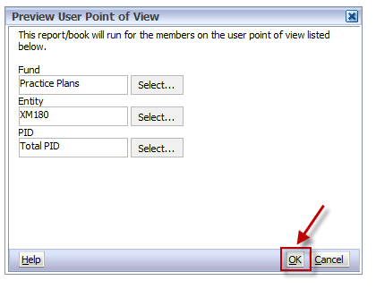
Again, you will be prompted to confirm the reporting period. When you have confirmed the criteria are correct, click OK.
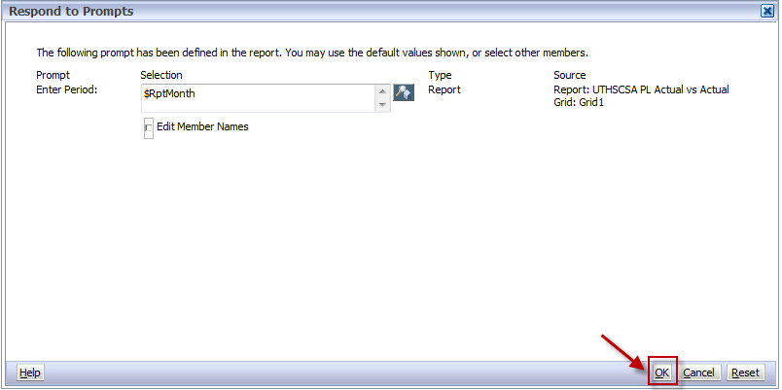

The HTML version of the report will appear on your screen. Keep in mind that in order for embedded account information to export, it first needs to be expanded in the HTML format. At this point, take a minute to expand line items you wish to see embedded detail for by clicking on the arrows beside the report line items.
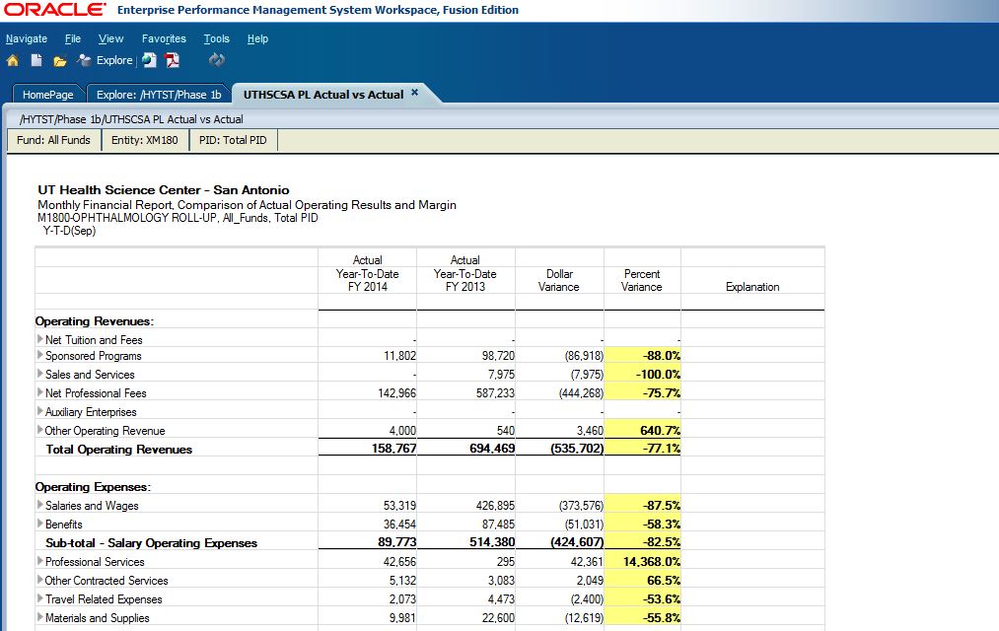
Click File, and hover your mouse over Export.
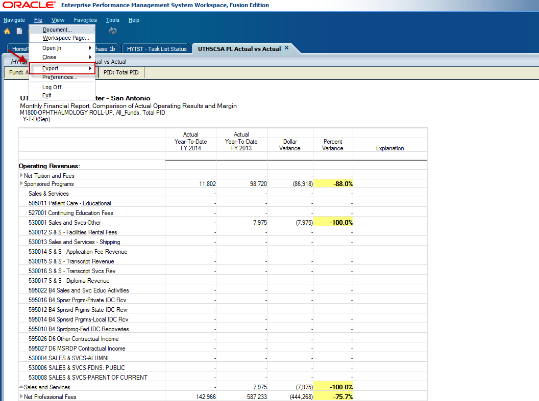
Select Excel.
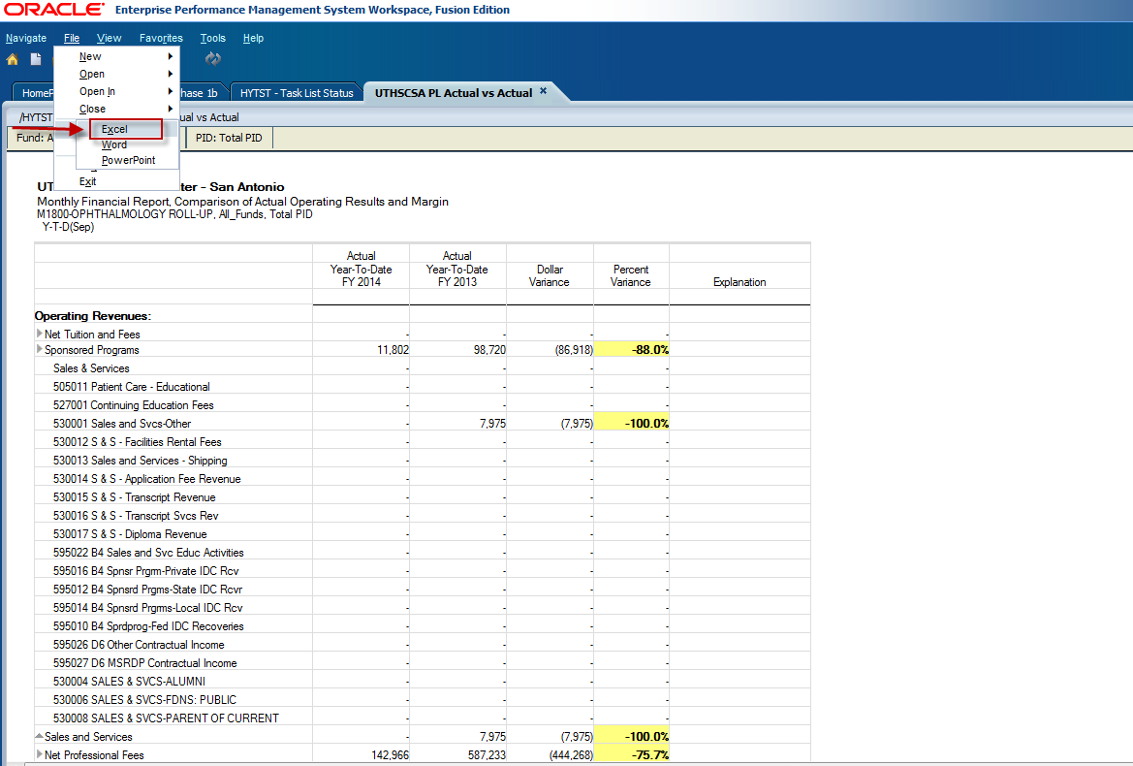

A pop-up window will appear. Click the Open button to open the Excel file.
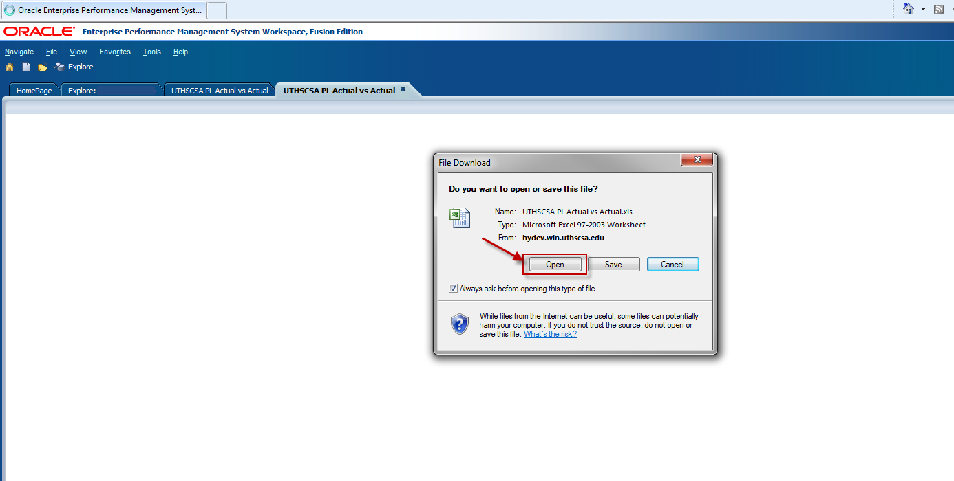

You will receive the below message. Click Yes to open the Excel file.
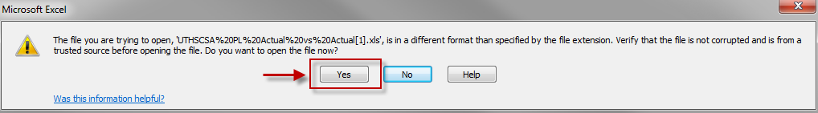

The report will open in Excel format as shown below. Notice the account detail for Sales and Services is itemized and presented on the lines above the Sales and Services budget category. This line item was expanded to see supporting detail. Also notice that the columns are wider than necessary.
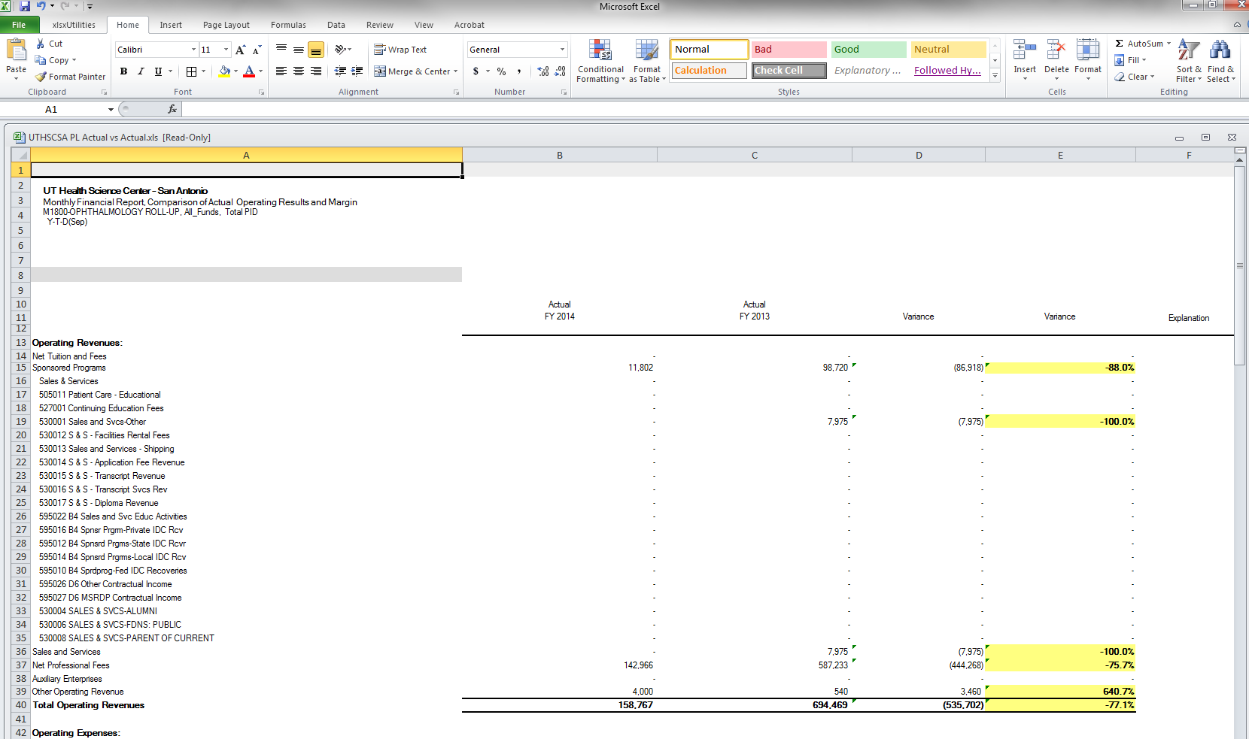

To format the columns, click in the top left corner to select the entire worksheet. Then place your cursor on the line separating columns A and B and double click. This will format the column width to only appear as wide as the longest string of text.
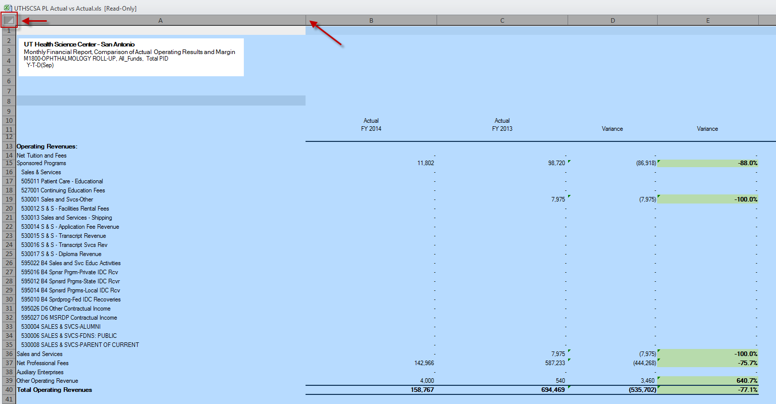
Below is what the report will look like when the columns have been formatted. Click anywhere to de-select the worksheet and to remove the blue tint.
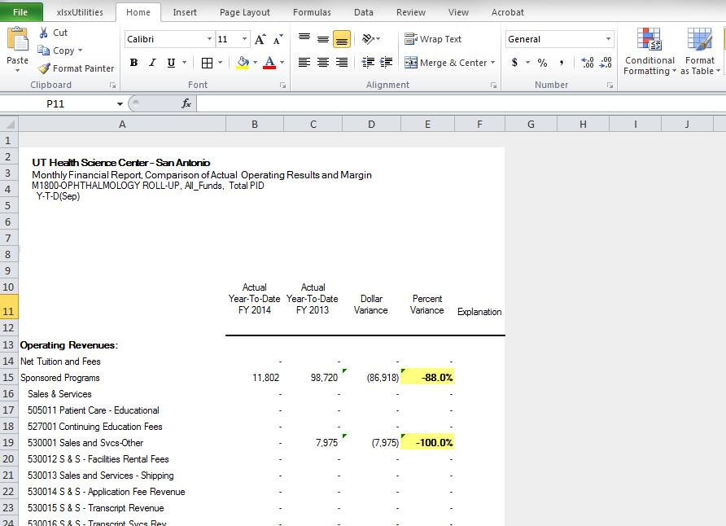

Enter variance explanations in the Explanation column by clicking the cell next to the line item you would like to explain. Then type your annotation.
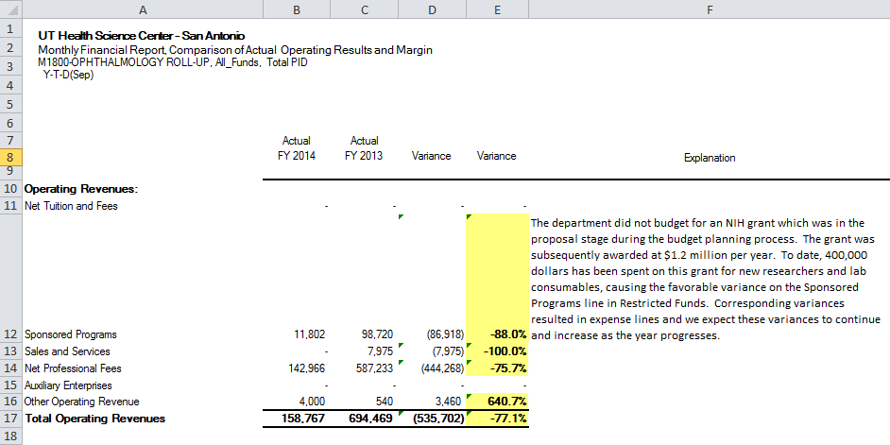

To delete unnecessary rows within excel, left click on the row number to select the entire row. Then right click and select Delete in the menu. To select a series of rows as shown below, left click on the row number and drag your mouse down.
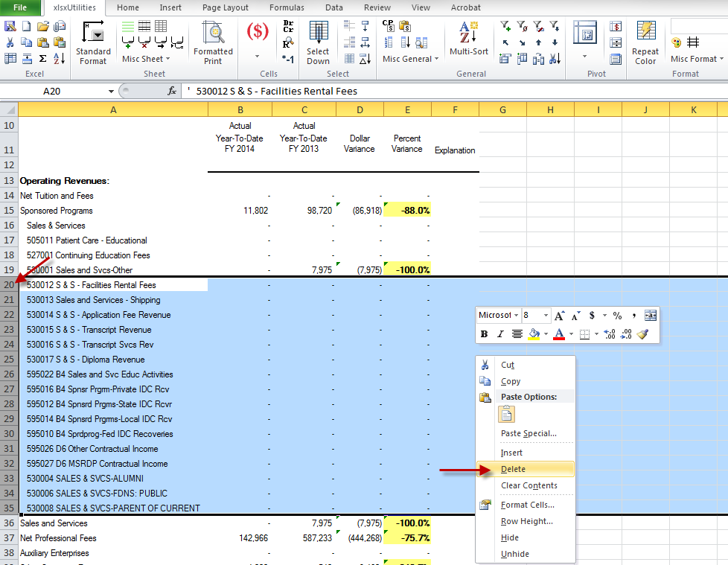

Be sure to save your report in an accessible location.
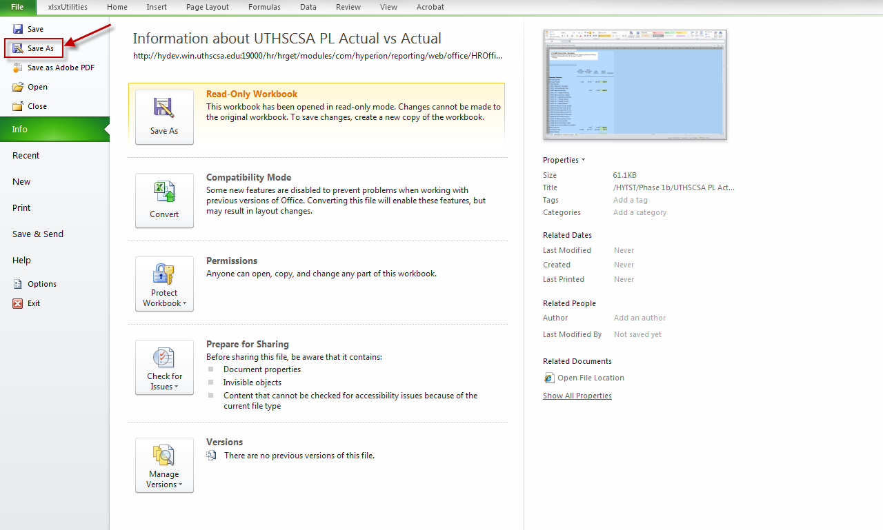

Cover Explanations
After you have investigated required variances and drafted explanations, it is important to take a step back and analyze the entire report.
Ask Yourself:
- What happened?
- What are the driving forces causing the change?
- What action is needed?

These questions should be applied to both the Actual-to-Actual and Budget-to-Actual reports, and to the All Funds report and the Practice Plan report to get a complete picture of your overall financial performance. Although not a required report, the Annualized Projection report may aid in your assessment. Refer to the previous training session or your training guide to run this useful informational report.
The answers to these questions should be compiled into a cover explanation and submitted to management with the reports. Below are examples of good Cover Explanations.

Example 1: The department experienced a 20% increase in patient volume over what was expected. As a result, the department was able to cover more expenses than projected by giving out of cycle salary increases and allowing employees to attend conferences while having no adverse impact to margin.
Example 2: The department lost a grant which had previously provided a significant amount of support. As a result, the department was forced to cut all expenses, salaries being the hardest hit.

Send to the EC Office

Primary Reports:
- Budget to Actual – Entity Wide Consolidated
- Budget to Actual – Entity Wide Practice Plan
- Actual to Actual – Entity Wide Consolidated
- Actual to Actual – Entity Wide Practice Plan
Include with each report:
- Cover Explanation
- Line Item Explanations
Consult with EC office for submission procedures:
- Designated Contact Person
- Shared Mailbox
- SharePoint Site

